Section 1- fundamentals

**Section 2 : AWS EC2 and Linux Basic**

**Section 3- Git**

**Section 4- maven**

**Section 5 - Create Spring boot microservices**

**Section 7 :- Manual deployment to AWS using EC2 using S3**

**Section 8:- AWS Elastic load balancer**

**Section 9 :- AWS auto scaling Group**

Section 10 - AWS cloudwatch , monitoring and sns

Section 11 - Deploy to AWS Elastic Beanstalk using RDS

Section -1 The fundamentals

**Monolithic application :**

Everytime we fixed a defect we need to deploy entire application

While adding new features it should not effect other module that bring m/s

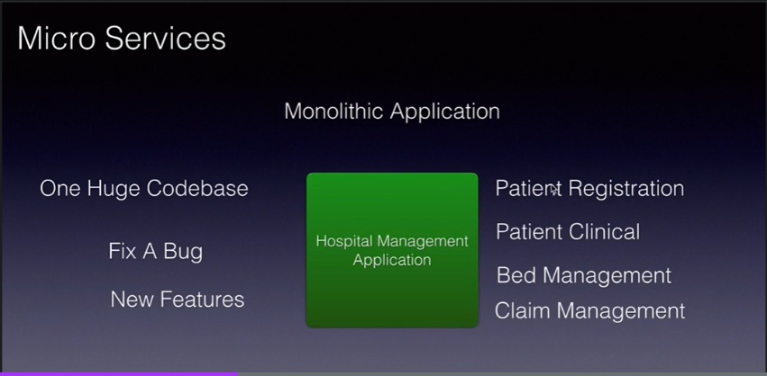

**Microservice**

m/s Can deploy on their own machine . And all communication happens b/w m/s through n/w calls

m/s is small and focused and also autonomous that is m/s can be deploy on own machine and each of m/s

Exposed api and communication among m/s happen through api by n/w calls

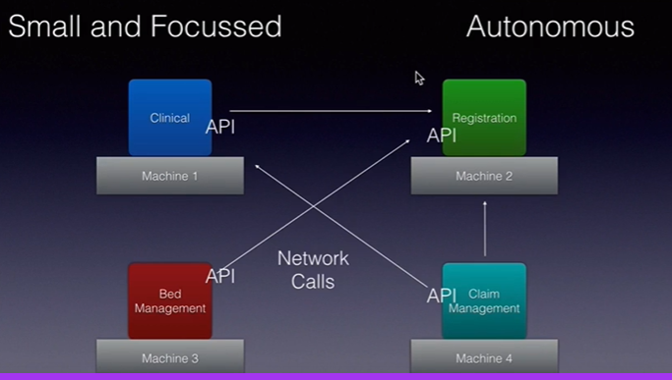

Microservices are self-contained, independently deployable, and autonomous services that take full responsibility

of a business capability and its execution.

**Advantages :**

1. **Heterogeneous :**

Each of the m/s can be written in different programming language and they can run on different platform or

Os and they all communicate using the api they exposed

1. **Robustness**

If one the application fails that will not bring down entire application

1. **Scalable**

we can increase the instance of m/s as the load increases

1. **Easy to deploy**

1. **Reusable and replaceable :**

One m/s use by many m/s

Better m/s we got the we can replace m/s with better m/s ( from third party vendor)

**Cloud computing**

What cloud computing is and why it is so popular

We provide these services to m/s locally or it provided in local network

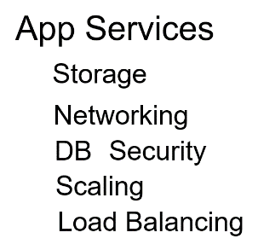

Note :

**Cloud computing provide above services to application in different level**

1. **On demand :-** we can access these services as required and only they will charged up what they used
2. **Ubiquitous :-** means we can access these services from anywhere and everywhere over a network
3. **Shared :** suppose we have 100 gb but we use only 50 gb then rest can be use by other company which

will bring down the cost

Example : uber pool will cost less

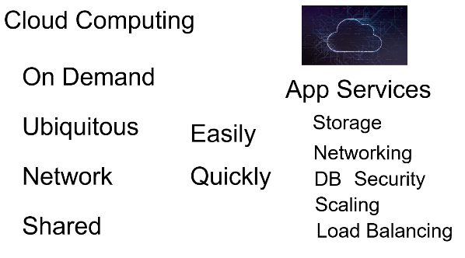

**Example :- google drive .** They are providing on demand storage for us

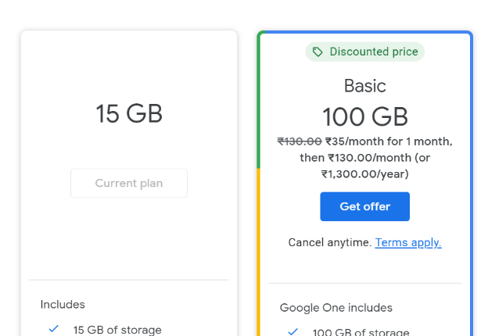

Better example of cloud computing **is AWS**

**In cloud :--**

We can simply focused on development

**Cloud Providers**

**Note :**

we can create our own cloud also but advantages of using existing cloud there is no initial investment

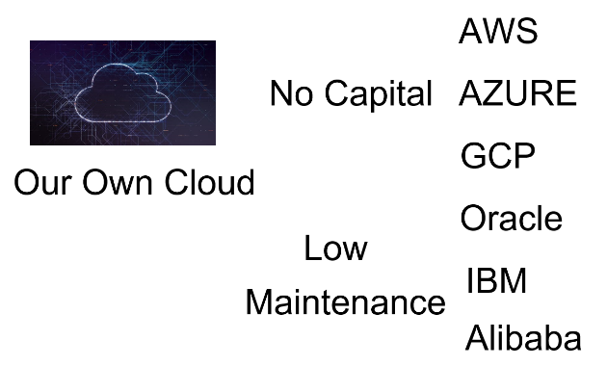

**Types of cloud**

**Three types:--**

**Public :** open for all . Anyone can create account and they can use the services provided by these cloud provider

**Private :** organization will create and maintain their own account

**Hybrid :** we can mix up public and private cloud

**Example :===** 1

public + private

d/b in private

Web server, java ,load balancing in public

**Example :---2**

We can also include two cloud

Aws(rds)

Azure(.net)

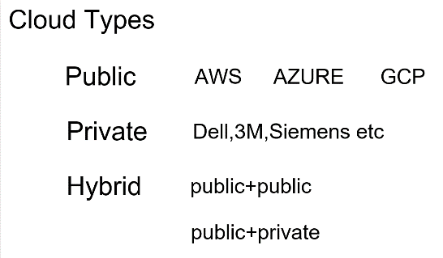

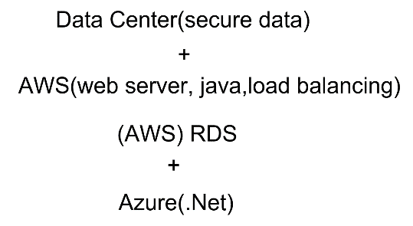

**Services Model**

Three different models are there when we are working with cloud providers

Note :

Any application to run it need all the following services

Data :-relational d/b or any other

Runtime :- java environment

Middleware : m/s talk with each other

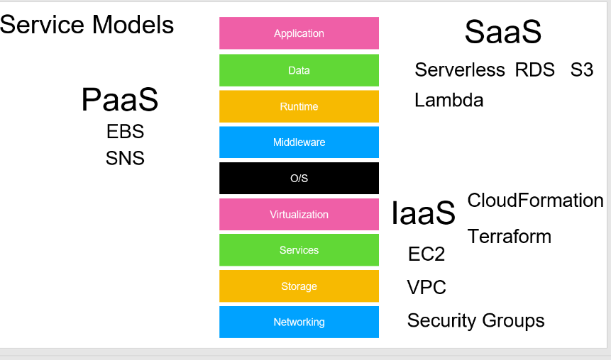

Once we have all these we can run our application

This is where service model comes in .

**The first model is IaaS (Infrastructure as service)**

Iaas :-

first 4 service by aws like n/w ,storage ,services and virtualization and rest of the service will be taken care by organization

Cloudformation and teraform :- will create all the infrastructure required for us

**Second model : PaaS (platform as service)**

In pass we need to handle application and data and rest of thing will be taken care for us.

From networking till runtime will be taken care by cloud provider

**Third model :-- SaaS ( software as service)**

All the layer will be ready for us, we need to see application only. Simply give the application and will run for u.

RDS:-- will maintain d/s

S3:--- all the data

**AWS**

**EBS :---** elastic beanstalk integrate all other aws services that is required our application to do work

For our ms to run these things we required

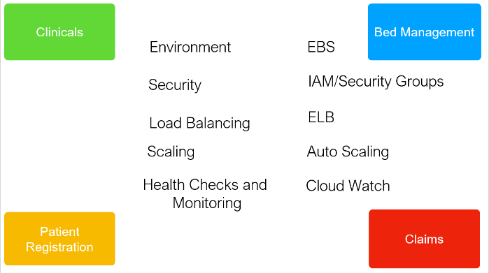

**Continuous Integration, delivery and deployment**

**Continuous Integration :** stop at build stage

**Continuous delivery: -** we run like production in stage. It go upto staging

**Continuous deployment :-** from commit till production there are no manual step required

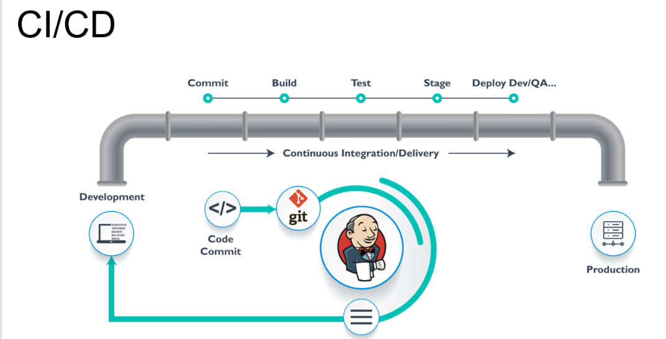

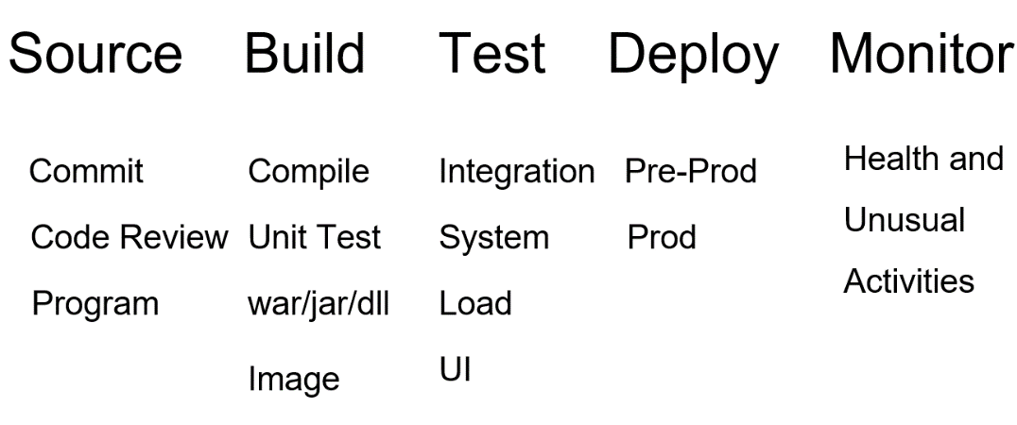

**Devops**

**Enable us to do CI/CD.**

**Devops** is a process we follow and in that process we come up with various tool and this tools keep changing depending on organization priority.

If we are using kubernetes the we can use prometheus monitoring tool

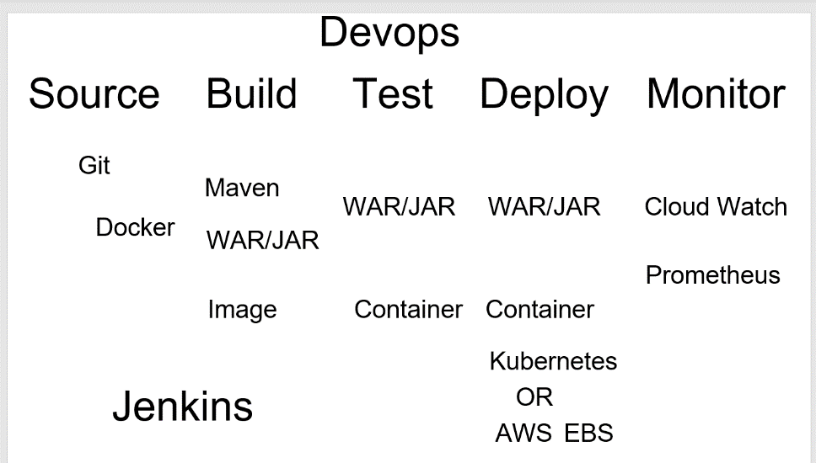

**Jenkins :--- help in CI/CD**

**Section -2 : AWS EC2 and Linux Basic**

**AWS Regions and zones :**

Aws services are spread around world and these geographical world are referred to as **AWS regions**

**These regions** are again divided into **zones** where **datacenter** are located.

These zones are interconnected and there would be atleast 2 zones for every region.

Even if one zone goes down the other zone would be up and running.

Aws maintain **edge location** across the zone act as cache so instead of request going to zone it will go to edge location .

So we as developer don’t touch region and zone but we should aware how some services work across region or same zone

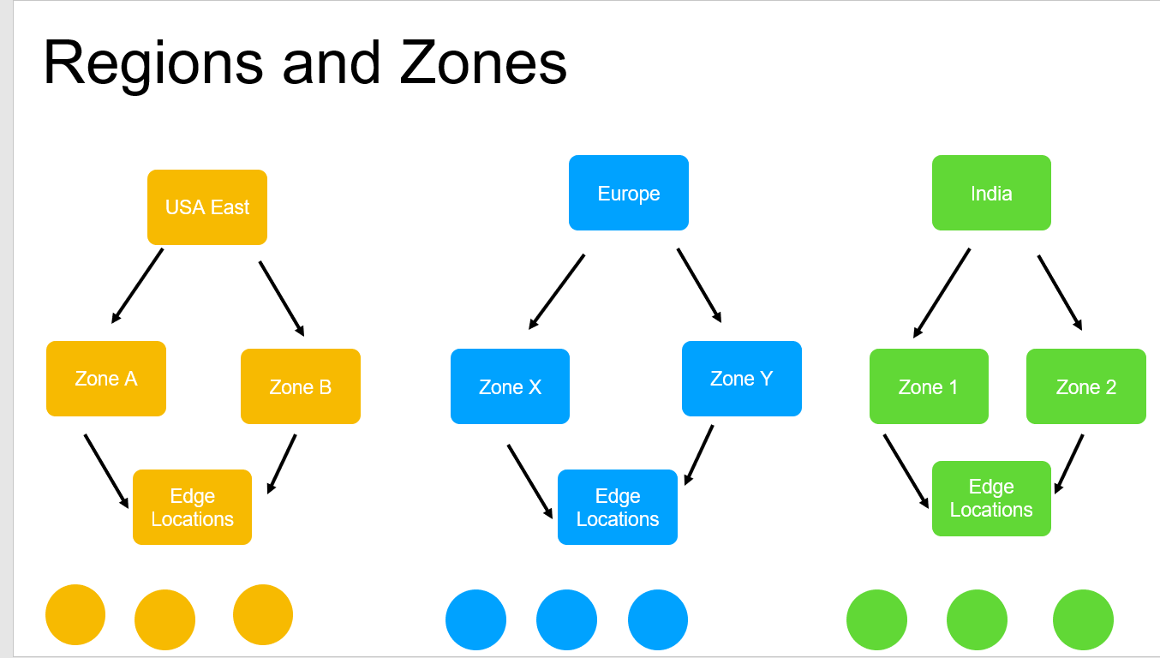

What is the purpose of AWS edge location?

AWS Edge location is the place where the data's are cached **to reduce the latency to the end users**.

They are located in the major cities around the world . These infrastructure are used to provide only the services

such as cloundfront, lambda, etc

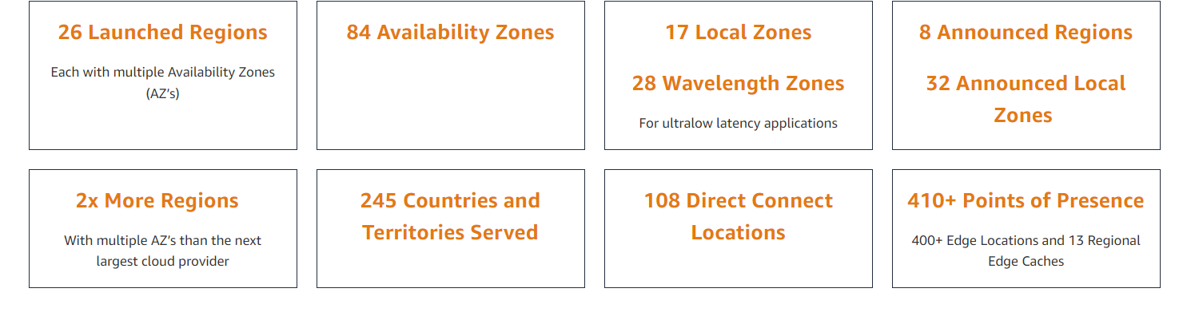

**EC2 Service**

**EC2 :- elastic cloud compute**

**AWS services that uses virtual machine to run our application .**

Amazon called these **instances** instead of call **virtual machine or server**

**EC2** give us **AMI (Amazon machine image).**

This machine image will have all requires s/w like OS and sw depending on the application we want to deploy and work with.

Example if it is java application we can pick with ami image as java then will have all these s/w ready to use.

Note :

once we choose ami and launch the instances then we can connect

On window we can connect with these instances using putty tool through ssh

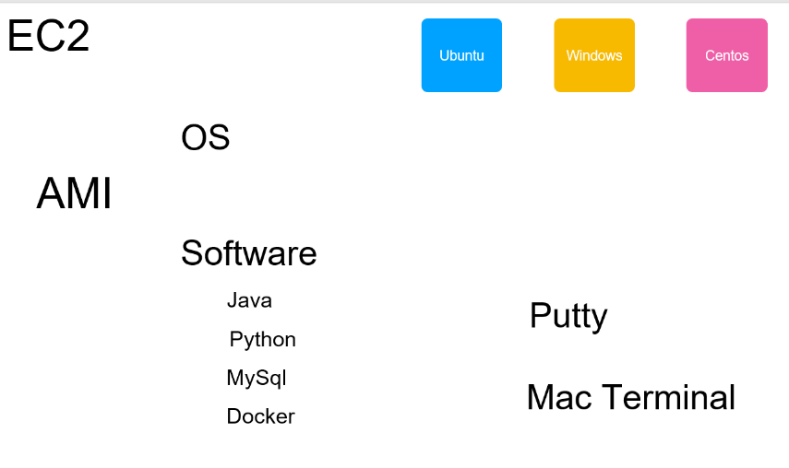

**Note:-**

Once we create a instance will get public ip and we can connect this but if we stop instance and start again then will get new public ip.

But if we want permanent ip address then we need to use elastic ip for which we will be charged for.

But in real time environment all the instance will have elastic ip

**Launch a EC2 instance**

Just like we install os in new desktop , we are exactly going to create EC2 instance in 7 steps considering

OS

CPU

Ram

Hard Disk

Step :- ec2- launch instance

**Step -1**

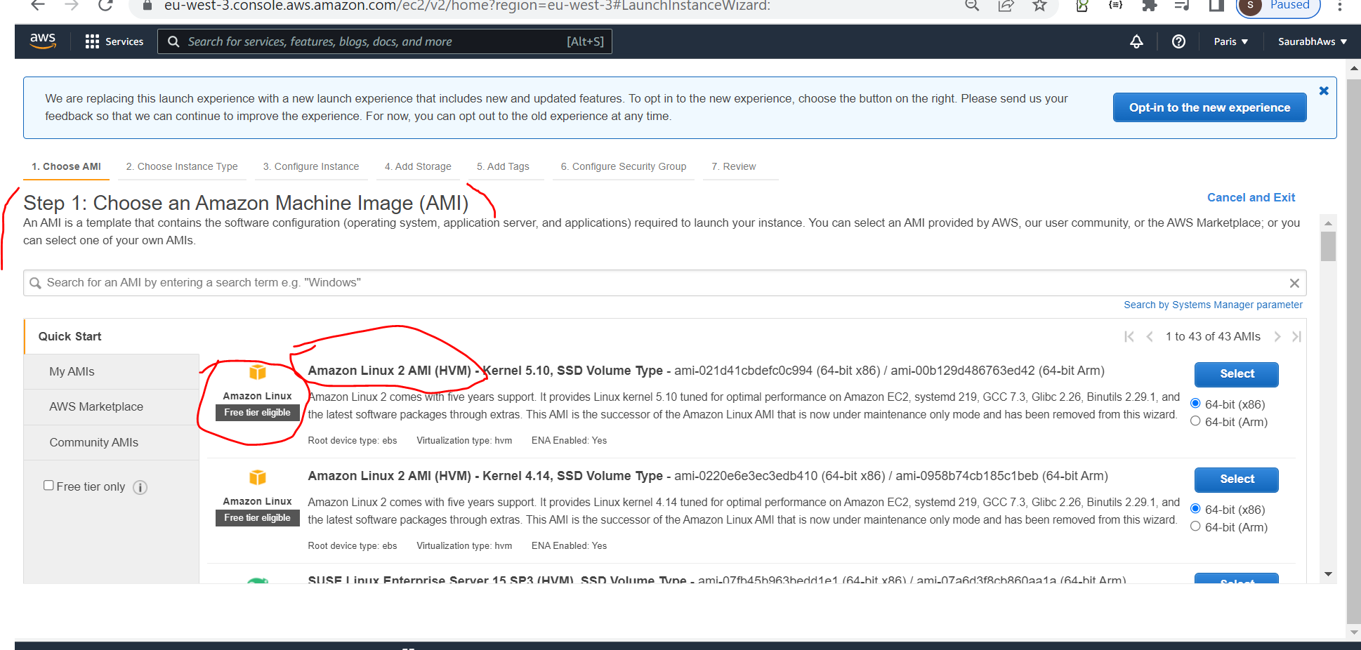

Select this one

**Step 2:-**

**Select default one :-**

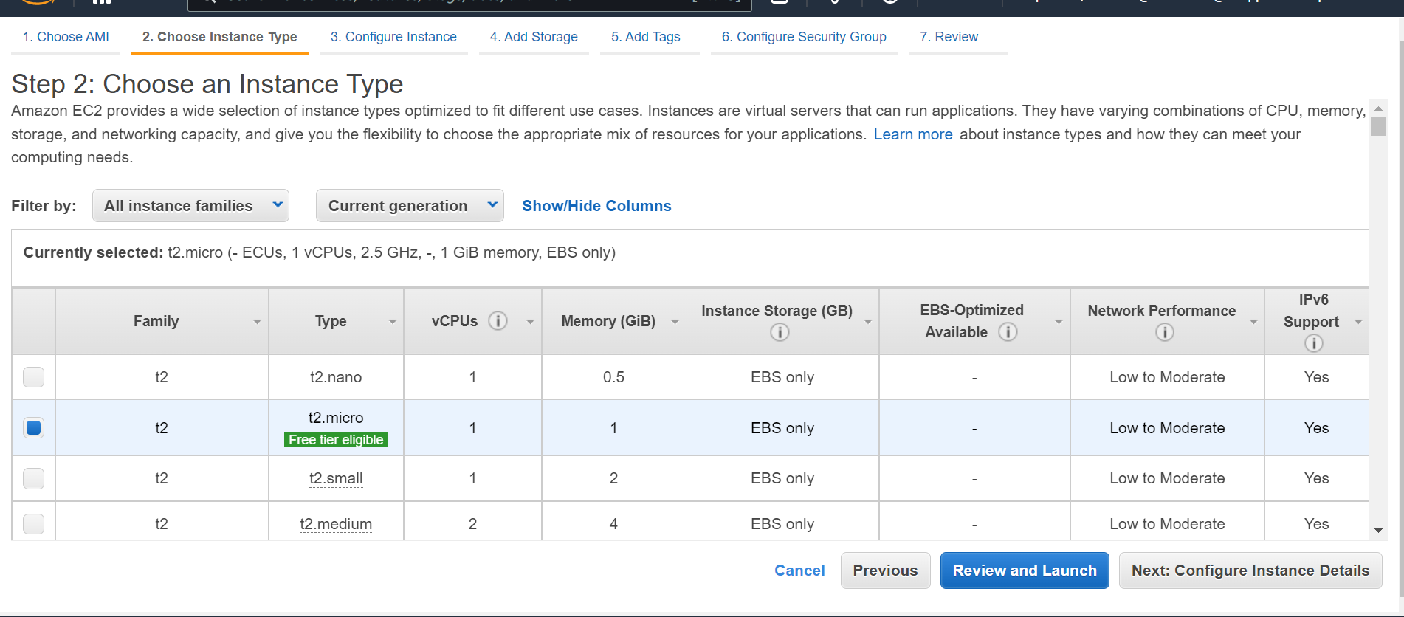

**Step 3:-**

Leave everything as default , configure one instance

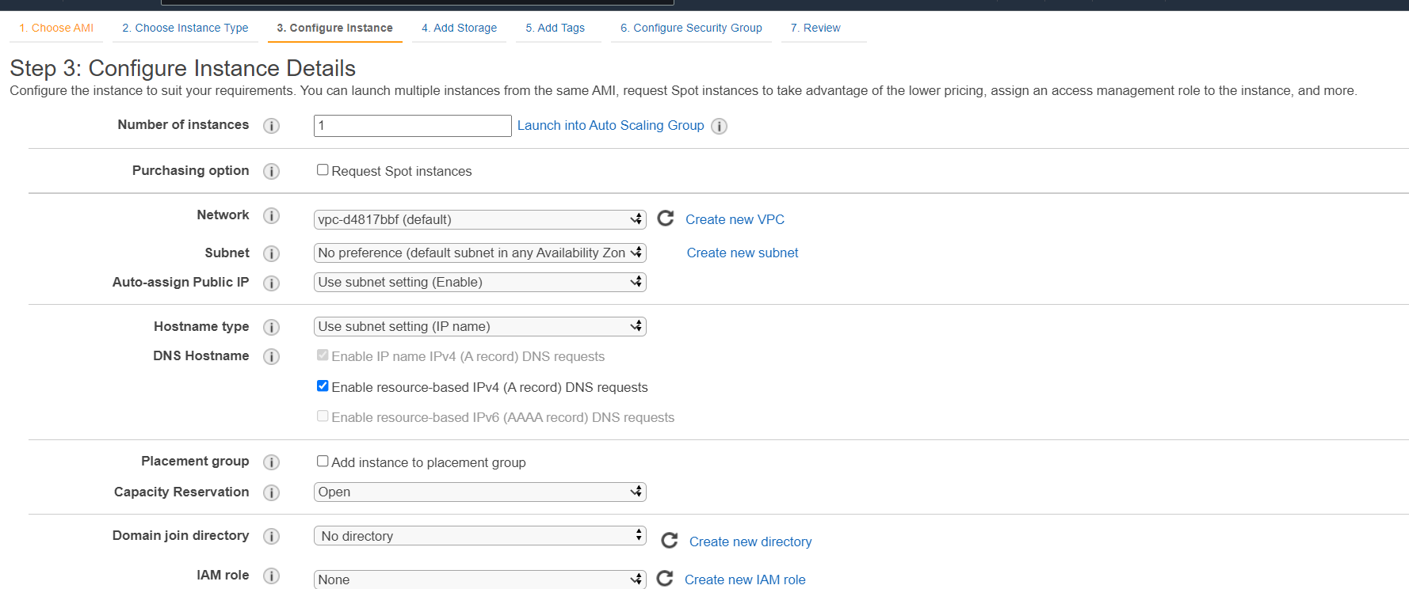

**Step 4:-**

Default storage is 8 gb

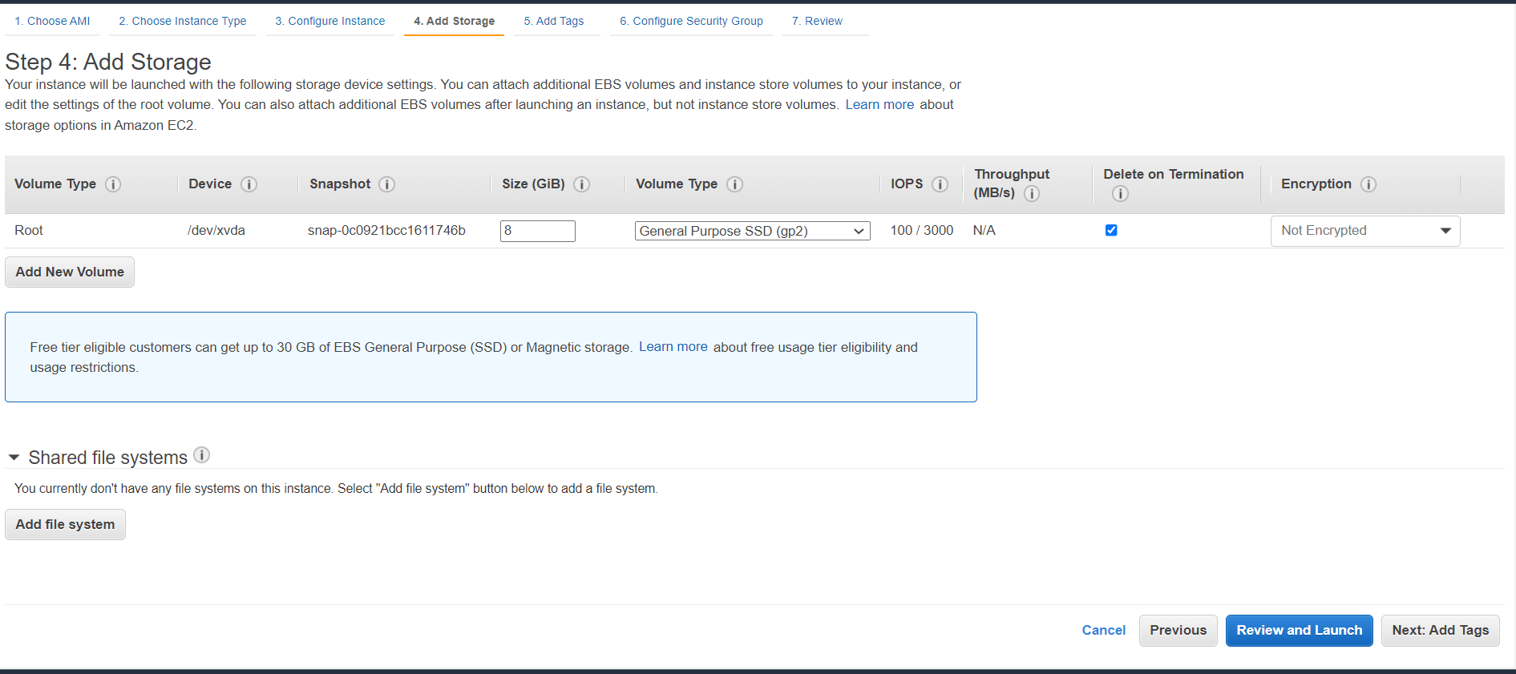

**Step 5 : this is optional**

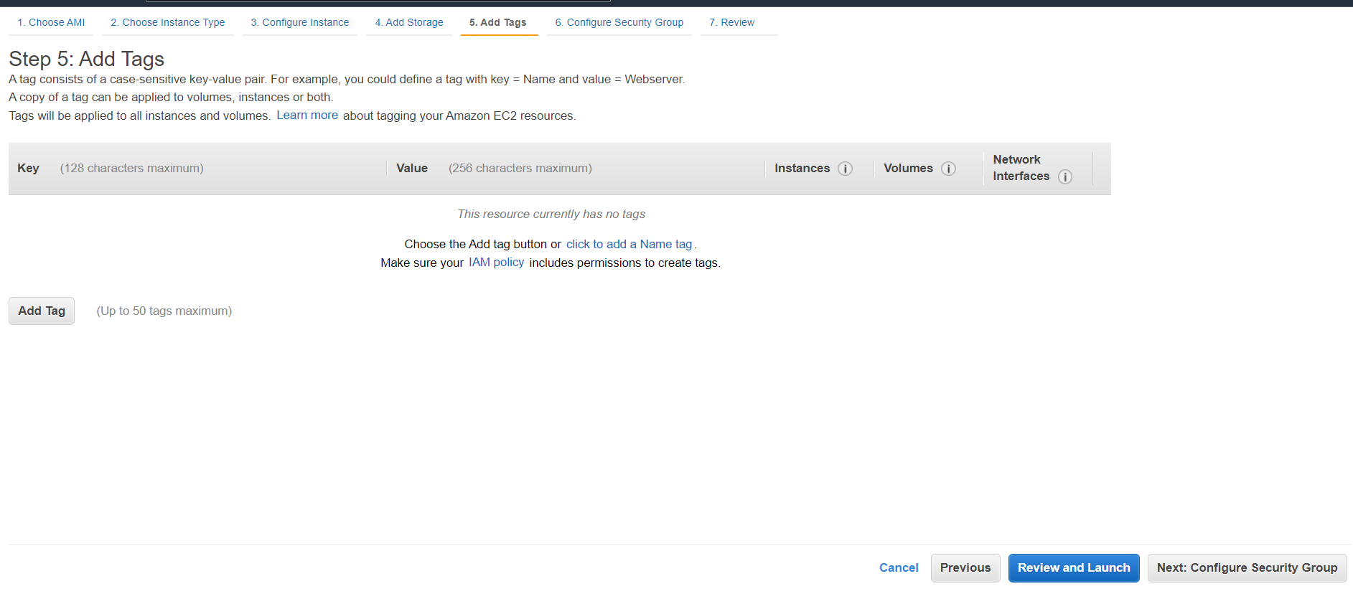

**Step -6**

Security group is the way to restrict access to our new instance.

By default only way is to access this instance is through SSH protocol using port 22

From any ip we can connect this instance

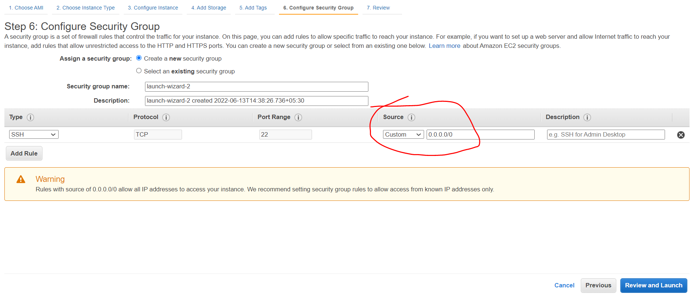

**Step 7**

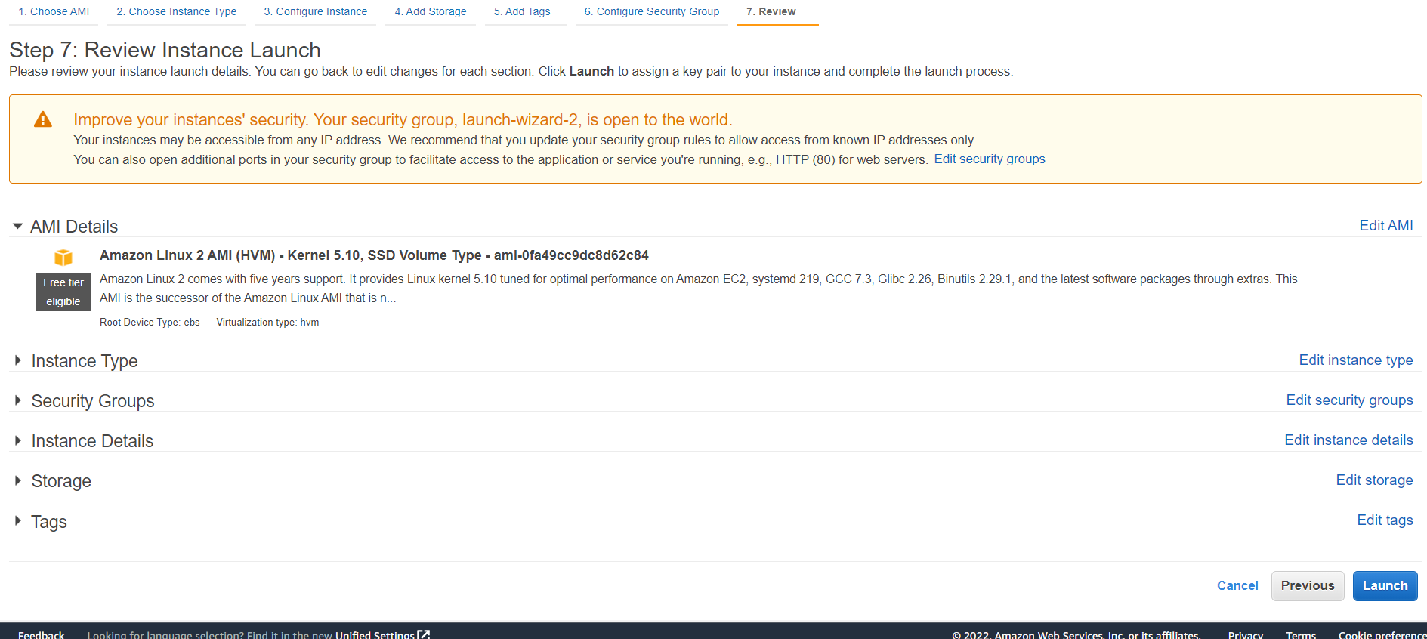

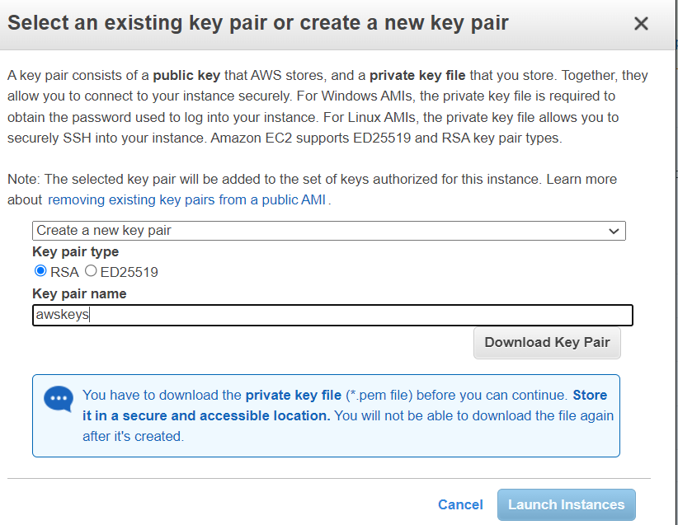

**Awskeys.pem :---**

it is private key and public key is automatically stored in aws

We need this private key when we connect through ssh to the instance

Note :

Public ip is changing everytime:-

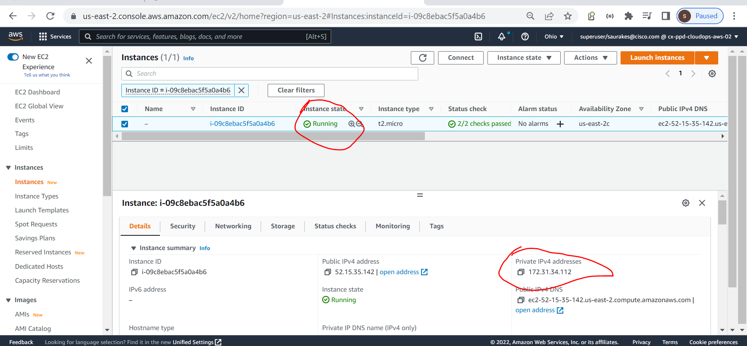

**SSH**

**Note :-**

Once we launch an EC2 instance in aws to communicate through local we need ssh protocol

**SSH** :-

secure shell is a protocol which enable secure communication between any two machine on the network.

The communication happen over port 22 and it use encrypt/decrypt when the data goes out and come in .

In case of aws public key is stored on remote instance and the private key is shared by the client.

We can use same private key across the client as long as public key remain the same.

All the key generation process is taken care by AWS and it store the public key on ec2 instance.

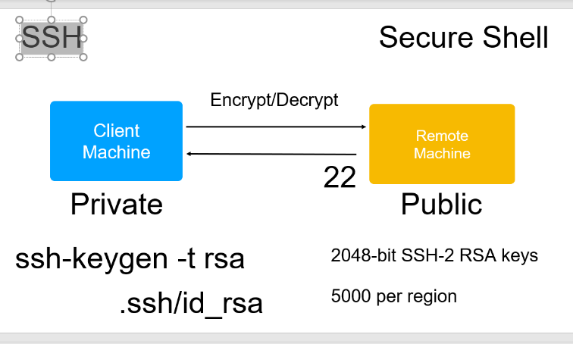

**Windows only - Install MobaXTerm ssh client**

**MobaXTerm :----** ssh client to connect to remote machine

Download MobaXTerm home edition

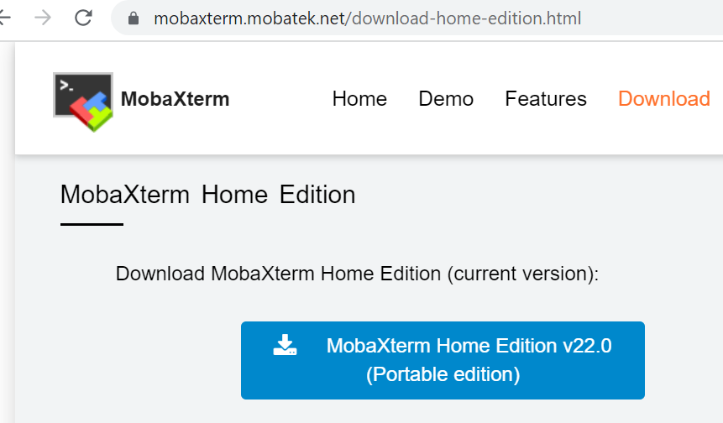

**Note :**

While using docker swarm and kubernetes it is super easy to use MobaXTerm because we can open multiple terminal

And also it is super easy to use. We don’t need to convert pem file into any other format.

**To launch a new session , new connection to connect click on session**

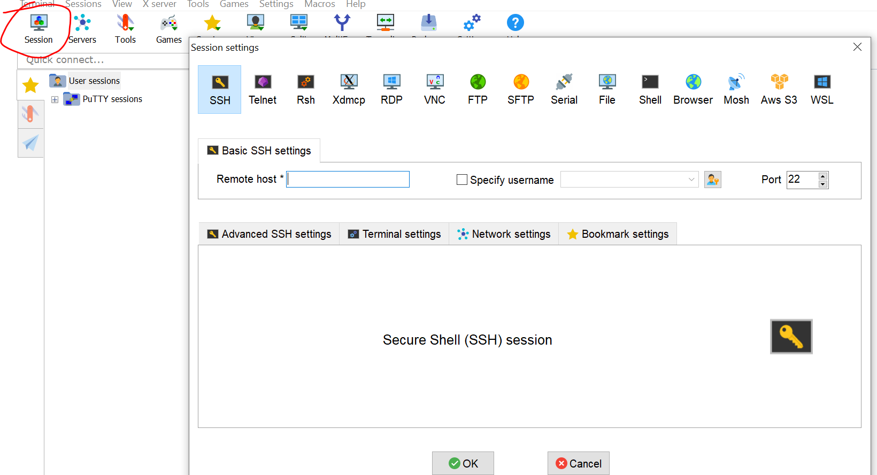

**1-**

**Here in remote host paste DNS name from ec2**

1. **For this to work we have keys :- go in advanced ssh settings**

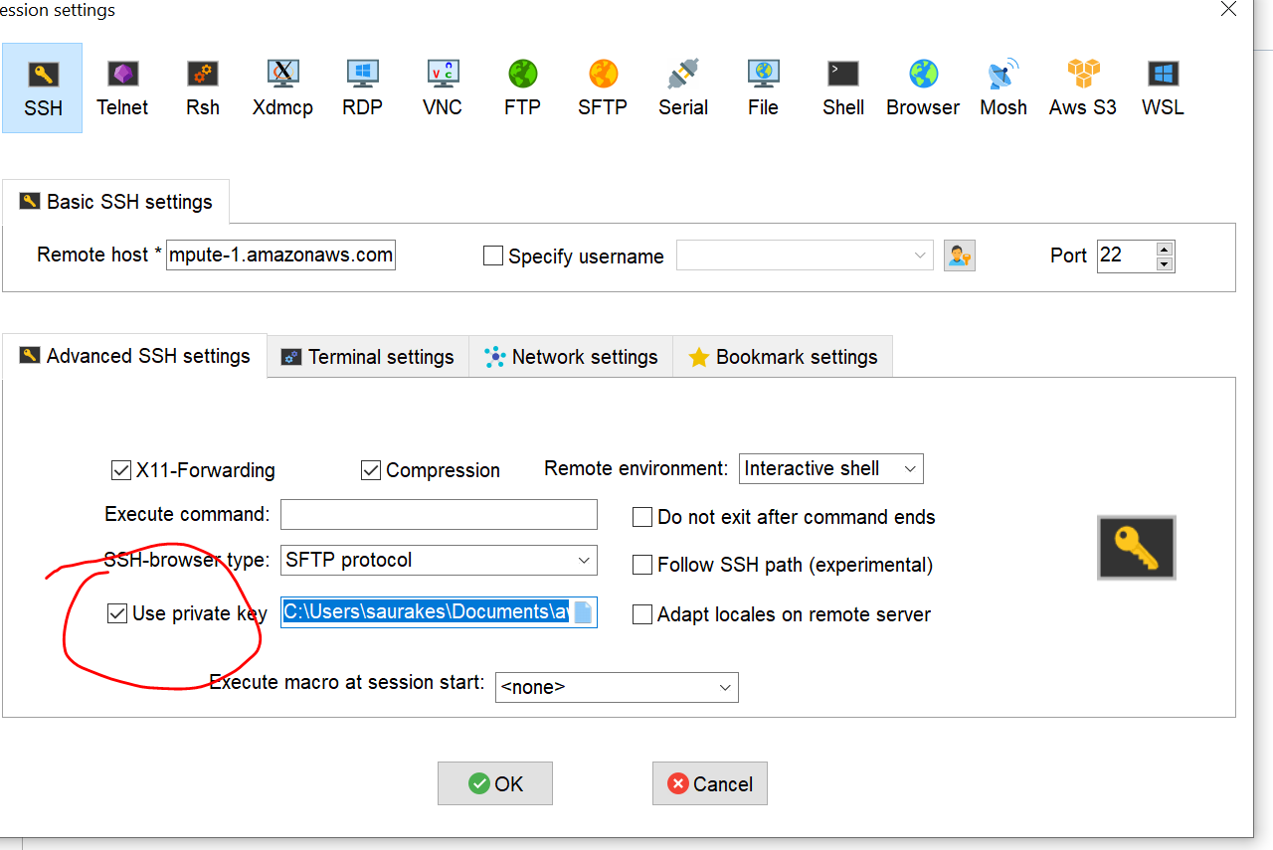

**Click ok**

**Default login name :---** ec2-user

By using sudo -I we become a super user and we can install any software

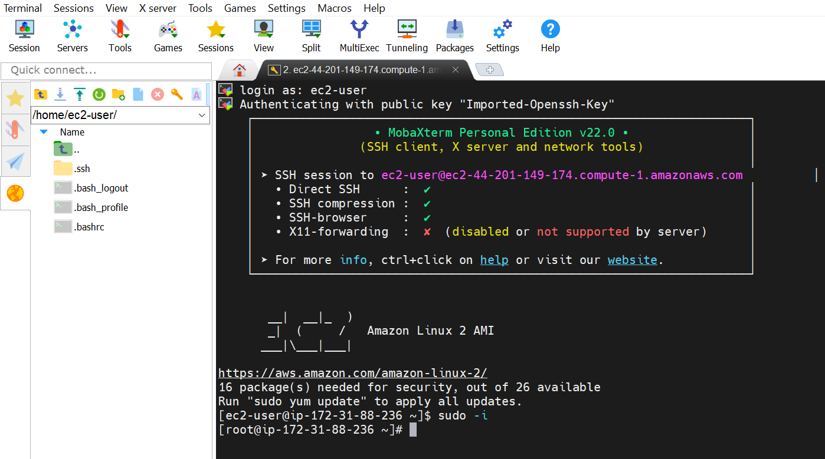

**Putty**

**Note :**

When we install putty , puttygen will get installed

Puttygen :- it help us to convert the key

Step 1:-

Open puttygen ,

click load,

click save private key,

it will save key as ppk instead of pem

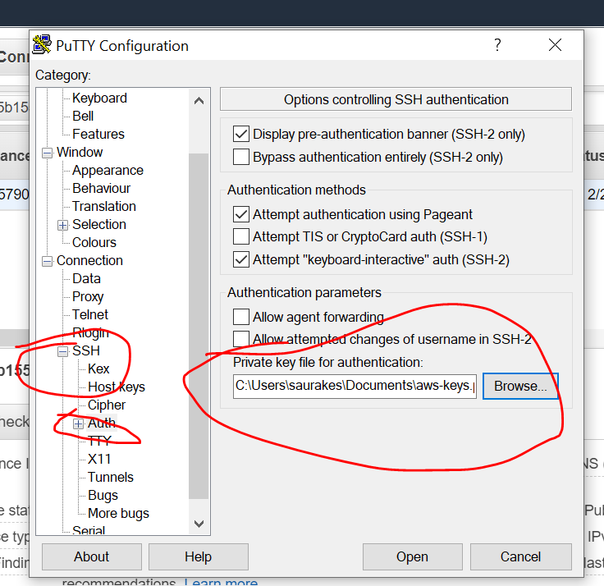

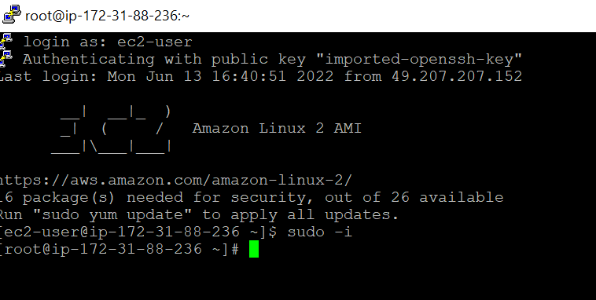

**Note :--**

It is asking only user name and not password because our private key acting as pw

**EC2 tips**

**Imp :-**

If we don’t want to loose ec2 session we need to run **top** command

**Max limit free tier :**

30 GB storage

750 hours per month

**Linux Directories**

**Objective :--** will learn all imp directories

1. Forward / represent root level directory

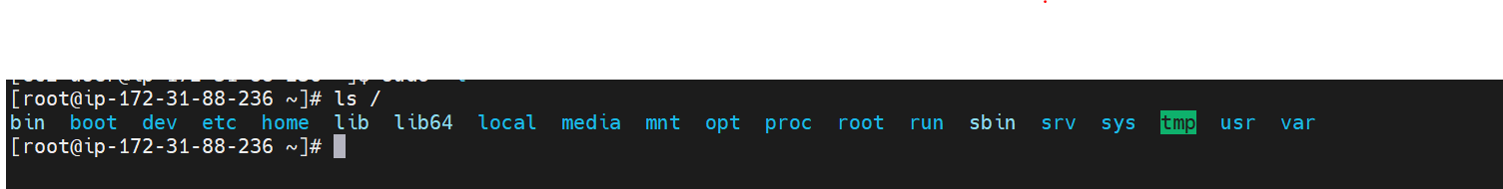

2- ls /boot : this will include all the linux startup file including the linux kernel



1. Ls /etc will have all the configuration file for system to run

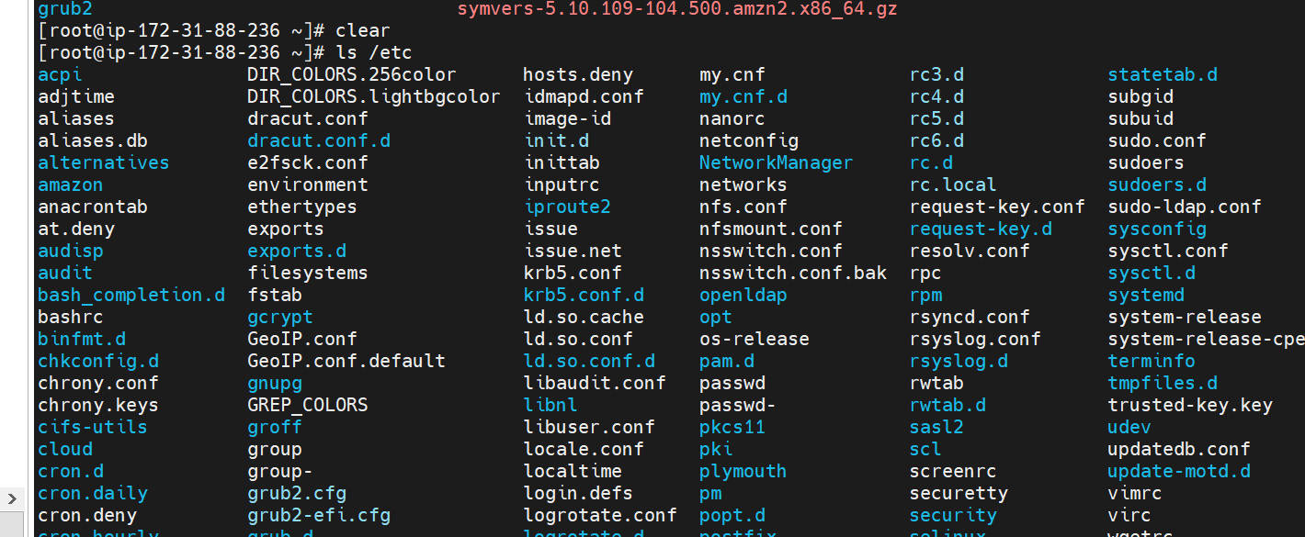

1. Ls /home this is home directory for every user

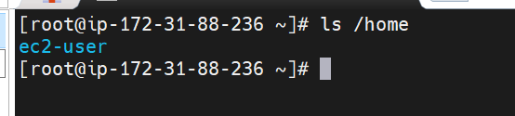

1. Ls /lib all the libraries for various program are stored here

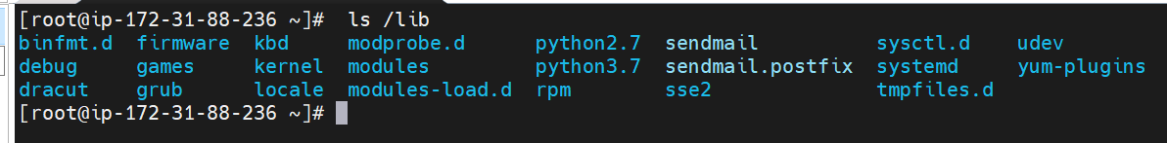

6 :- ls /opt all the binaries are stored here

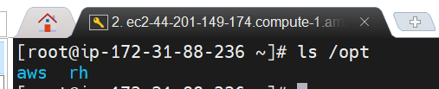

**Browsing directories and files**

**Ls -a :--** will list all files including hidden files

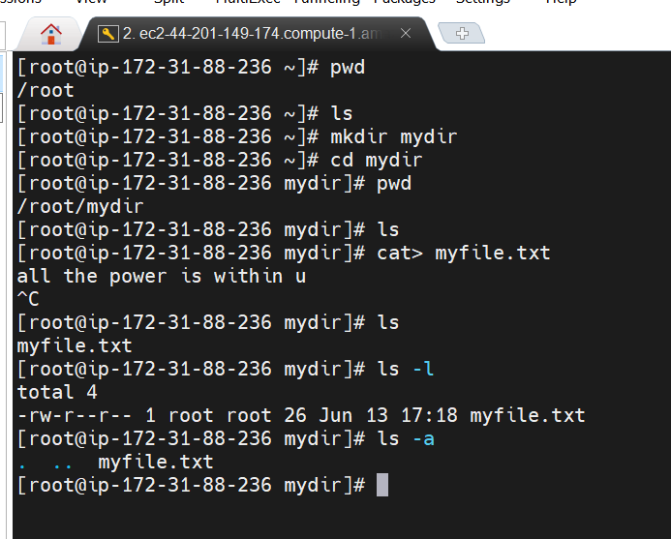

Copy and move

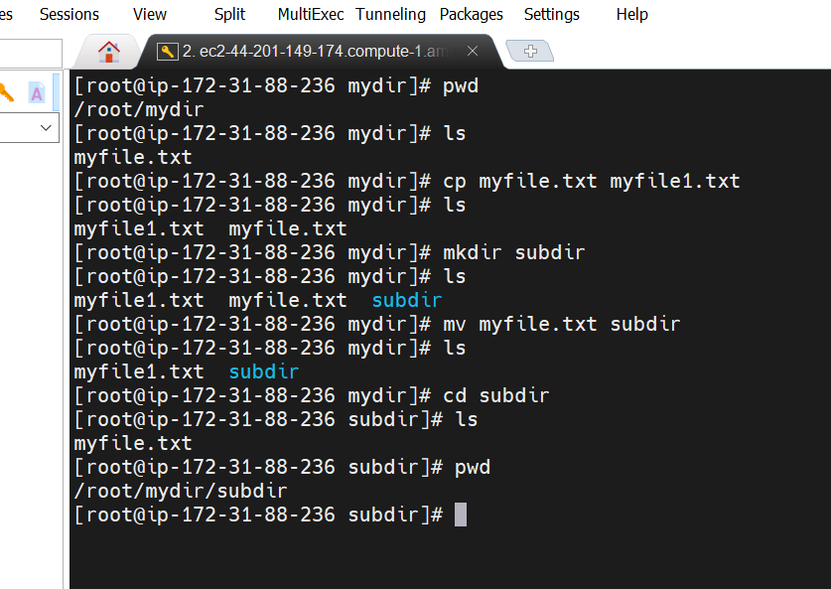

**VI Editor**

**Command mode**

**Insert mode i**

**Execute mode :wq write and quit**

**Shift +I :---** it will go in starting of line

**- a :-** we can append data where cursor is there

**Shift +A :-** it will go to end of current line

**Small o :-** it will create a new line where cursor is there

**Shift o :-** it will insert a new line before current line

**Small s :-** it will remove cursor pointing data

**Dd -** remove q entire line

**2dd :-** remove 2 line

**Yy -** copy a line

**p---**paste

**Installing sw packages**

**Will learn yum command**

1. **Yum list installed :-** that will show all the sw installed

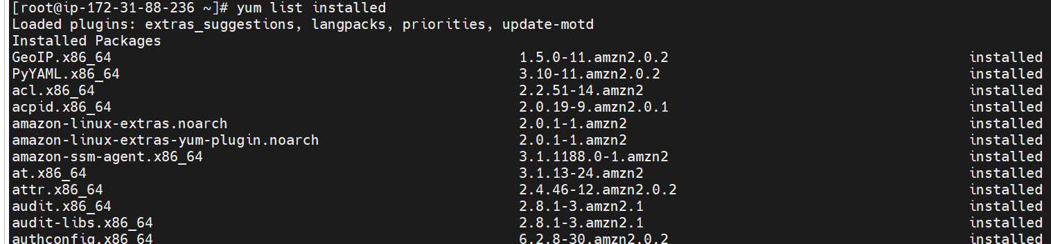

Yum install httpd

Yum remove httpd

To see log

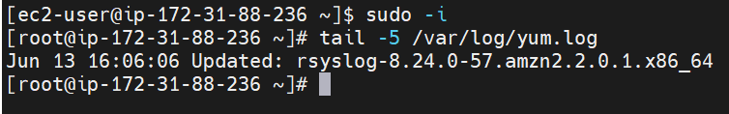

**Yum history**

**Section 3- Git**

**Version control, also known as source control,** is the practice of tracking and managing changes to software cod

**Introduction**

Everytime we push changes in version control system it will create new version for us.

**There are two version control system**

**Traditionally :**

**Centralized**

**Ex :-** VCS ,CVS,IBM clearcase

What if centralized VCS goes down

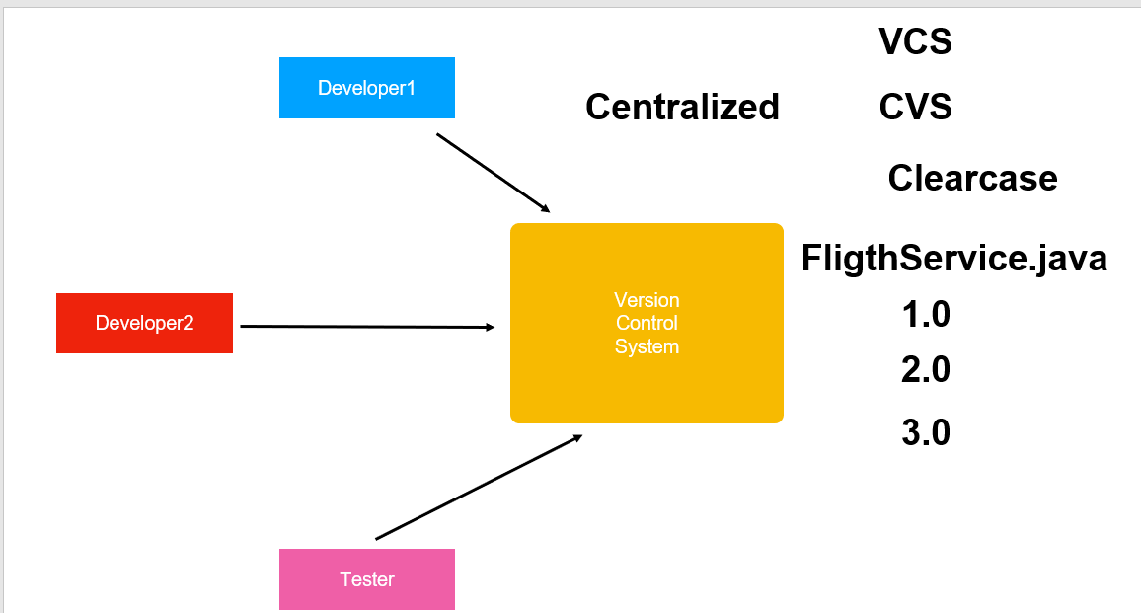

Cannot work offline , if want to work with any file then need to connect with network.

What is centralized version control system?

Centralized version control systems are based on the idea that there is a single “central” copy of your project somewhere

(probably on a server), and programmers will “commit” their changes to this central copy.

That is where distributed VCS come in and the **entire project come in as local repository** or work area

**Git** is a free and open source distributed version control system designed to handle everything from small to very

large projects with speed and efficiency.

**Git** is popular distributed version control system

Free and open source

Fast and light weight

It uses SHA1 --- secure hashing algorithm to save date

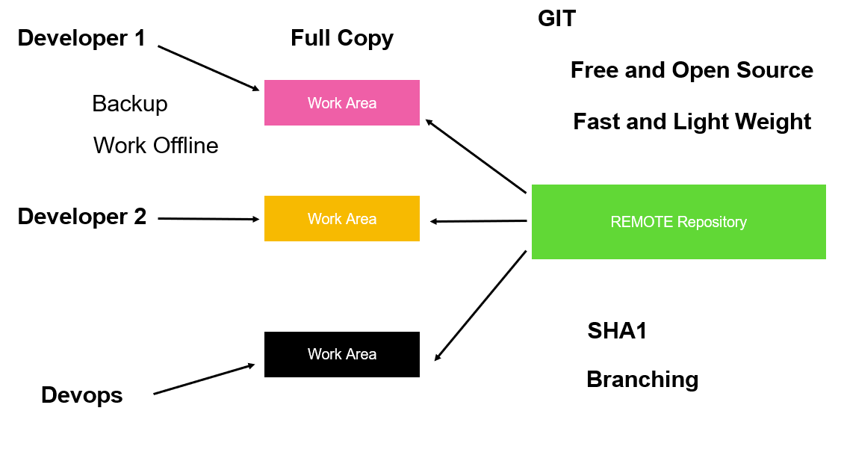

**Git Terminology**

**Objective :-**  Git workflow

When we join a new company all these organization will maintain a remote repository

**Clone** :--- to get a local copy of remote repository

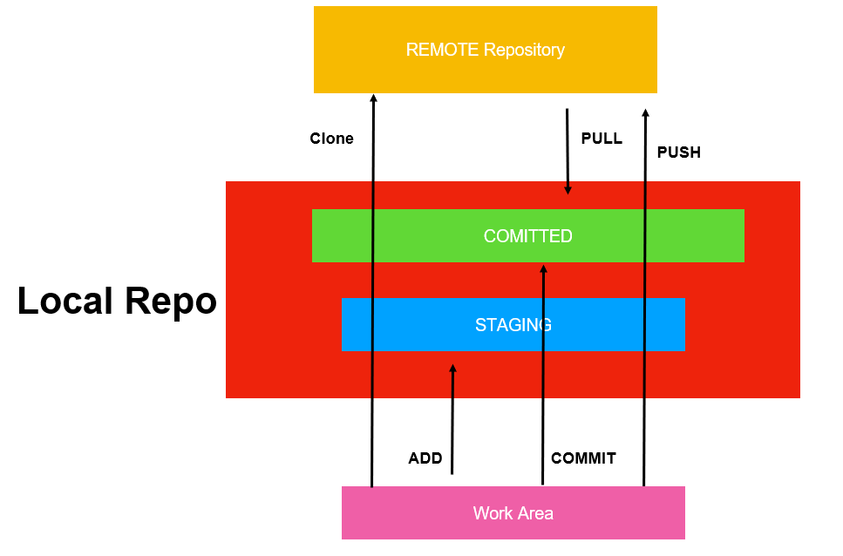

Everytime we commit a new commit id is associated with it and head is a pointer which always point to latest commit.

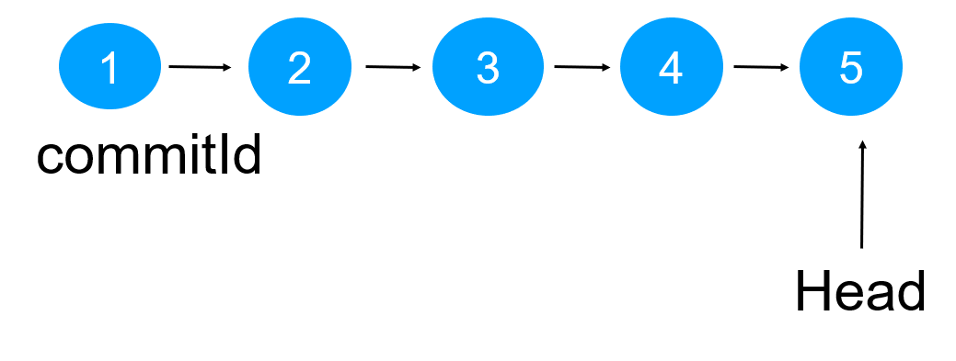

And if we delete latest commit head will move to previous commit and so on

**Git Configuration**

**We can configure git in three different level**

**Objective :---** how to provide configuration info to git using config option

**Note**

**Git internally store all information in file .gitconfig**

Git config --global user.name "saurabh"

Git config --global user.email "saurabh@gmail.com"

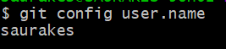

**Git config --list :- list all the properties**

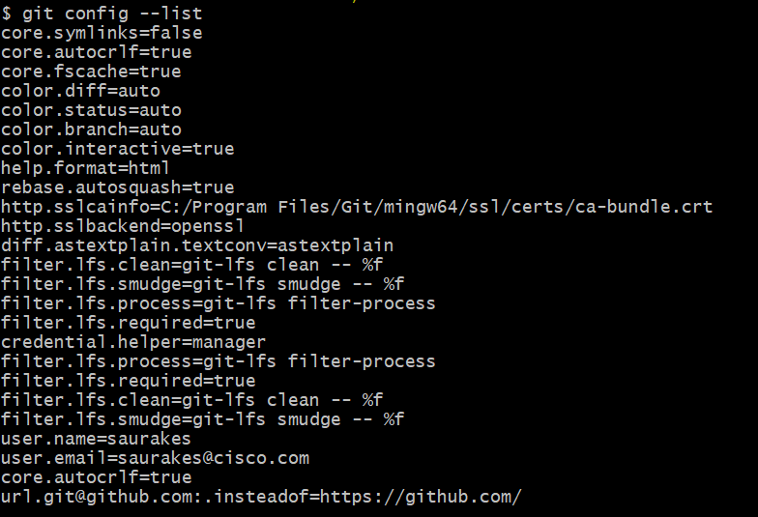

**Git in action**

**Step 1 :--** so far it just a folder

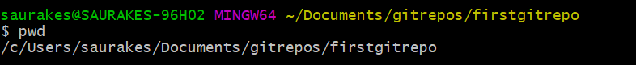

**Step 2 :--** to make git repo we need to run **git init**

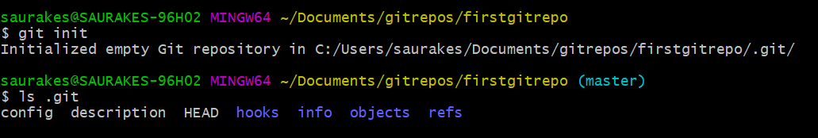

**Ls .git :---** this is where git store all the info while performing git command

**Unstaged file** :--- git rm --cached <file>

Git init

Git add

Git commit -m "message"

**Log and diff**

**Git log :---** will show history of all the commit we make

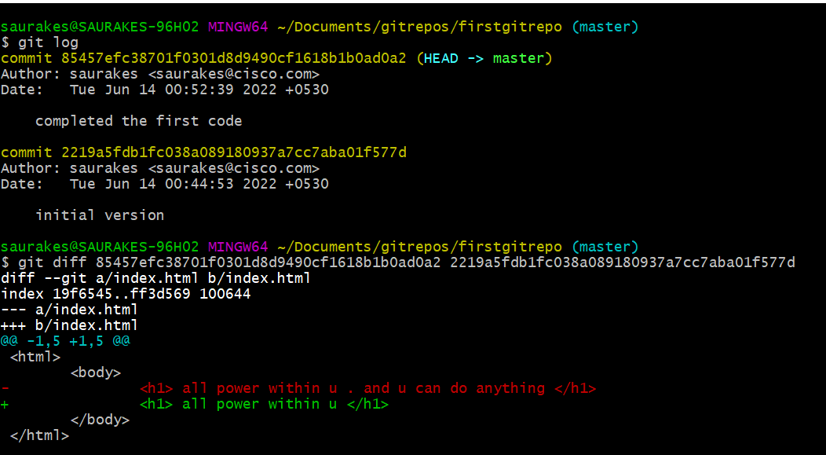

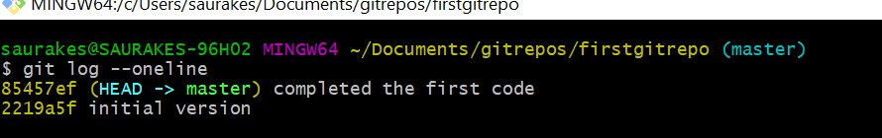

**Revert Changes**

**Objective :**

**Undo changes**

**Before staging :**

By mistake we change file but we don’t want to add it

Command to run :-**- git checkout filename :----- this will replace my file with local repository**

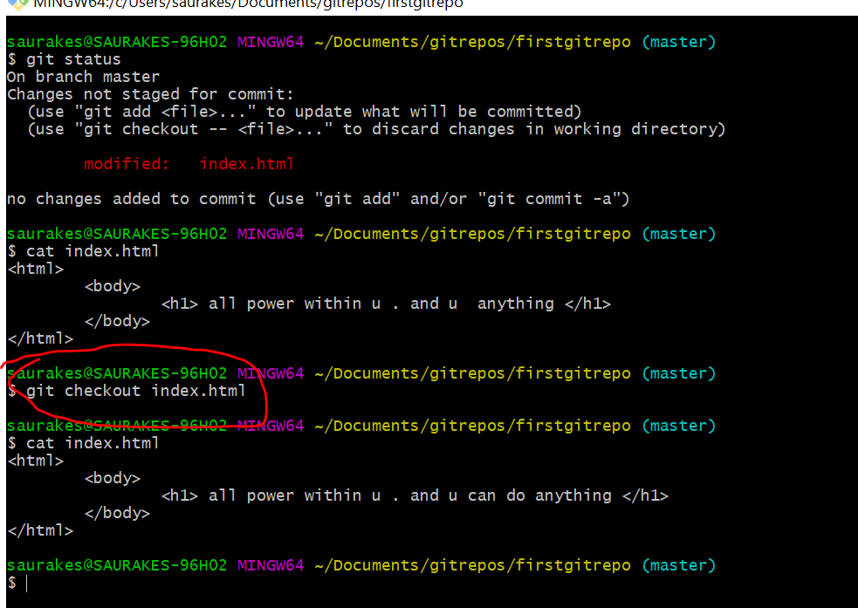

After staging

Git reset HEAD index.html :--- it will move to previous commit

Git checkout index.html

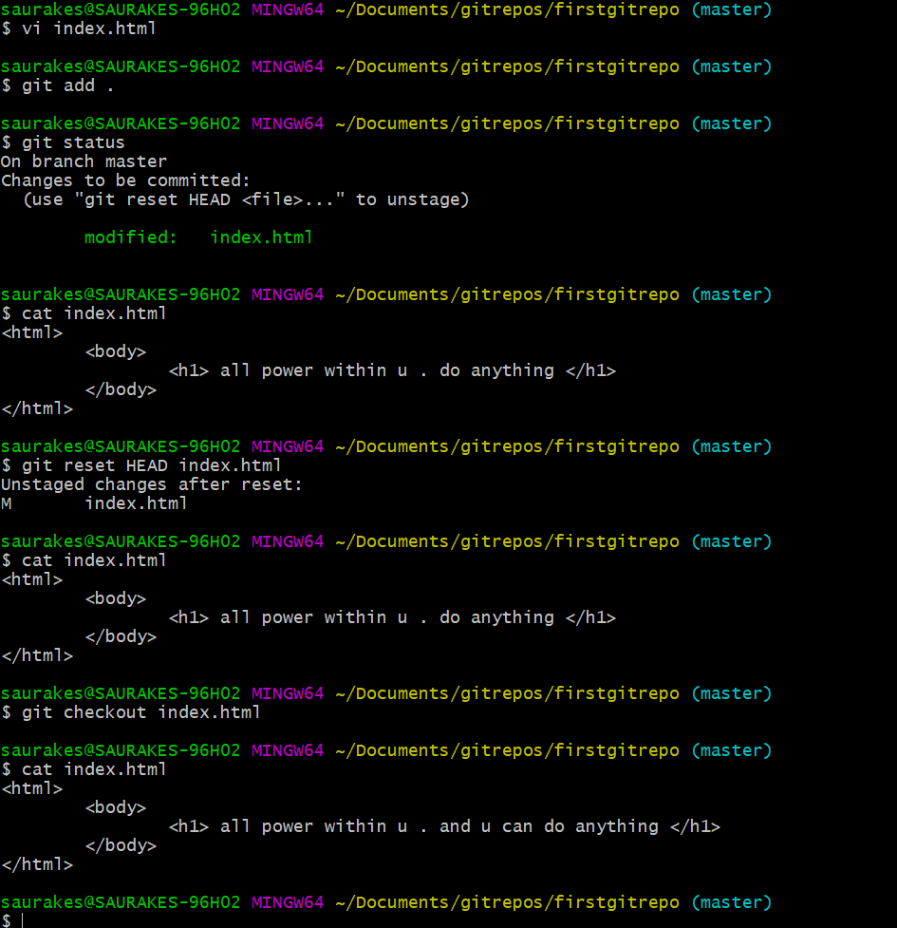

After commit

**The secret git folder**

**Note :**

When we run git init git has created **secret directory**



1. **COMMIT_EDITMSG :** it has last commit message

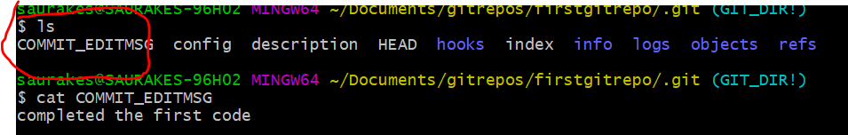

1. **HEAD :-** it always point to latest commit



1. **Config** :-- all configuration info will be there

1. Hooks :- if we want to execute certain shell script on commit we can put under hooks folder

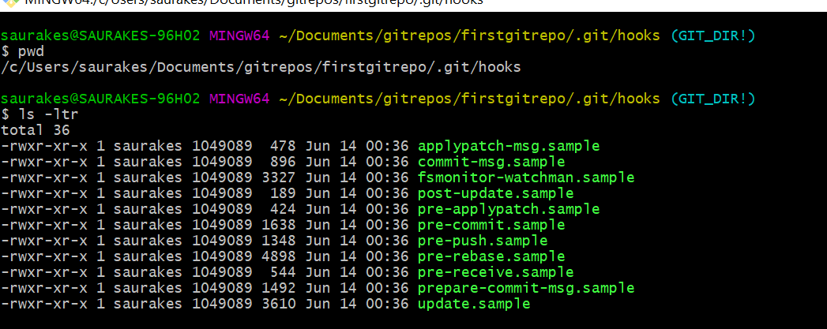

1. **Info :**-- all the info about our repositories

6-**: Objects :-**- everything in the git is object. Each commit is object

1. **Logs** : where all the commit information is there

**Branches**

**Git branch :---** will show current branch

By default branch it will create master and asterisk always point branch u r on.

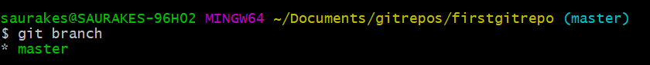

**Create branch from master**

Git branch dev

Git checkout dev

Or

Git checkout -b dev

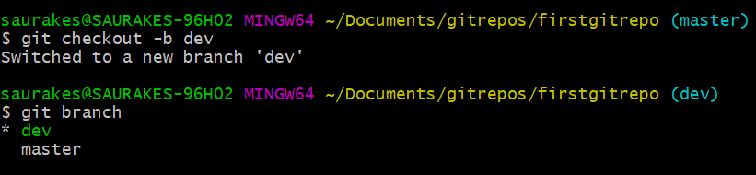

**We change index.html in dev branch and commit. These changes are not in master branch**

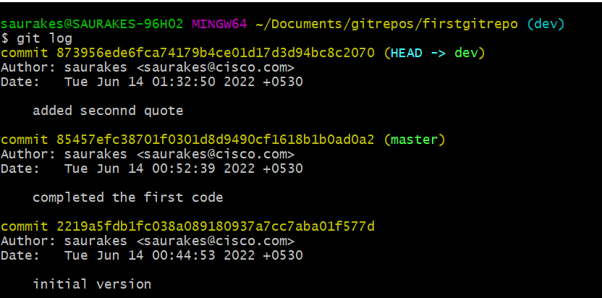

**Latest code is not there.** We need to merge into master

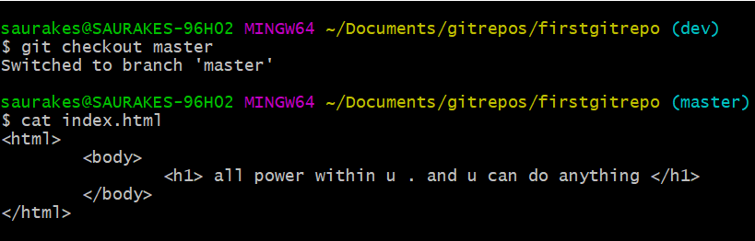

**Merge**

**Git merge dev : ---** we are merging into master from dev branch

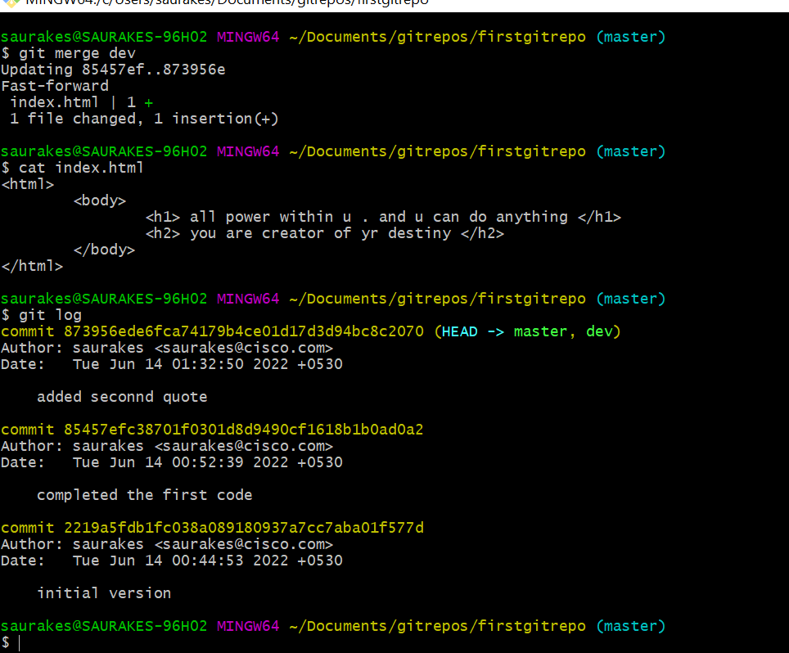

**Resolving merge conflicts**

When we resolved a merge conflict we need to commit again ( git add and git commit)

**Delete branch :** git branch -d branch name

**Create Remote repo**

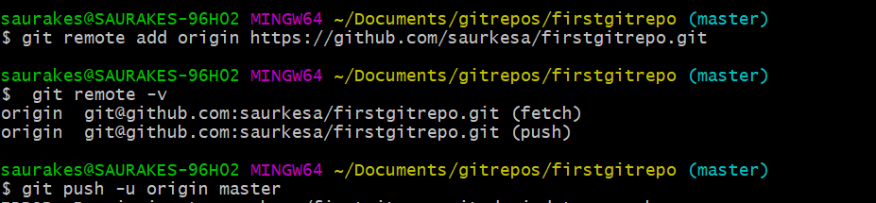

**Origin :----** pointer to url

**Push and pull**

**Merge conflict on same branch**

**Fetch vs pull :-** pull fetch actual file and fetch show the changes

**Git Reset**

**Objective :**- want latest commit to be gone because we have issue in them

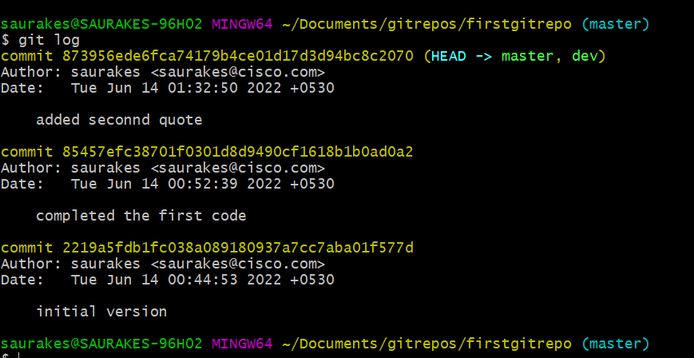

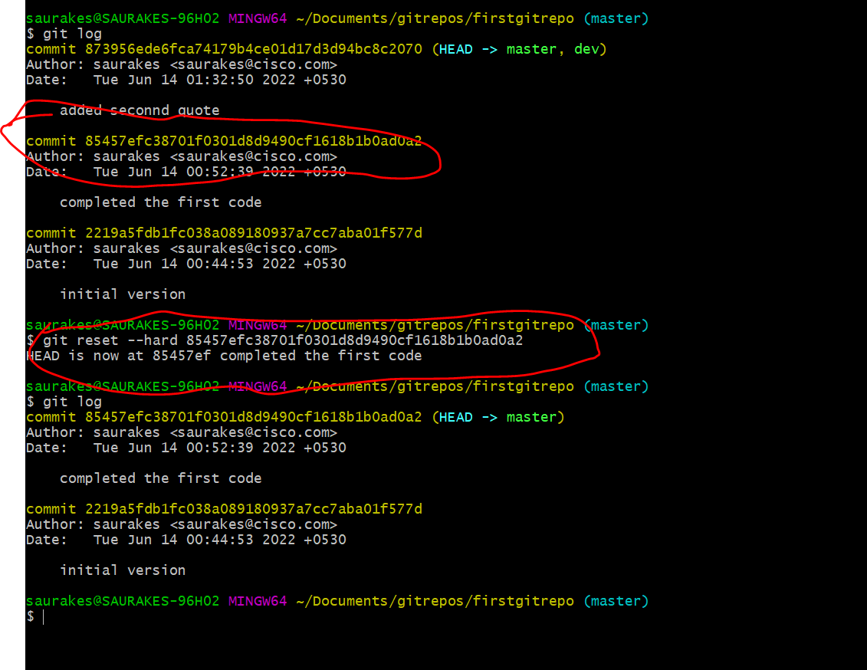

**Note :**

Git reset is dangerous , normally we should not do it because latest commit will be gone

**Git push -f**

**Revert**

**It will create a new commit by undoing the changes in last commit**

**Example**

**1,2,3,3',2' ----------**-from 3 ,3' commit will create that is like 2 and 3 will be maintain it will not gone

**git revert** makes a new commit. **git revert** simply creates a new commit that is the opposite of an existing commit.

**Concept of Cherry picking**

Let we have three commit and problem is with commit 2 this is where cherry picking helpful

1-2-3

head

1-2-3-3'-2'-3'' and in 3'' we will merge 3 code also

**Stash**

Git stash

Git stash pop

Section 4 :- Maven

Maven : build automation tool

**But it do much more:-**

**Compile**

**Run Tests**

**Package jar and package war**

**Deploy to server**

All these tasks can be automated using tools such **as maven**

**Note :**

The folder structure can be different like for standalone application , for web java project

but beauty is maven provide several archetype , think archetypes as templates.

All maven project we can create within ide

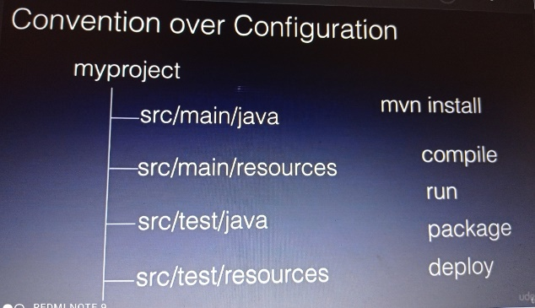

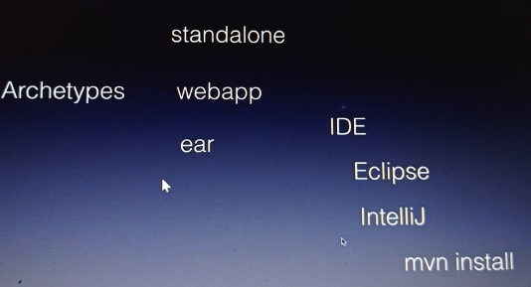

**Why maven**

**1-Common interface,** all the developers follow one structure

Mvn clean install

1. It pull dependencies and bundle them into war files
2. maven support repositories, we can create our own jar and push them into repository, any other developers can use it

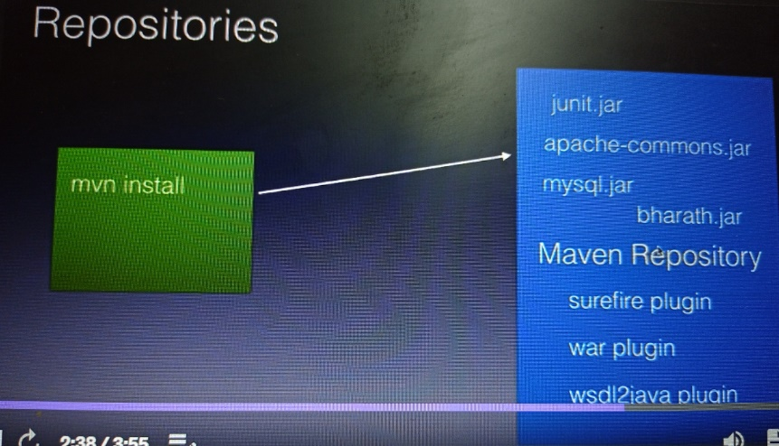

What is a Plugin? "Maven" is really just **a core framework for a collection of Maven Plugins**.

In other words, plugins are where much of the real action is performed, plugins are used to: create jar files,

create war files, compile code, unit test code, create project documentation, and on and on

1. Reuse

Plugin model

Compiler

Surefire plugin :- use for test

Wsimport

Note :

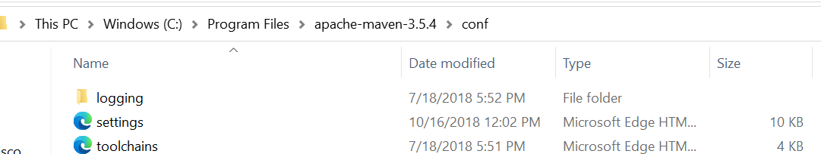

**Using settings.xml** , we can change default behavior of maven and we put under .m2

Settings.xml is use to customize the behavior of maven

**Create a java project**

mvn archetype:generate -DgroupId=com.bharath -DartifactId=hellomaven -DarchetypeArtifactId=maven-archetype-quickstart

-DinteractiveMode=false

**POM** : project object model

**POM XML**

These 4 fields are called **maven coordinate**

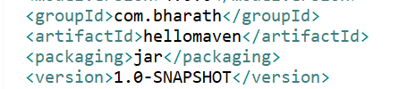

***Building the project from command line***

Mvn install :--

Compiling

Running the Test

Packaging the project

Maven create target folder when we build , it put all the compiled classed under target/classes

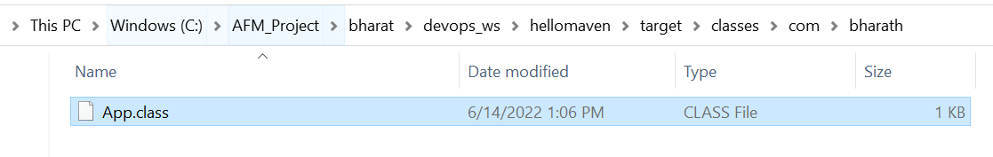

**To run the jar file**

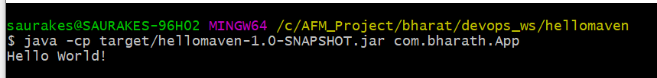

**Plugins**

**2 key concept :-** Maven plugins and goals

**A maven plugin** is collection of one or more goals

Example :

archetype :generate

Install:install ( install goal from install plugin)

**A goal is** specific task which we run independently or it is part of bigger build

**Compile**

**Test**

**Package**

**These goals can also take parameters**

mvn archetype:generate -DgroupId=com.bharath -DartifactId=hellomaven -DarchetypeArtifactId=maven-archetype-quickstart

-DinteractiveMode=false

pluginId:goal id (refer)

**Achetype :----plugin id**

**Generate :- goalId**

Here generate goals are with parameter

Note :

Every maven project by default comes with compiler,jar,war plugin but we can override them in pom.xml

**Life cycle and phases**

**When we run mvn instal**l we are saying maven to execute to run life cycle phase

Process resource

Compile

Test

Package

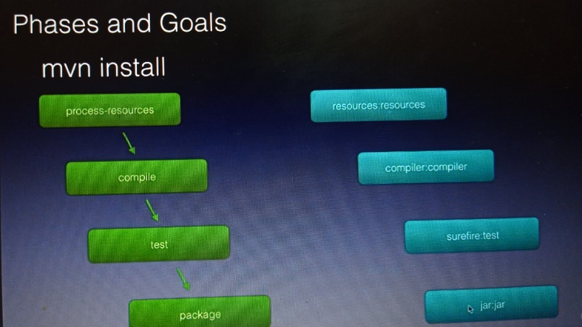

**Maven Coordinates**



**Repositories**

**When we run first time mvn install ,** maven download jars and plugin from center locations on internet.

It is download what is required for the build from the central repository

All the maven library available publicly under this

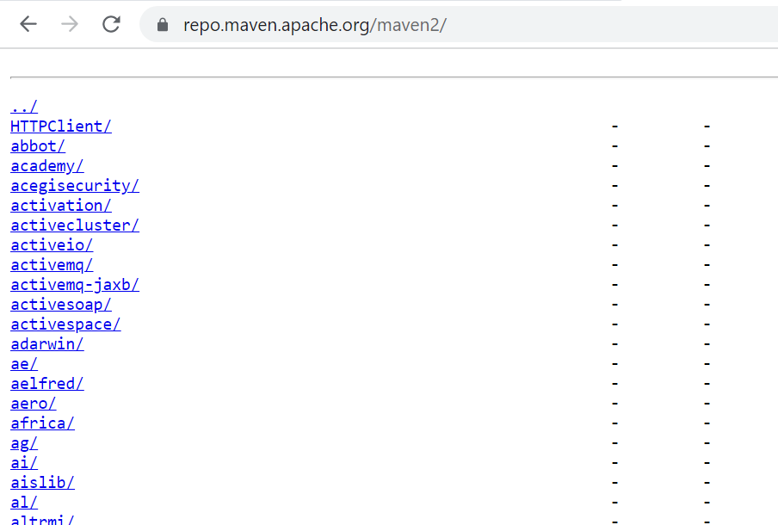

**Note :-**

If we want certain libraries that is not available in central repositories then we have to use enterprise level repository.

Mirror of central repository and we can add jar.

Maven also create local repository on developer machines

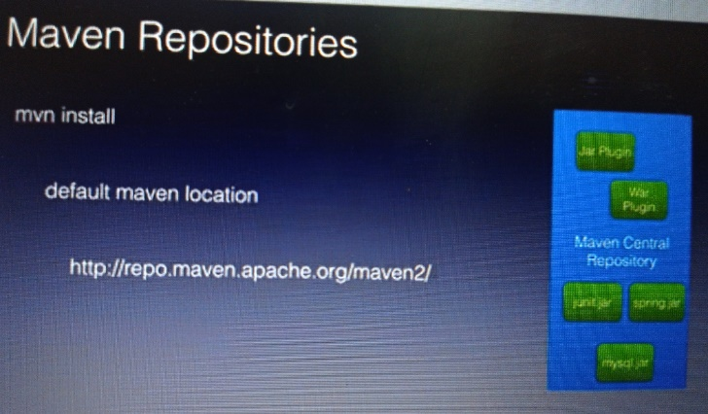

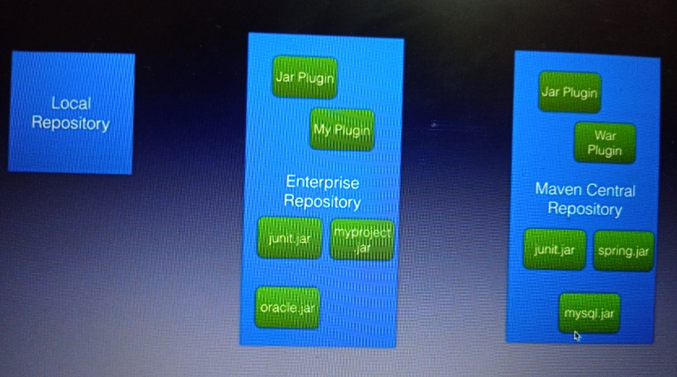

**Create java and web project**

mvn archetype:generate -DgroupId=com.bharath -DartifactId=java-project -DarchetypeArtifactId=maven-archetype-quickstart

-DinteractiveMode=false

mvn archetype:generate -DgroupId=com.bharath -DartifactId=java-web-project -DarchetypeArtifactId=maven-archetype-webapp

-DinteractiveMode=false

**Section 5 Create Spring boot microservices**

**Usecase**

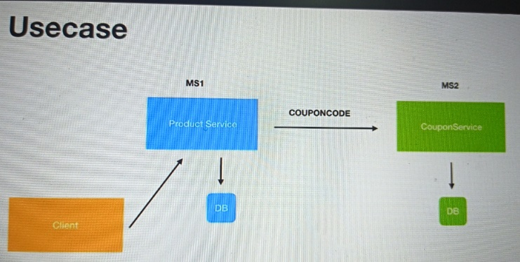

Product m/s

Coupon m/s

These two m/s will expose restful api which will allow client to create a product and in the process

Product service will use a coupon service to apply a coupon code that client passes in and

Get the discount so all the coupon information is maintained by coupon service and product service is

only responsible for creating the product in the d/b along with price and description details which the client passes.

**The process here ;-**

is take client request , the product service will call the coupon service get the discount for coupon code

which the client would have passed apply the discount on the price which we get from coupon service

And then save the product to the d/b. all the coupon info will save in coupon service d/b

Coupon service couple of api exposed :-

One is create the coupon

Second to get coupon

**Create the d/b table**

create database mydbnewtest;

use mydbnewtest;

create table product(

id int AUTO_INCREMENT PRIMARY KEY,

name varchar(20),

description varchar(100),

price decimal(8,3)

);

create table coupon(

id int AUTO_INCREMENT PRIMARY KEY,

code varchar(20) UNIQUE,

discount decimal(8,3),

exp_date varchar(100)

);

**Create the project**

**Steps**

Create the project

Create model and repository

Create the rest controller

Configure the data source

Test

**Create coupon service**

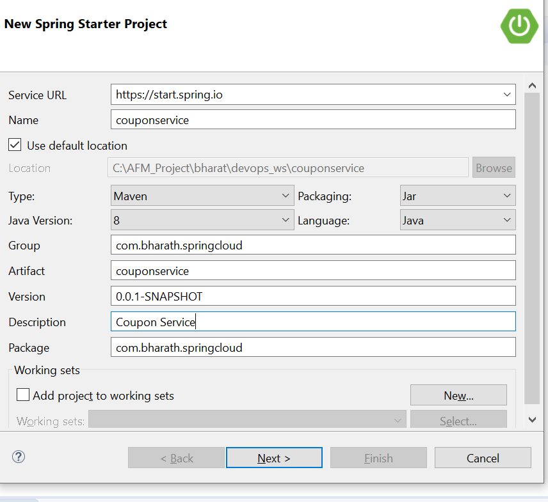

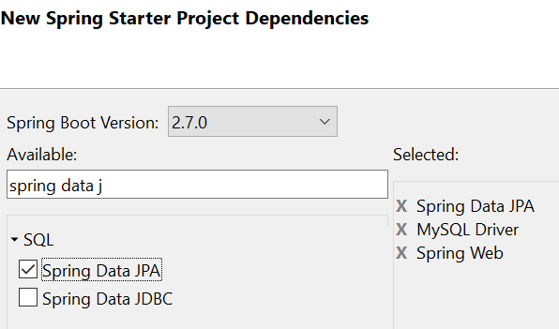

**Create model and repository**

**Model :--**

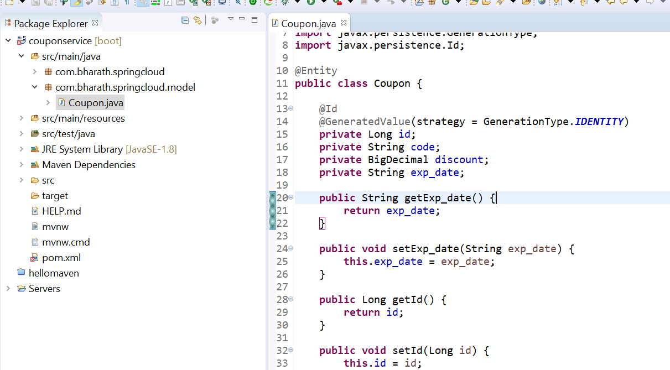

**Repository**

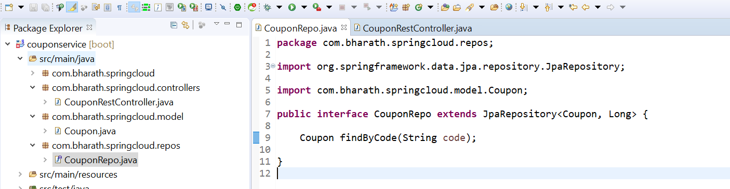

**Create The Rest Controller**

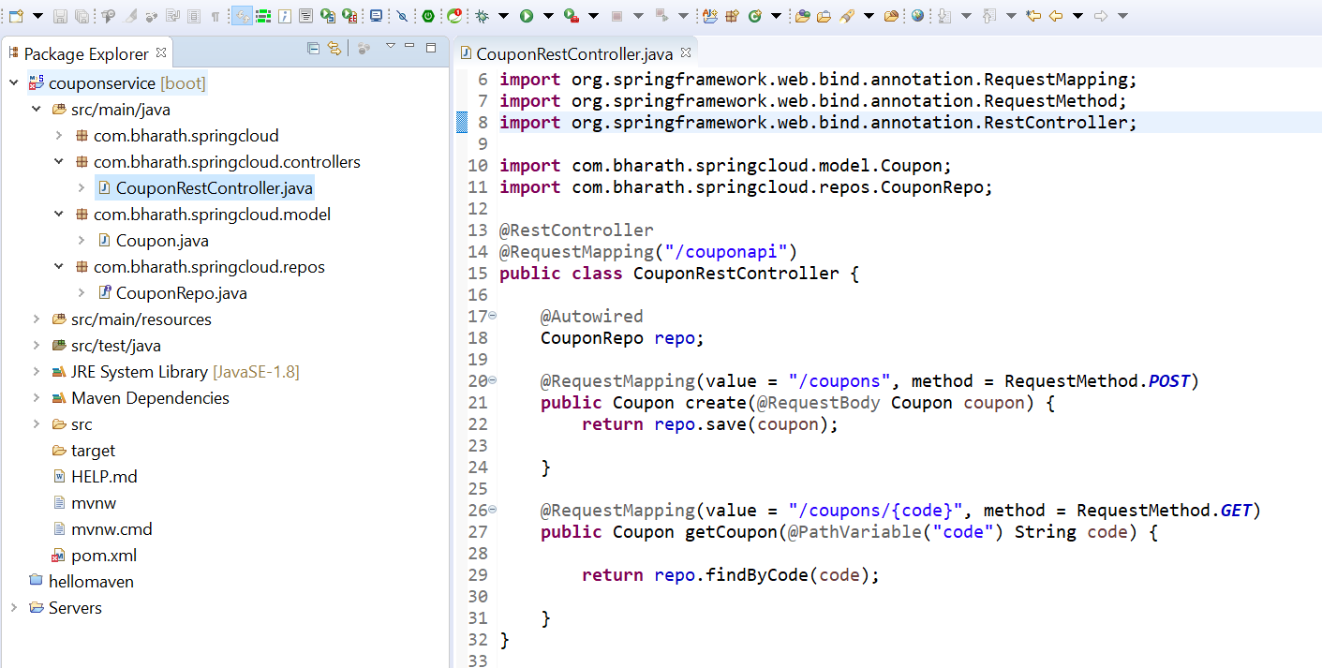

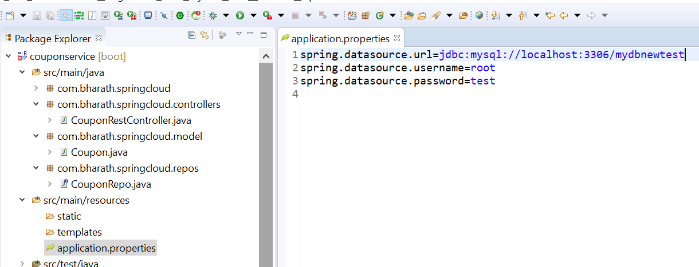

**Test**

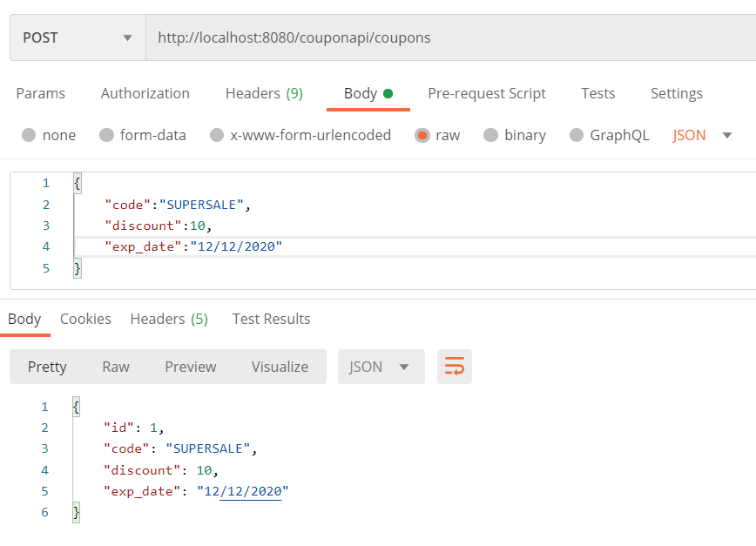

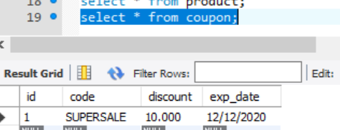

**Get method :**

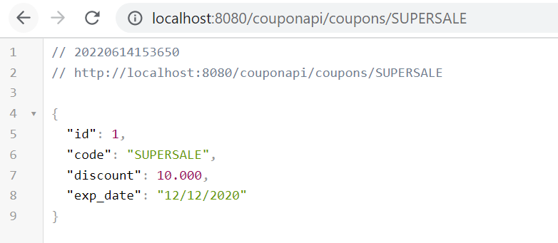

**Create Product microservice,repos,model and rest controller**

Same dependency as previous project

**Model**

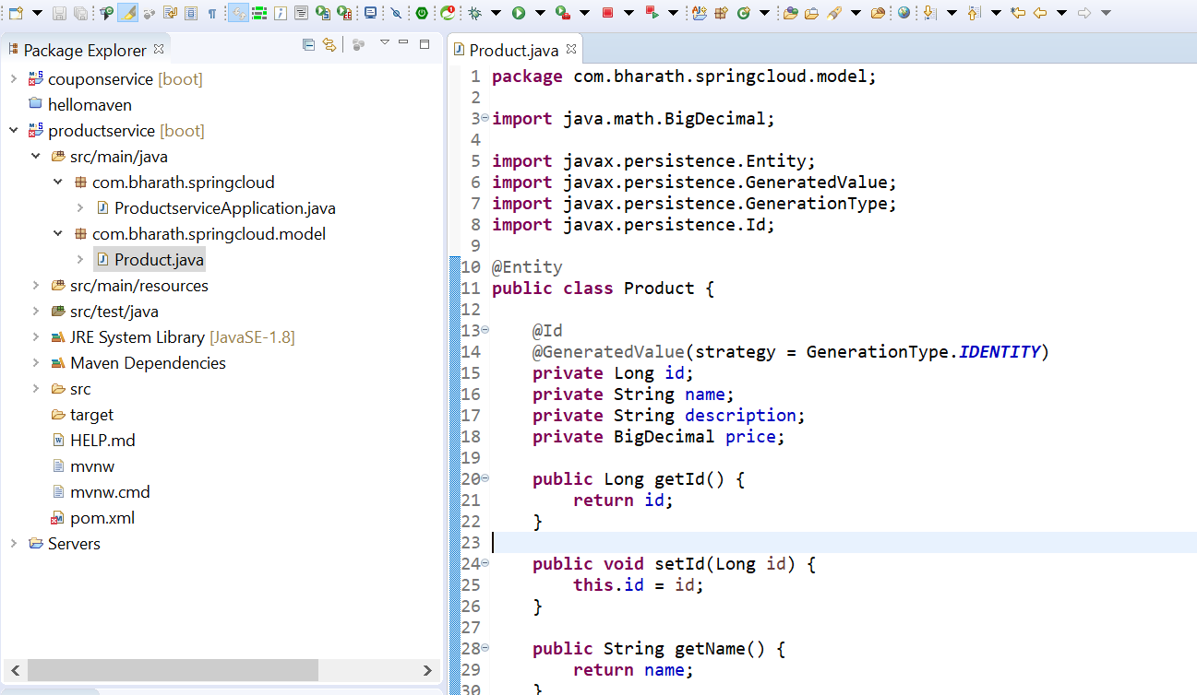

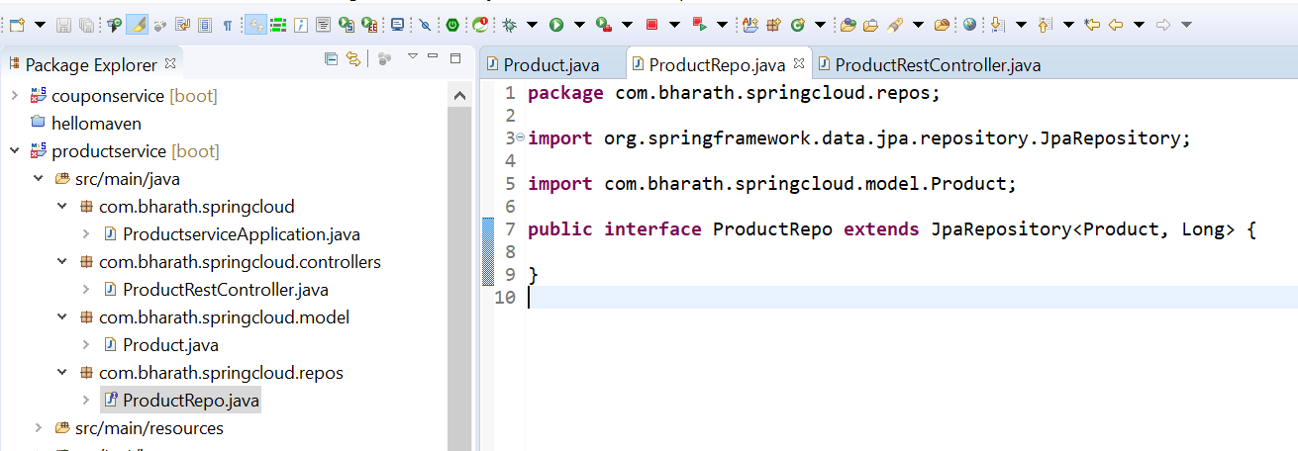

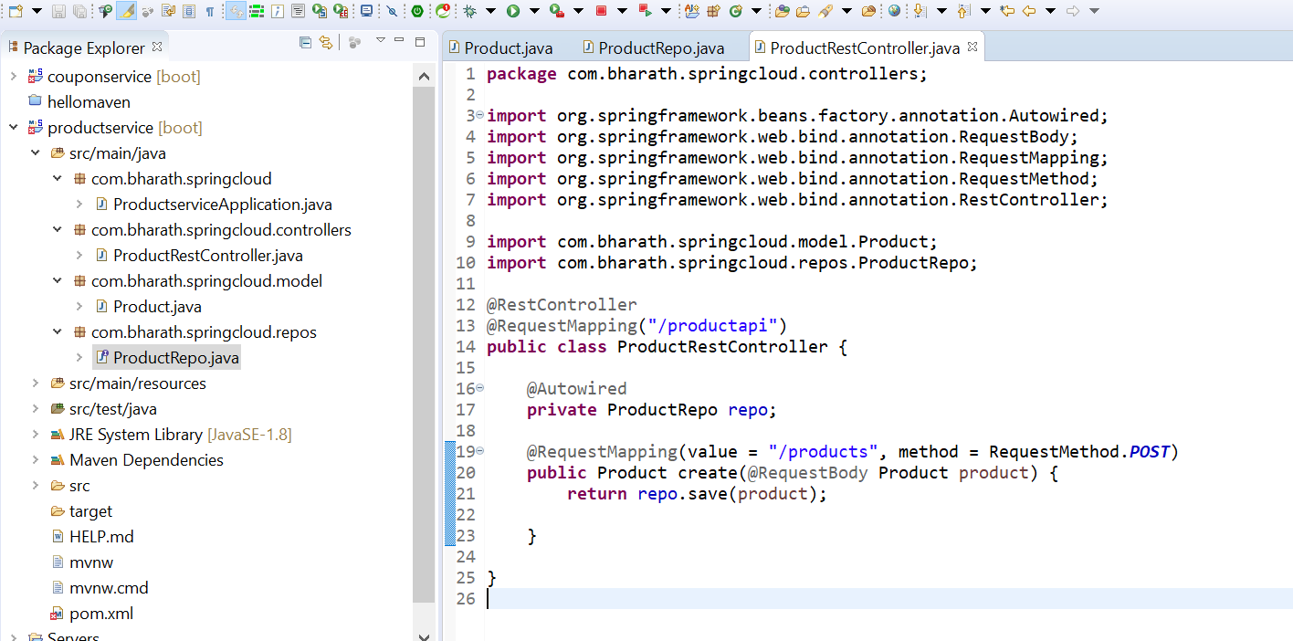

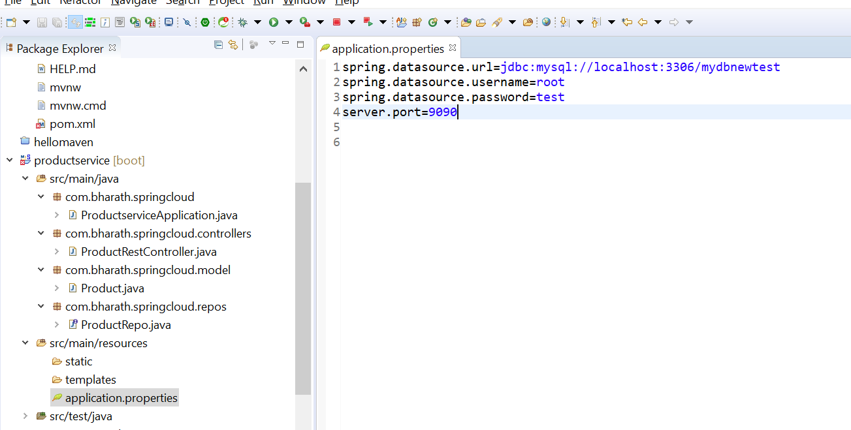

**Test**

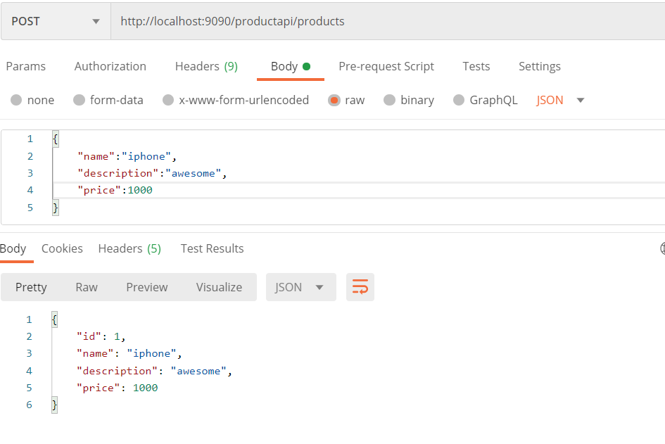

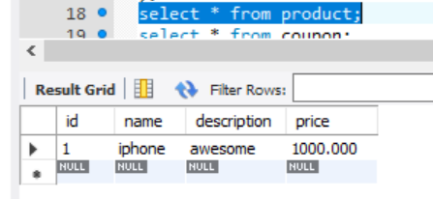

**Integrating microservices**

**Step 1 :**

Will add couponCode in Product.java since this field we want to pass in coupon Microservice

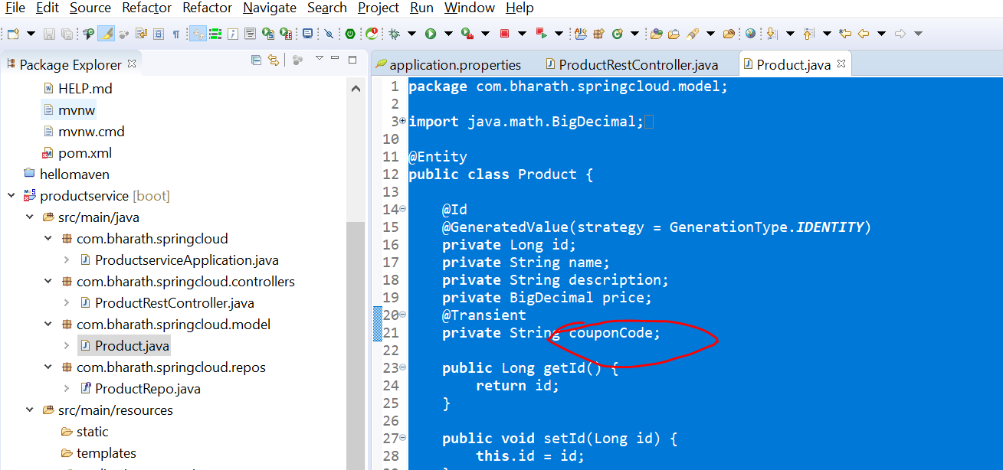

Step 2 :--

coupon.java we need to create in product m/s under dto pkg.

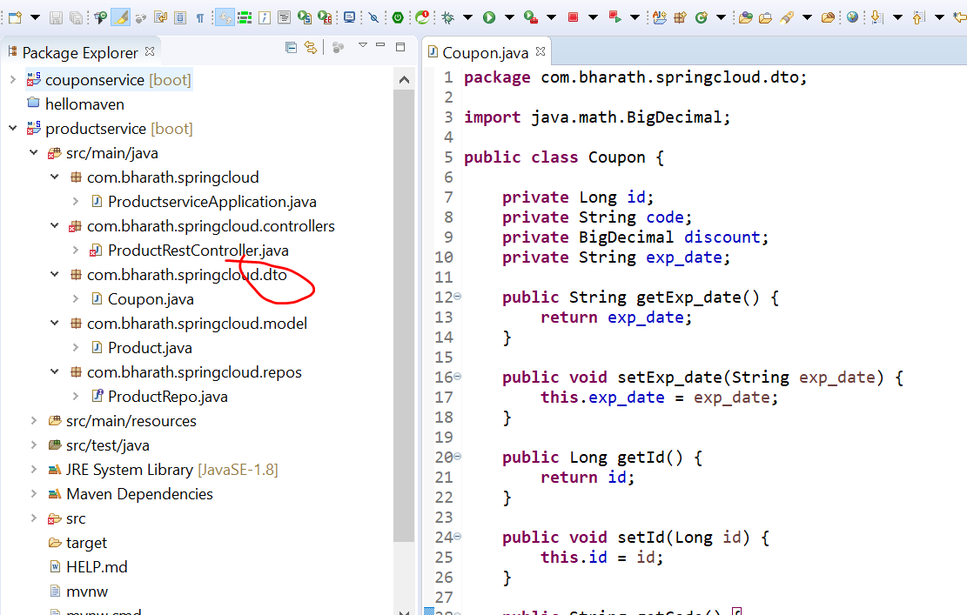

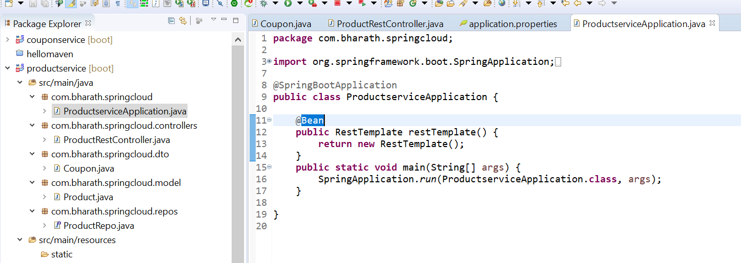

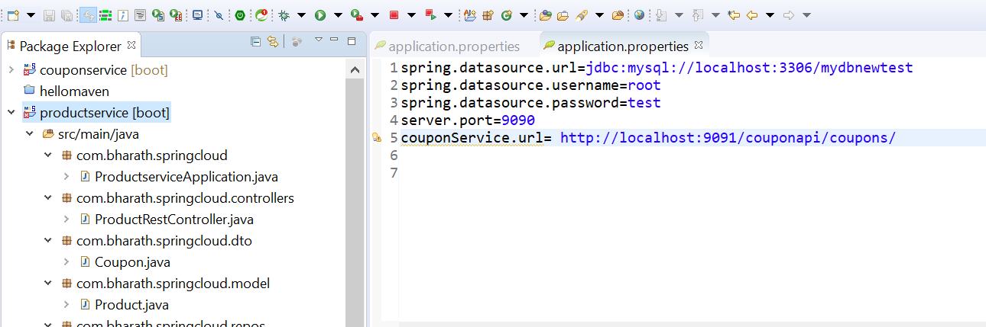

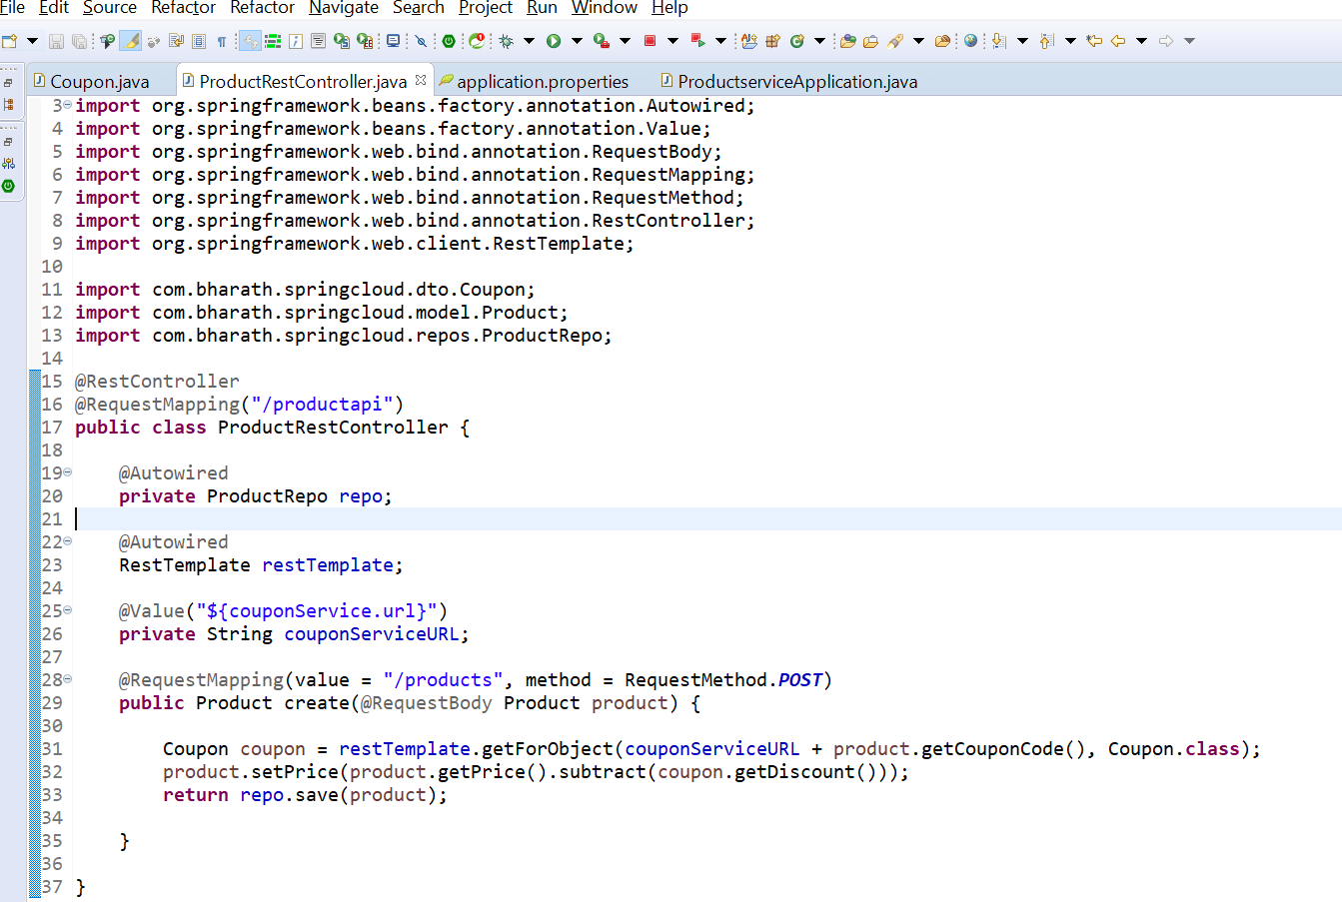

**Test**

**ProductService :---9090**

**CouponService :9091**

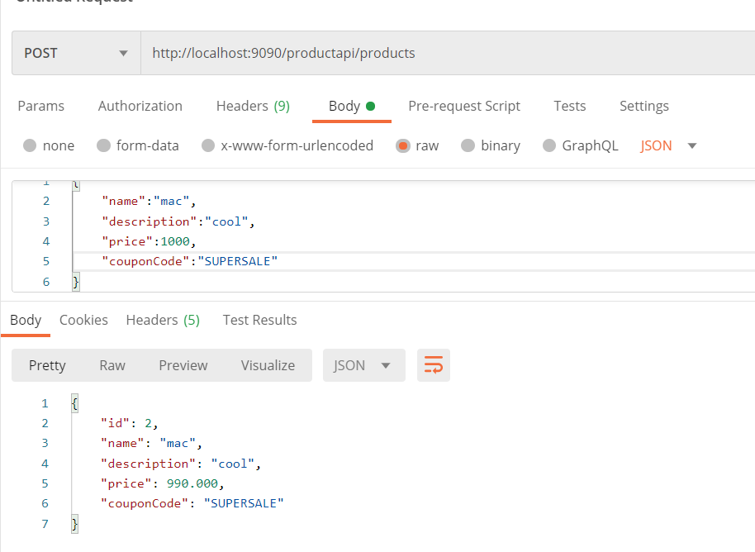

**Section 7 :- Manual deployment to AWS using EC2 using S3**

**Aws s3 service**

**S3 :-** simple storage service

It like google drive for our application running on aws. So we can store all the files that application need.

It uses Object based Storage internally.

EC2 :--=- use EBS and EFS ( elastic block storage and elastic file storage) to install operating system and all the required S/w

In s3 to store our file or download the file we need to create buckets.

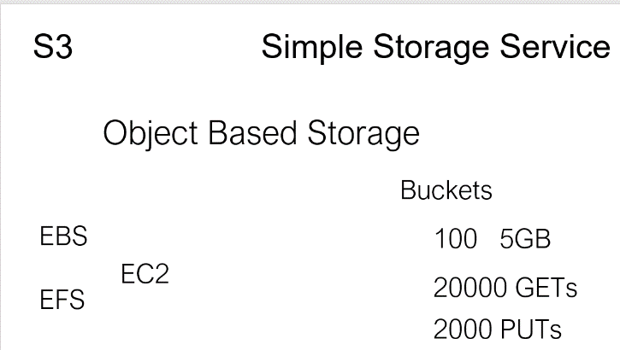

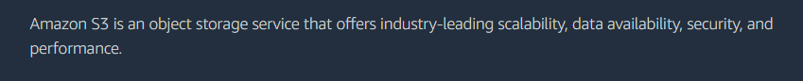

Note :

Bucket name to be unique across aws

If we upload file in bucket to make it access we need to make bucket level public as well as file level also

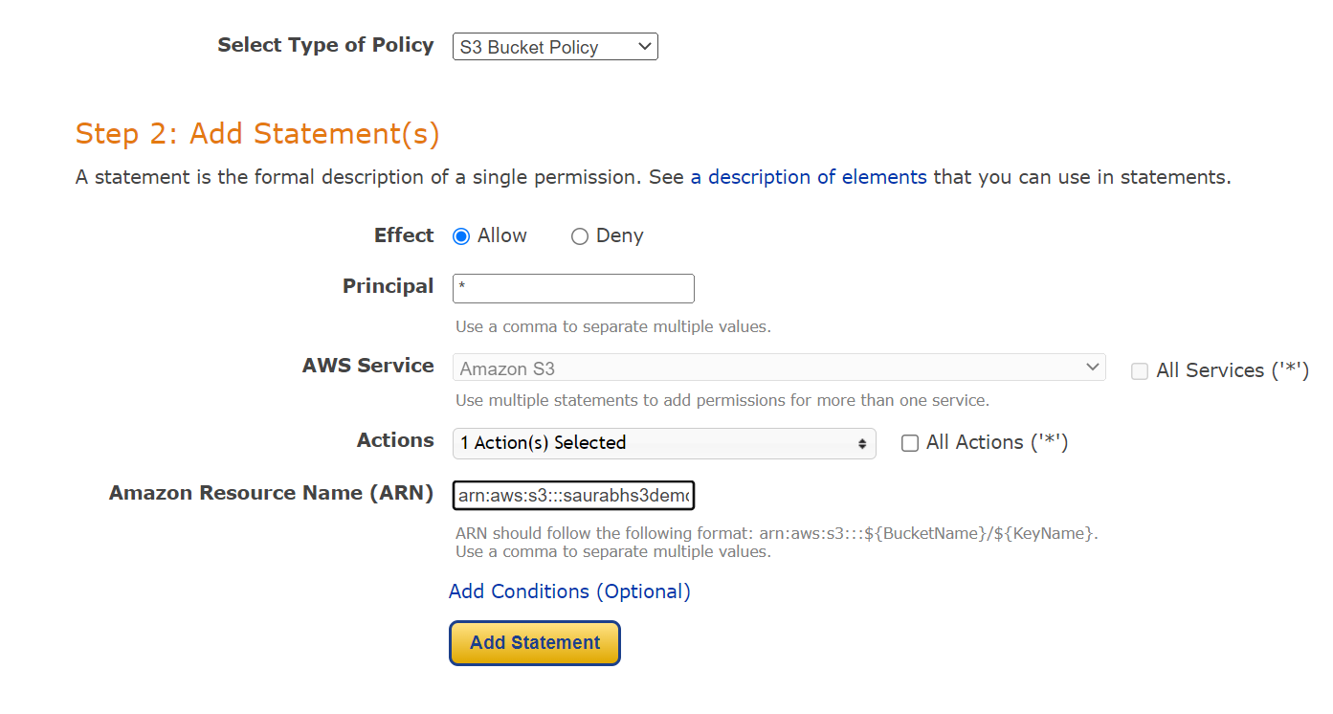

**Click on this object url**

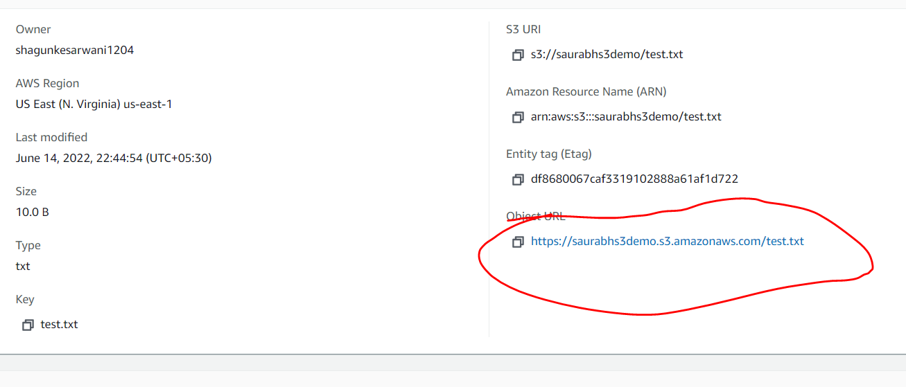

**Now our file is public**

**Launch instance and setup the instance**

**Step**

**Install mariadb and java in ec2**

**Create db and table in mariadb and install java at root level**

**Upload couponservice jar in bucket**

**Wget jar in ec2**

**Run app in ec2**

We install maria db in ec2 which will act as mysql

Install java 1.8

Also create table

**Objective :-**

We will manually deploy our application using **EC2 and s3**

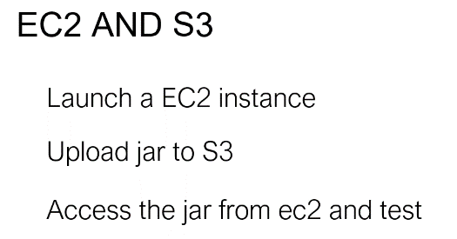

**Mariadb** is open source version of mysql

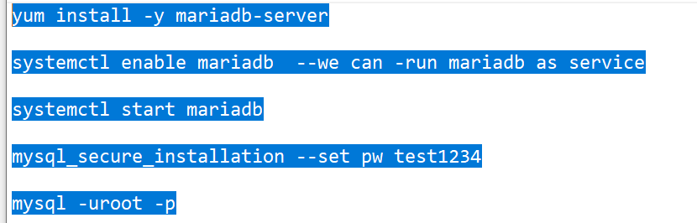

**Run one by one in mobaxterm in ec2 machine**

**Step 1**

yum install -y mariadb-server

systemctl enable mariadb --we can -run mariadb as service

systemctl start mariadb

mysql_secure_installation --set pw test1234

mysql -uroot -p

---------Java----------- come out

yum install java-1.8.0-openjdk ----it will install java

alternatives --config java

**Step 2- create table**

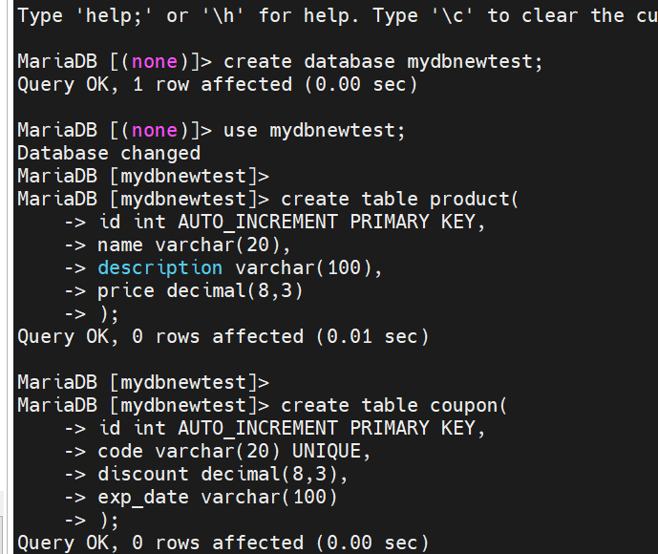

**Step 3:- Upload coupon service jar in s3**

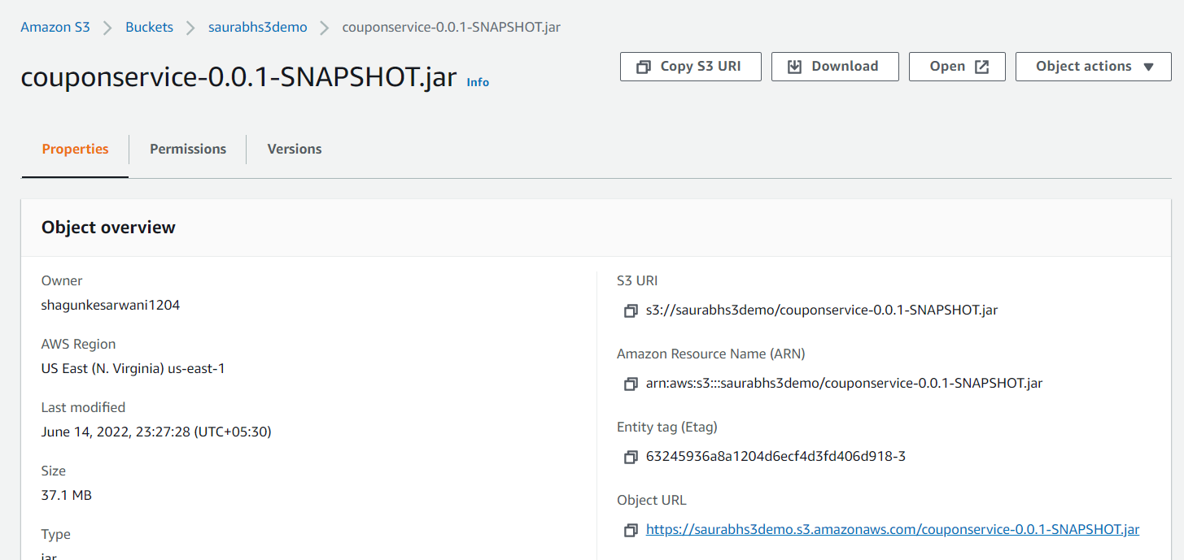

**Step 4:-**

**Note :---** wget will download jar in ec2 machine and run it

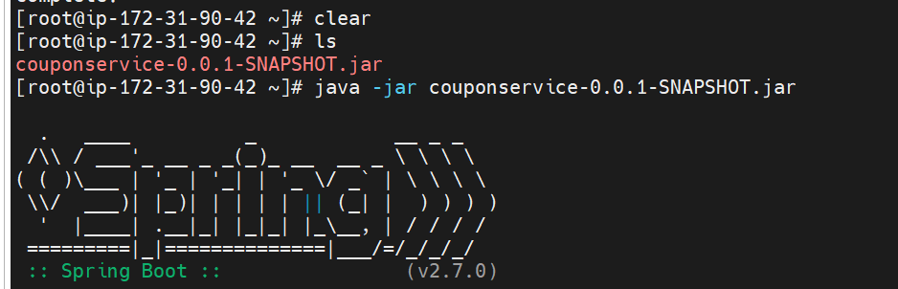

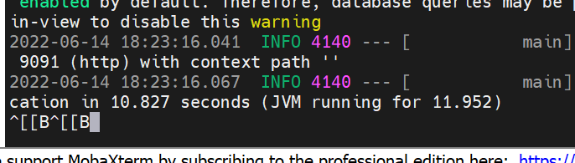

It start in 9091

**Step 5:--- enable security in ec2**

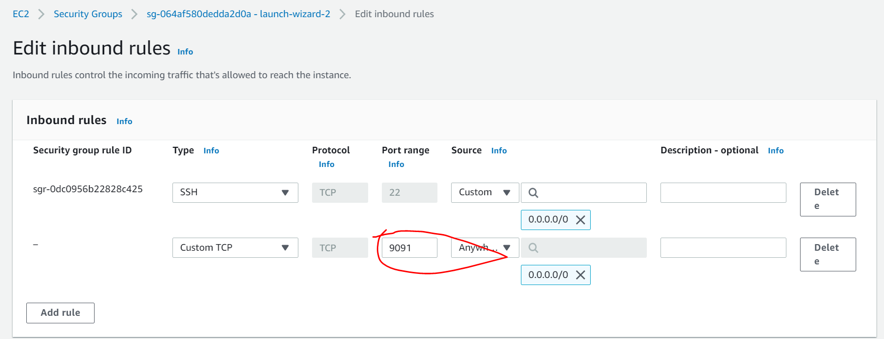

**Copy dns name and type in postman**

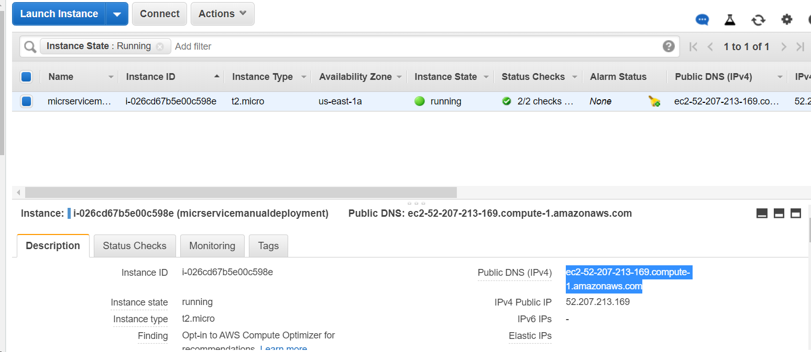

**Now we are running our app through ec2**

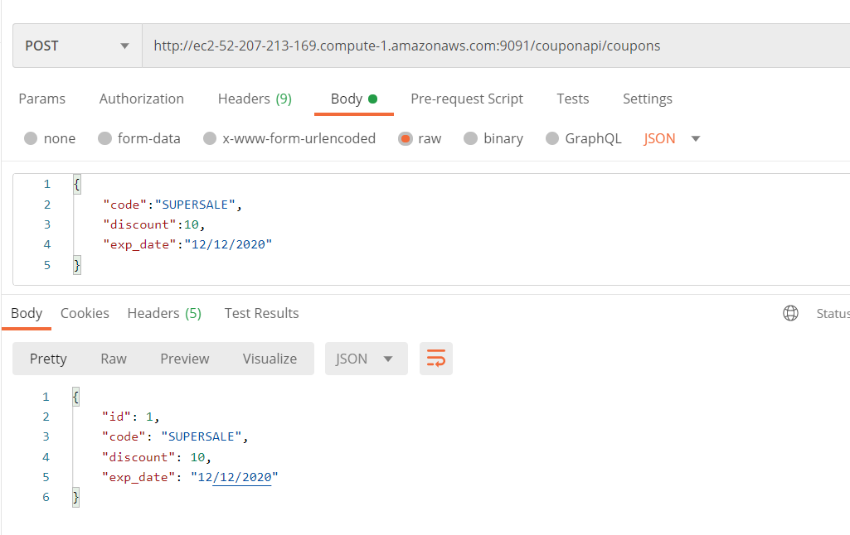

**Automate app launch**

**Note :**

The next time we run ec2 instance we need to run same command again to start server instead of them we can automated

If we stop ec2 and start again , mysql will be automatically like services in windows since we set

systemctl start mariadb

**imp**

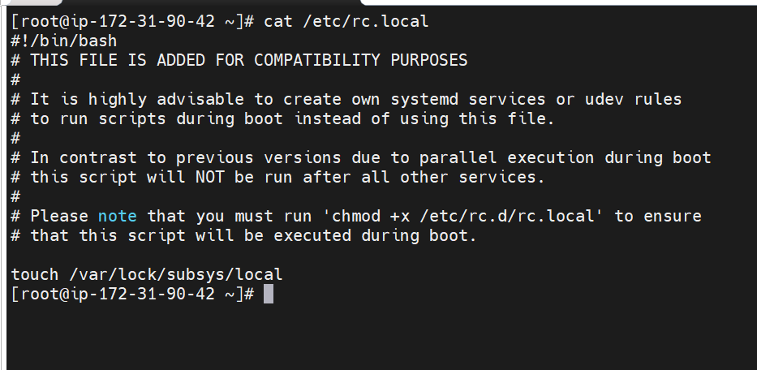

Note :

**Rc** stand for **run command**

So whatever command is written in this file whenver machine started or rebooted these command execute

So when we write java -jar command in this automatically it will get executed

**Step 1- Copy jar file in ec2-user**

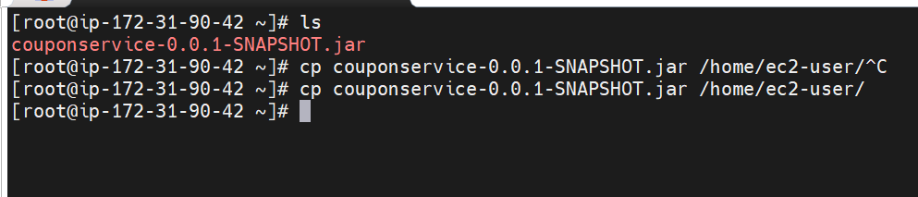

**Step 2:--Vi /etc/rc.local**

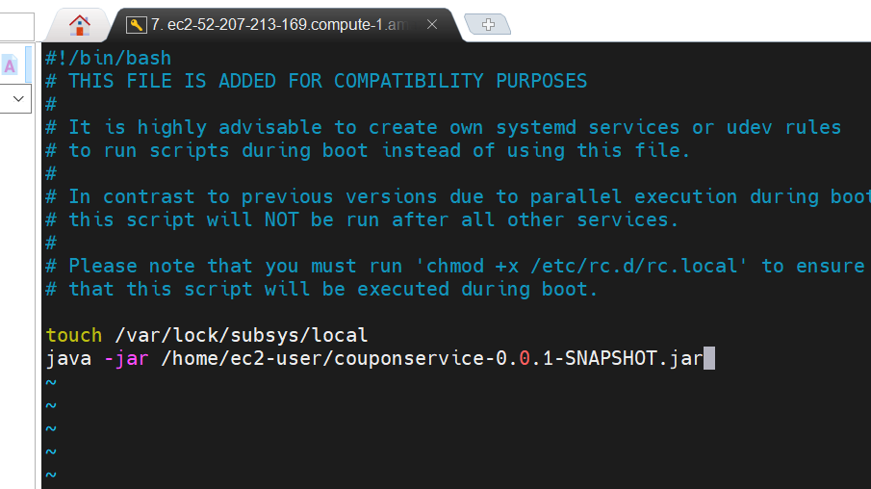

**After this need to run this :---**-chmod +x /etc/rc.d/rc.local



**Now stop ec2 and start again**

**Everytime start and stop with new public key we need to connect ec2 machine**

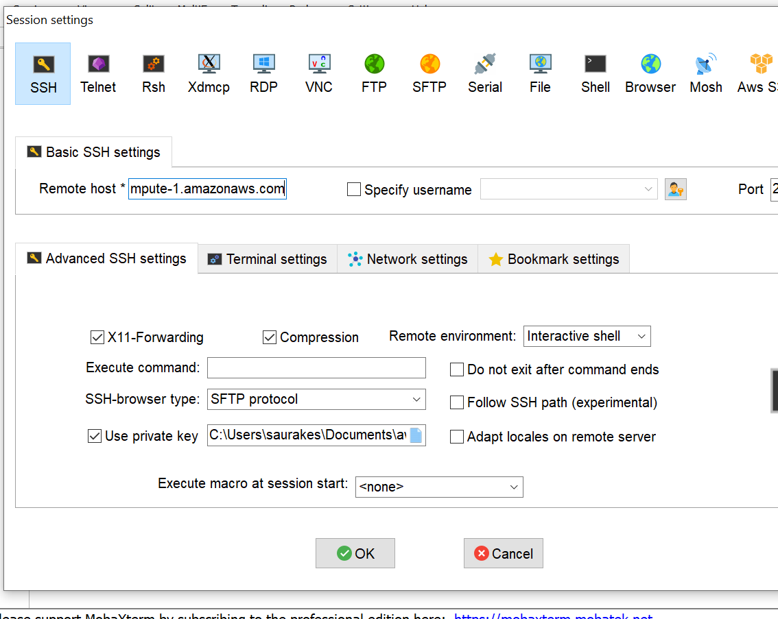

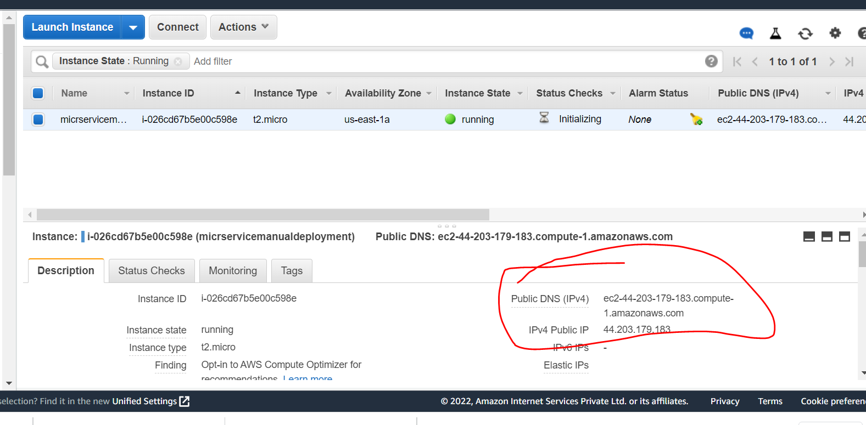

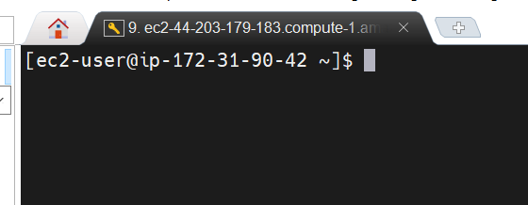

**After login everything is already up like db, spring boot app , we don’t need to do anything**

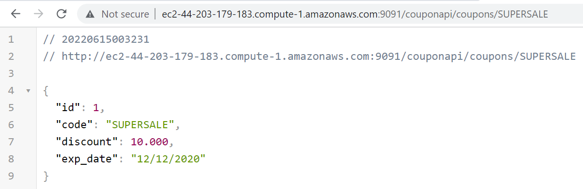

**Upgrade - Install amazon linux extras**

**Yum install stress -y**

**Amazon-linux-extras install epel -y ------------**we need to install this then only other command will work

**Yum install stress -y**

Now we can install docker or anything else

**Imp Requirement :---**

need to create ami out of ec2 instance . Going to create our own ami

That we can reuse as many instances we want

Once we create ami of this manual deployment m/s it already have java installed in it , my sql d/b setup

It will have current data inside the d/b which is one row of coupon in the coupon table.

It will also have our springboot application deployed.

We can create any number of instances from ami and all those ami have all set up is there, we don’t need to do any setup.

So we going to use ami when we will learn **load balancing , autoscaling**

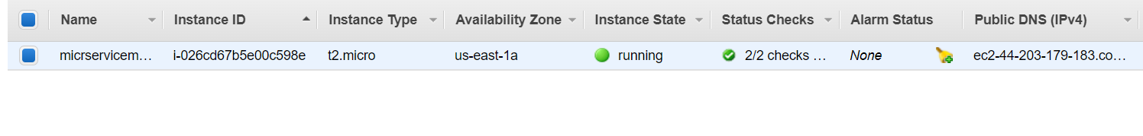

**Before that install one sw in this ec2 machine**

**Install stress command** since we are using it across the instances we are launching from **ami later on**

**What is stress command?**

The stress tool is a workload generator that provides CPU, memory and disk I/O stress tests. With the --cpu option,

the stress command **uses a square-root function to force the CPUs to work hard**. The higher the number of CPUs

specified, the faster the loads will ramp up.

**Yum install stress -y**

**Create custom AMI and scale the app manually**

**Requirement :---** create ami from our own instances

AMI :- have java ,mysql,couponservice Application

We can simply take the image and launch it where we want on planet and we will get up and running a new instance that is the beauty of ami

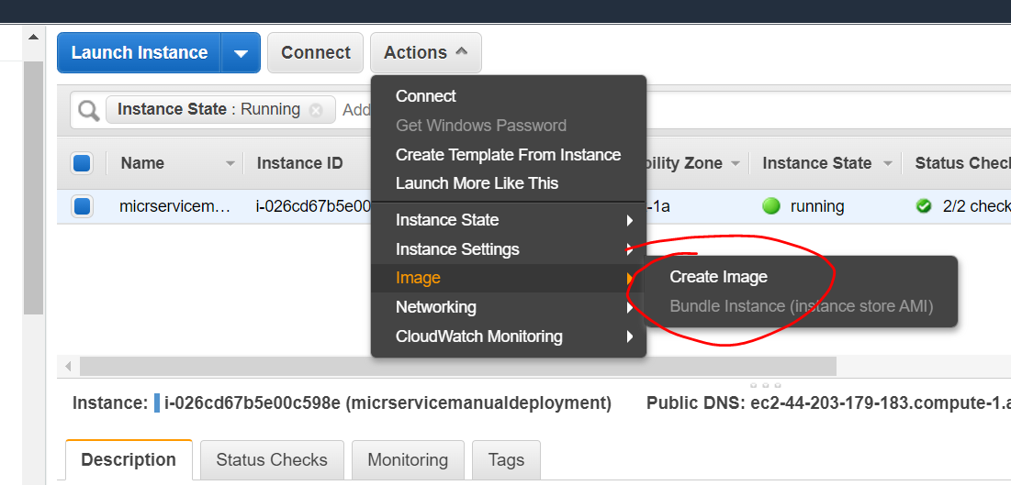

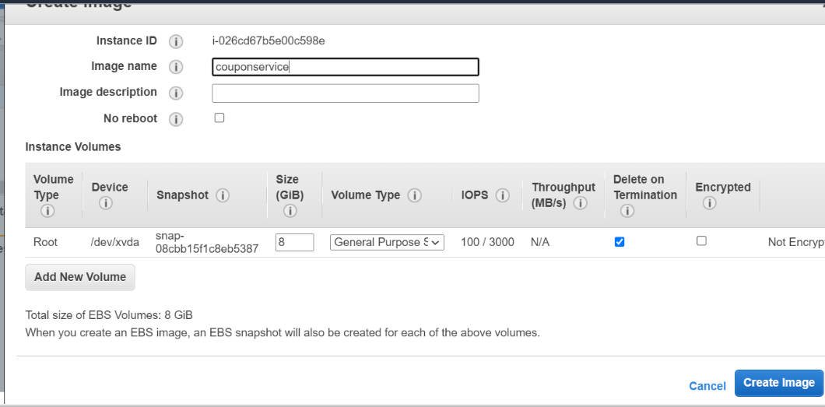

**This is our own custom image . Now we can launch instances using this ami**

**We can reuse security group across instances** if we know same rule is going to apply across instances

Ami available

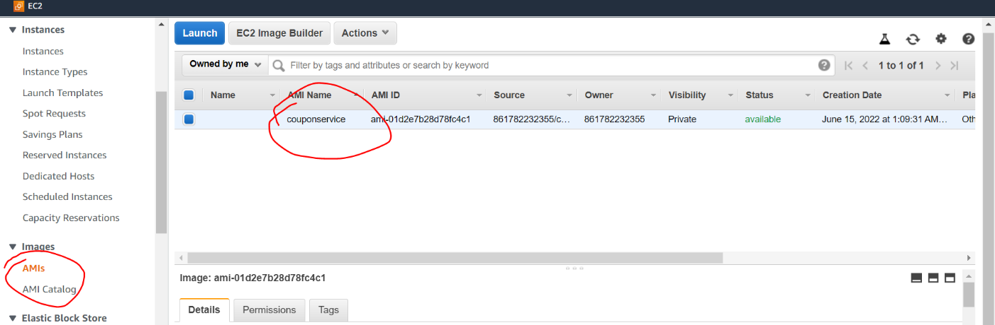

Will launch instance from this ami

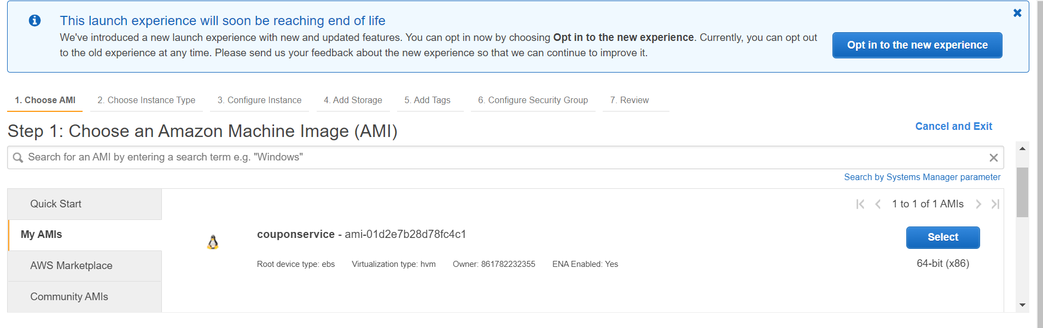

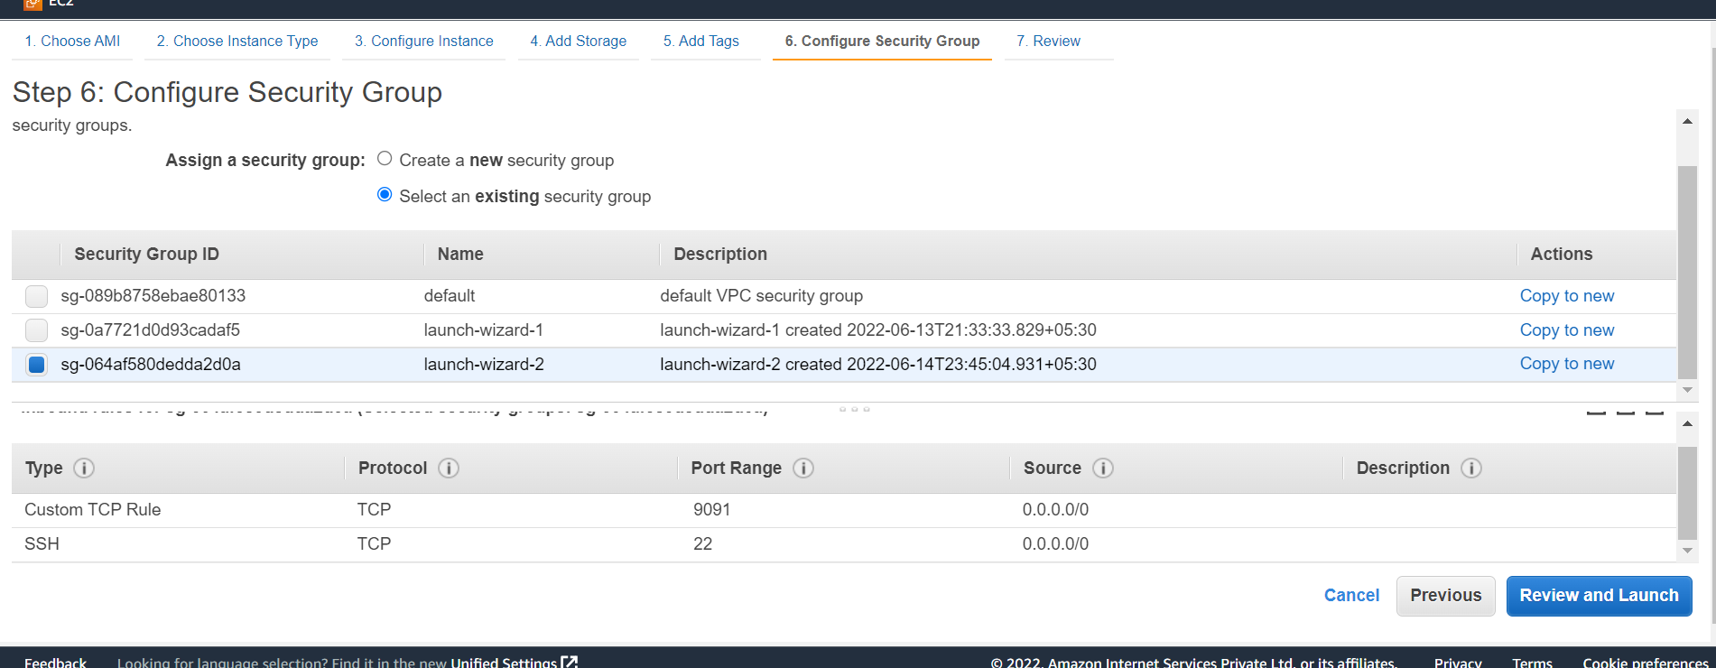

**We can distribute this ami image to anyone who want to use couponservice and we can create instance from this**

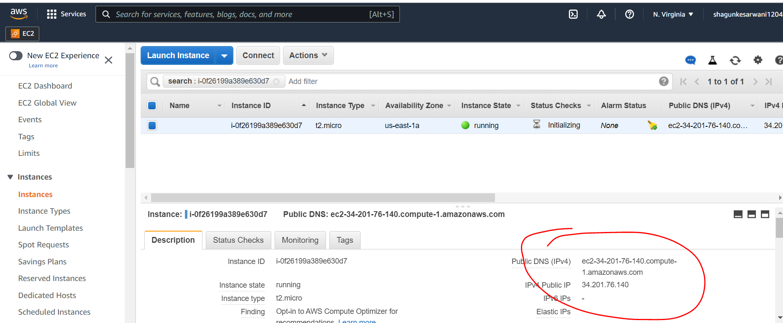

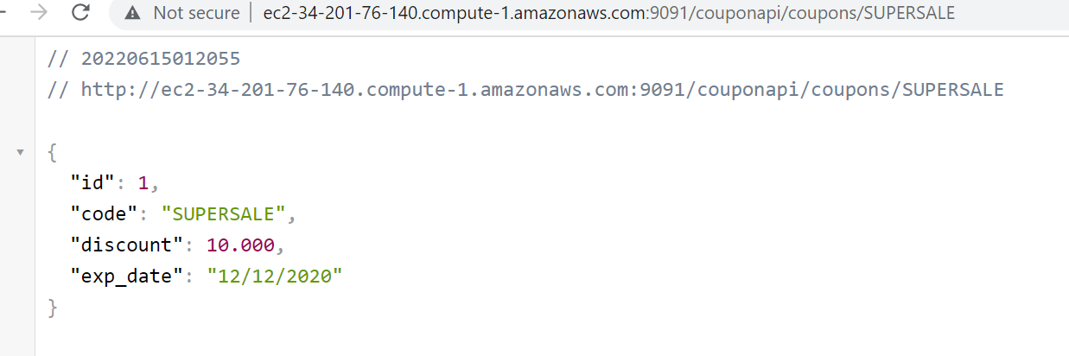

**It will capture the current ec2 instance and it will put into image**

**Spring boot app is up and running because we included in rc.local**

**Section 8:- AWS Elastic load balancer**

**Introduction :**

As our m/s application grow popularity and number of incoming request grows and if incoming request routed to same M/S.

It will crash at some point that is where multiple instances come, will deploy same instance on multiple virtual machine

And then we will balanced the load across these machine that is where elastic load balancing come in picture.

It will automatically load the balance for once we configure with all the m/s.

**There are three diff ways in which elastic load balancer can be created**

1. **Application load balancer**
2. **Classic load balancer**
3. **Network load balancer**

So depending on kind of application we are working with and where we are deploying them will use one of them.

**They have some commonalities and difference**

**Application and n/w -- commonalities -** they work with VPC ( virtual private cloud)

**Whereas classic load balancer work with ec2** that we set up

**Application and classic work with 7th layer so they can deal with https traffic** So they can route the traffic to other m/s

based on the content of request.

Whereas n/w **load balancer work at 4th level (tcp and udp level)** . It is very fast

**Create Load Balancer**

**Objective**

How To create elastic load balancer to balance the load b/w multiple instance we have

Two instances we have

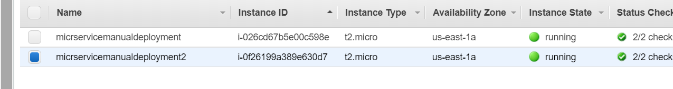

**Create elastic load balancer :**

**From web browser it will receiver at port 80 and redirected to 9091**

**imp**

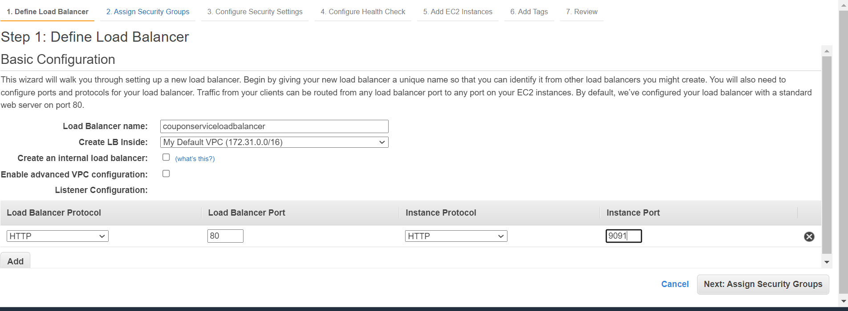

**Note :**

**Load balancer will do certain health check on the instances by hitting a url which we provide here**

**Unhealthy threadhold :**  if any of the instance not response for couple of time it will bring down those instances

Ping path : /couponapi/coupons/SUPERSALE

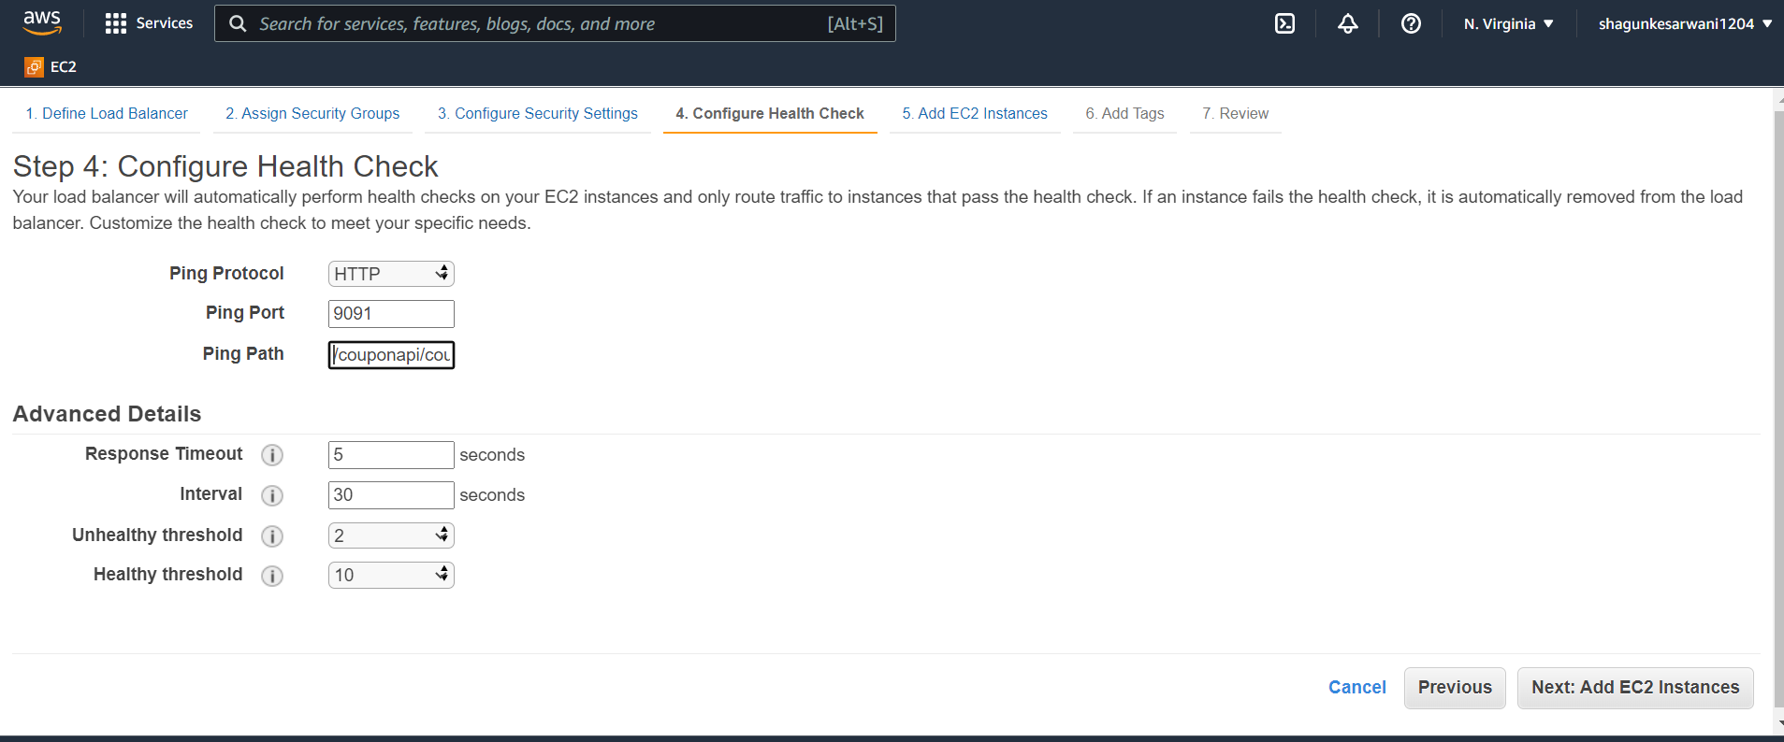

These are the instances between which we want to balanced the load

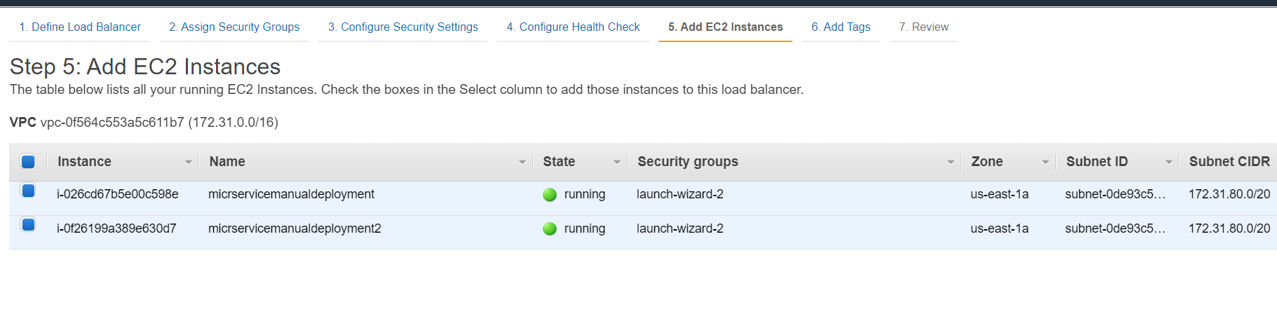

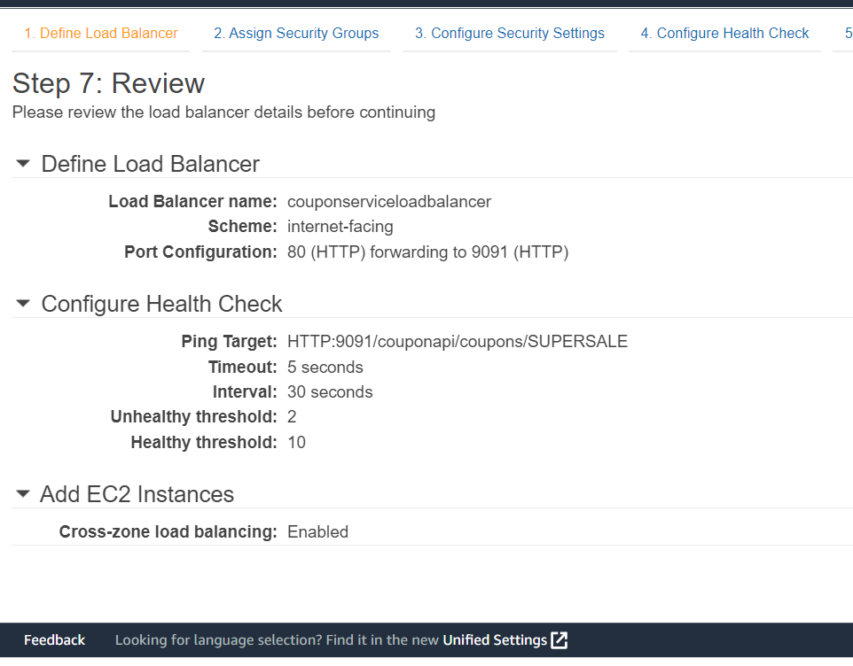

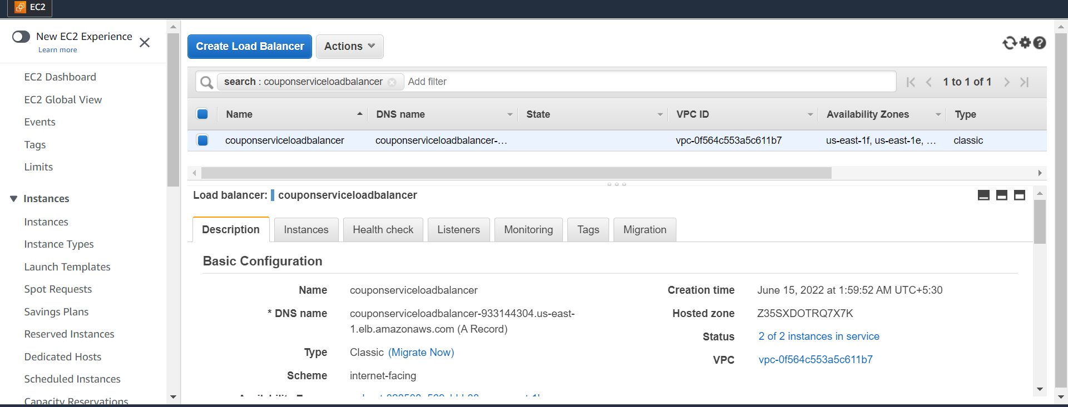

Add inbound rules 80 for load balancer

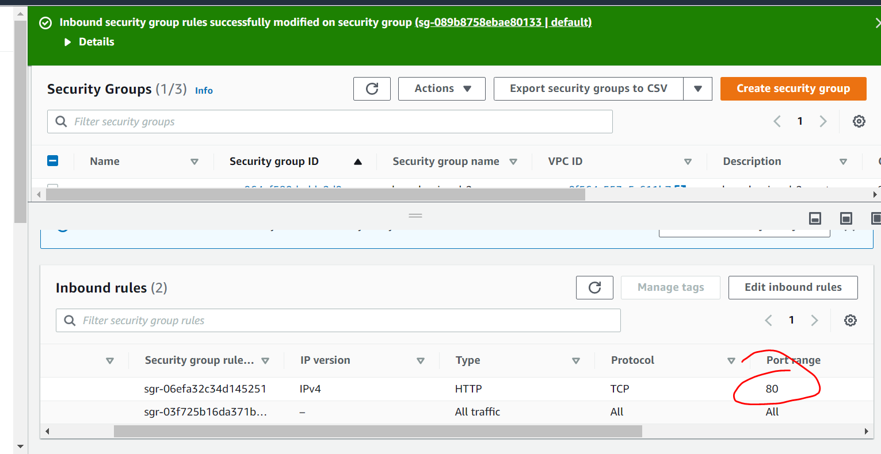

**Test**

**Objective :**

**To check if load balancer distribute the loads**

**Copy the dns name** of load balancer and using that we are able to hit

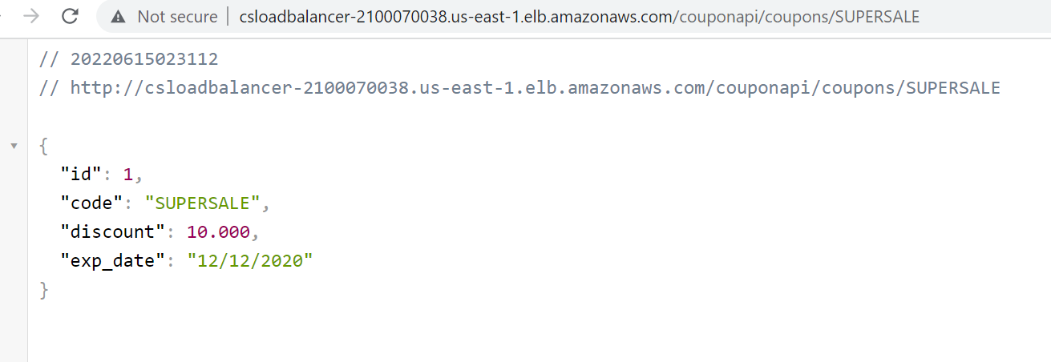

**Updated discount in one of the ec2**

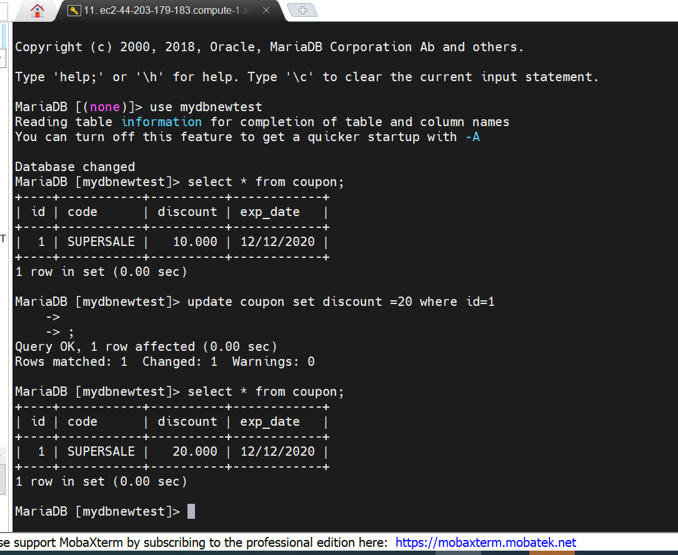

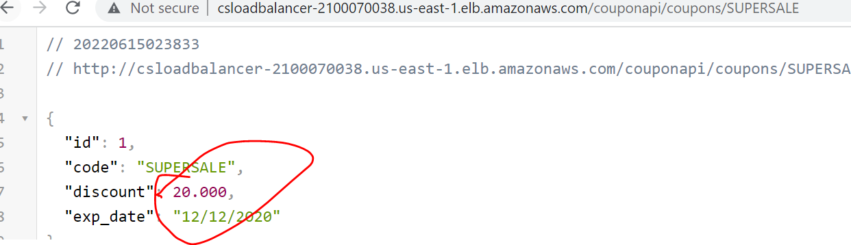

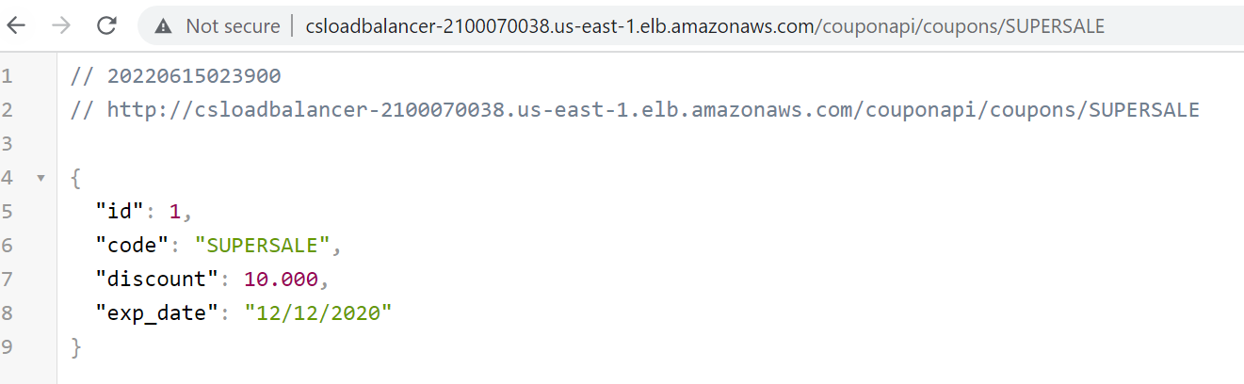

**Section 9 :- AWS auto scaling Group**

**Auto scaling :**

will scale up or down our ec2 instances so if we have one instances is running and as the load keep going up so we can configure

Auto scaling so that it will launch as many number of instances as required.

If the incoming request goes down or load become then we should configure auto scaling in such a way number of instances

should come down

Saving us cost for us that’s is why it called auto

**It is two step process**

First we create launch configuration

Second configure Auto scaling group using that launch configuration

**Note :**---- launch configuration is very similar **how we create aws instances**

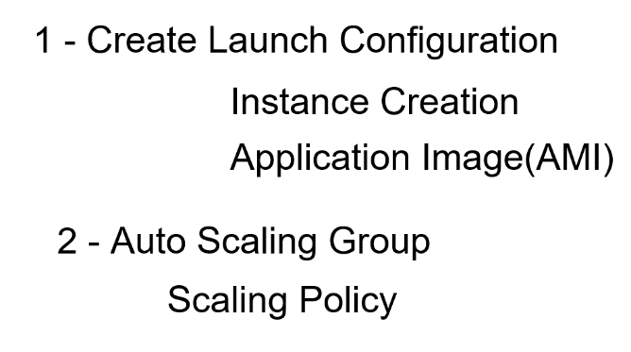

Even we can create for own custom image

**Note :-**--

in scaling policy we can raise alarm like if system cpu raise 80% then create another instances

If cpu uses come below 40 get rid of the instances

**Auto scaling group :** decide when to scale up and down launch configuration is used by Auto scaling group to launch the instances

**Create Launch Configuration**

**Note :**

Automatically instances will be up and own depending on load

**Stop the instances**

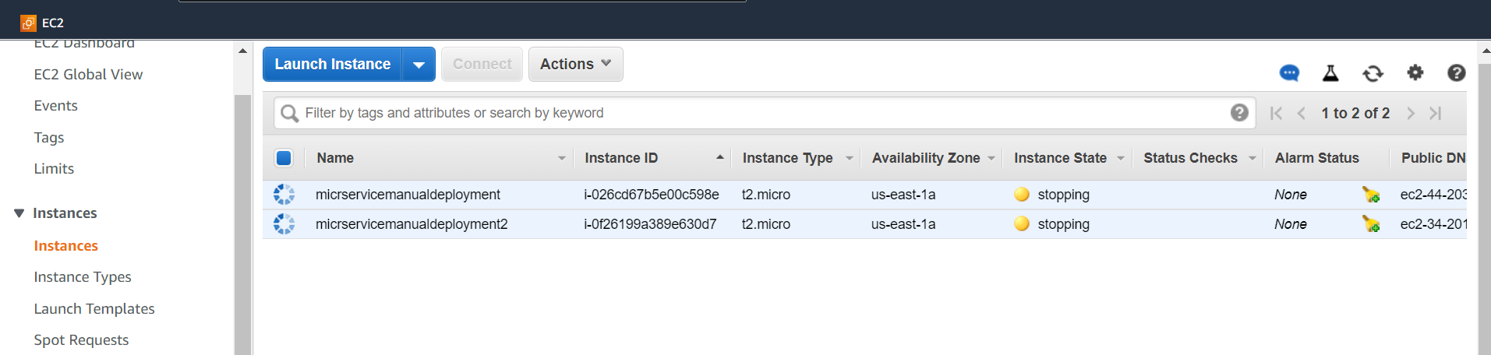

**Step 1 :**

**Create launch configuration this is like how we create instances**

**Once we create launch configuration then we can create auto scaling group**

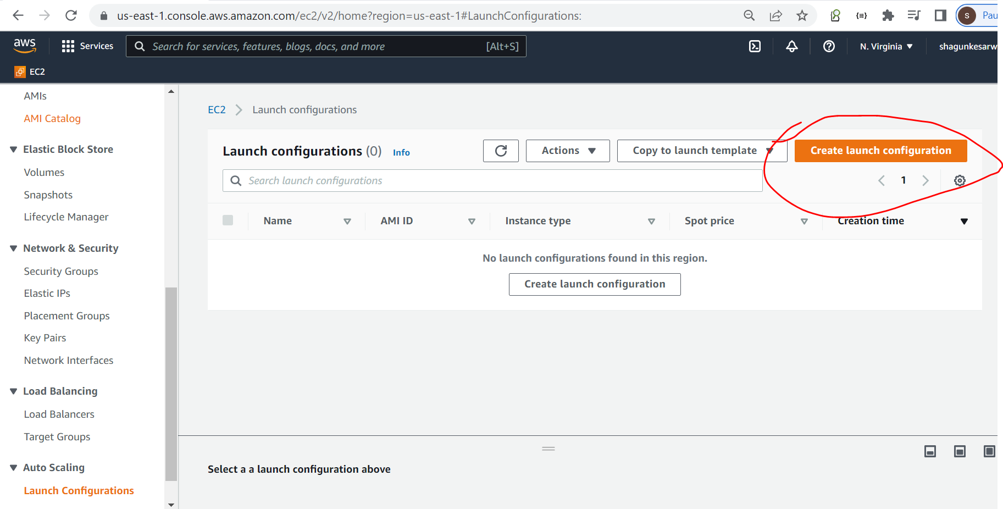

**Click on** create launch configuration

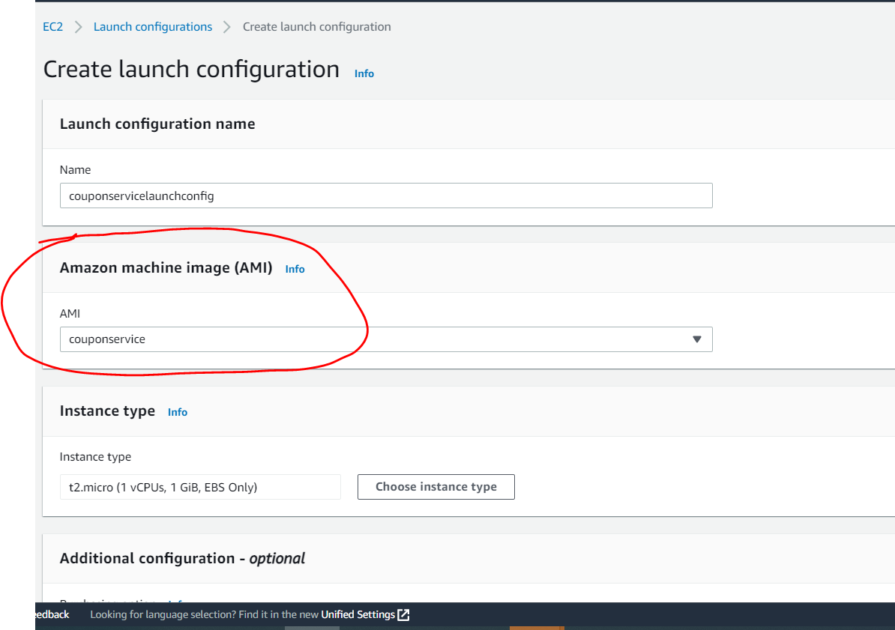

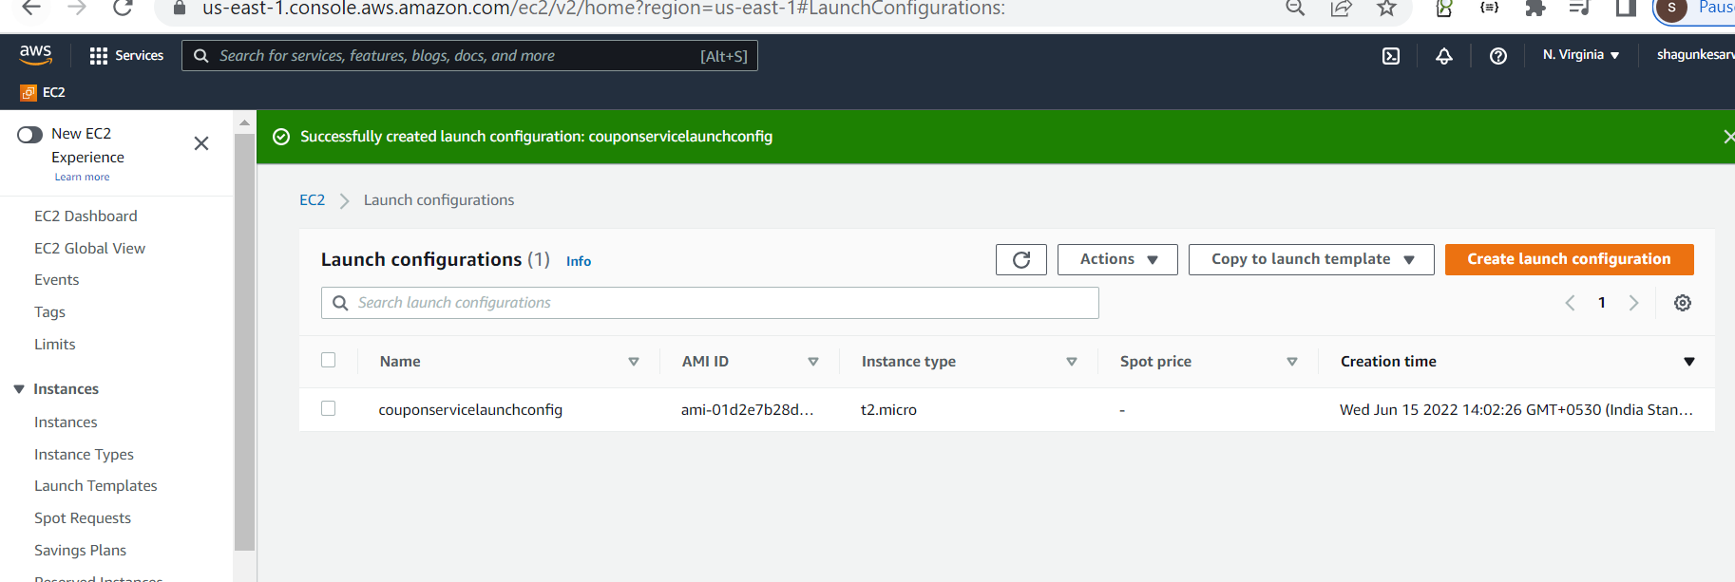

**Create Auto Scaling group**

**Step -1**

Select launch configuration and create auto scaling group

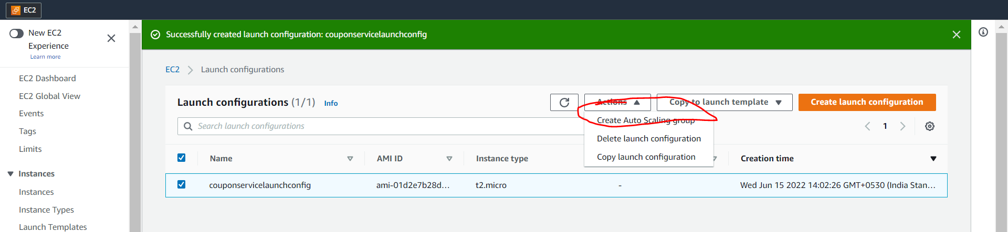

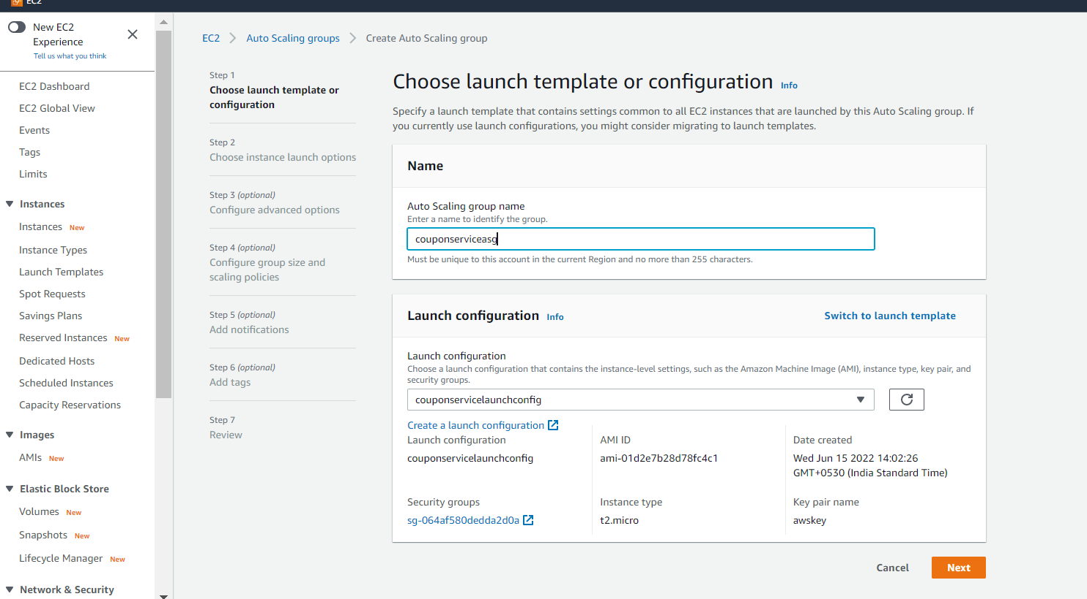

**Multiple subnet we can pick up**

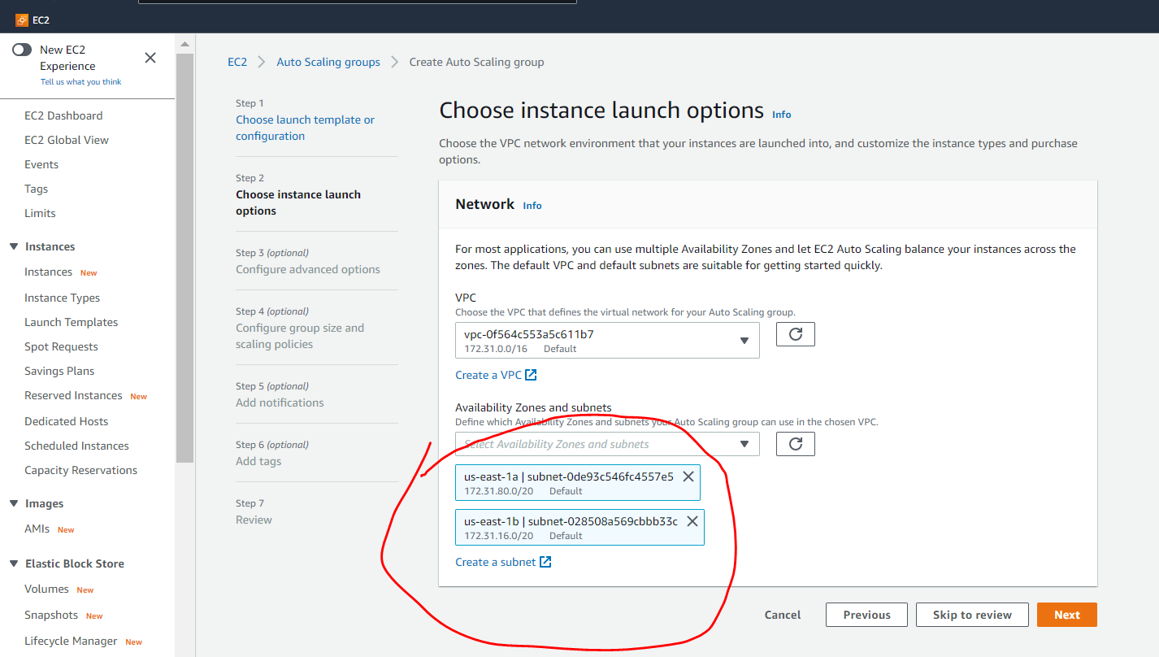

**Note**

When two instances launch one instance will go us-east-1a and one instances will go us-east-1b

**Imp:**

**We can also attach load balancing while create auto scaling .**

**For this demo we are not going to use it**

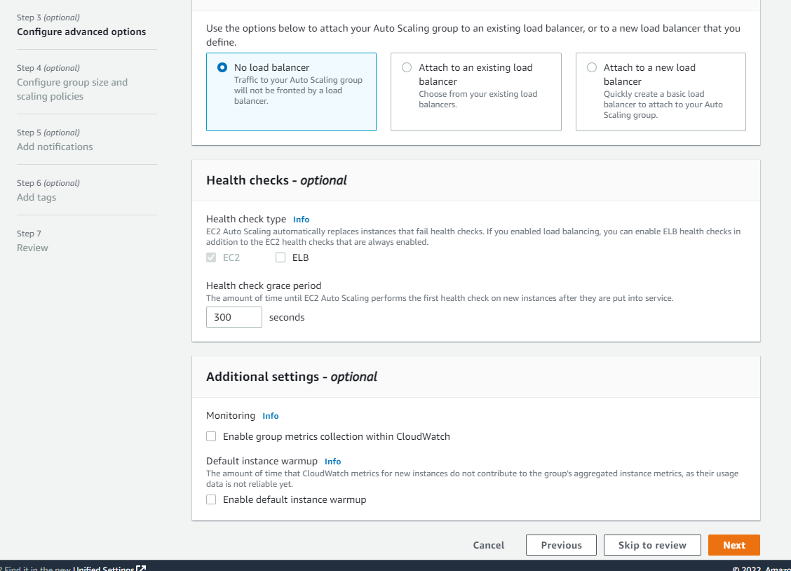

**This is imp step** where we will configure group size and scaling policies

Group size has three field

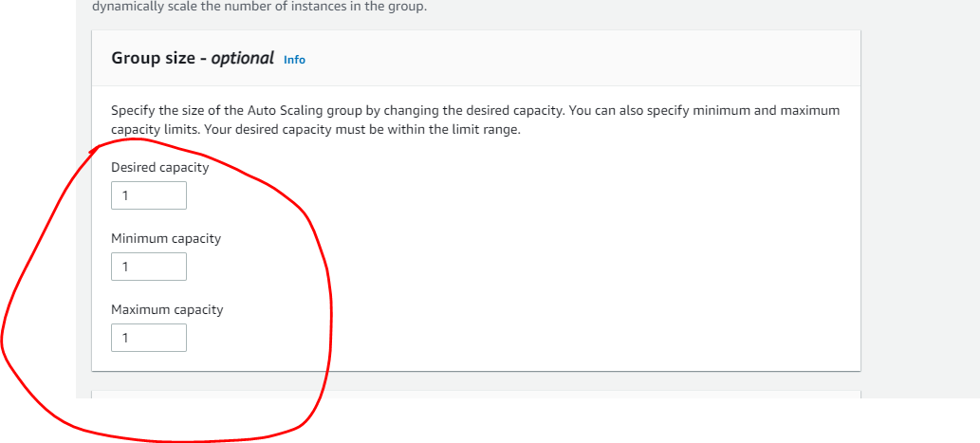

**Desired capacity** is the ideal one for our instances or application. It can be 50 or 100 instances

Maximum capacity : when load increase how many instances we want

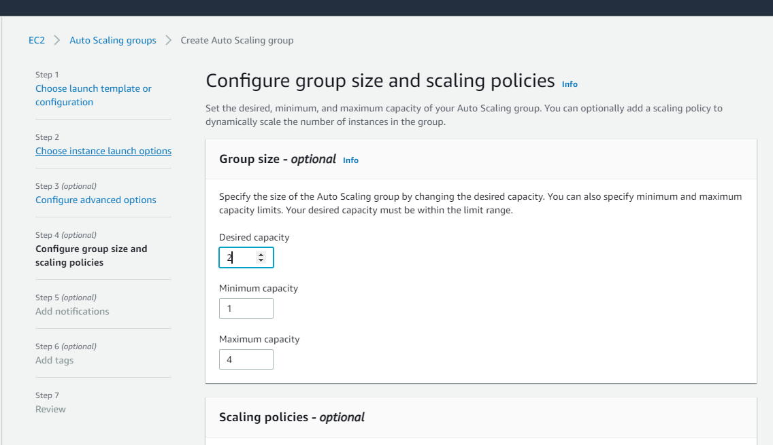

**So this is ideal it will start with 2 instances once load down then it will come to 1 instance and load increase it will scale to 4 instances**

We need to create target scaling policy also

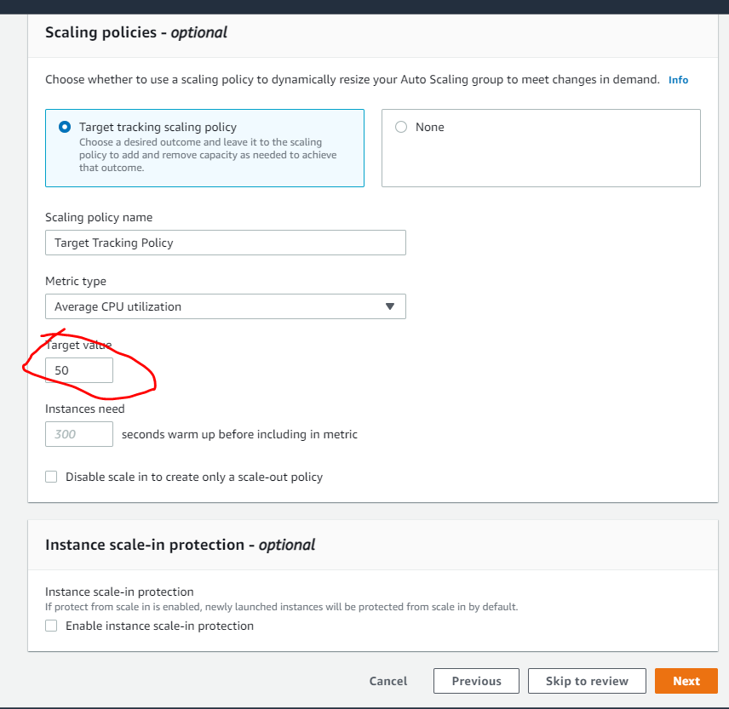

If cpu utilization above 50 scale up otherwise scale down

Note:

Also we can add **notification** if something happens that will do latter

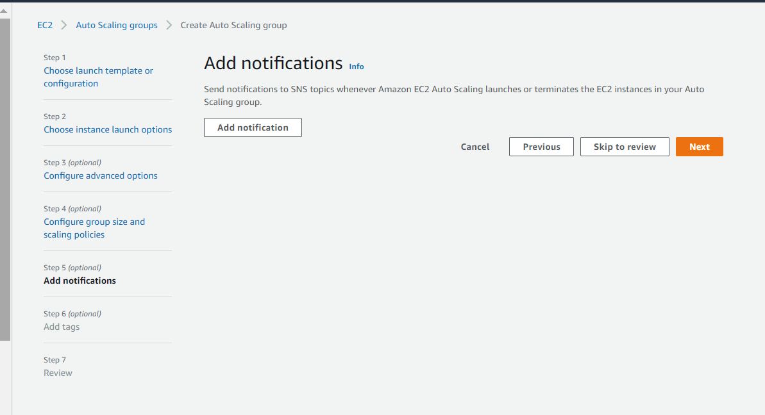

As soon as will click to create asg , it will create instances for us

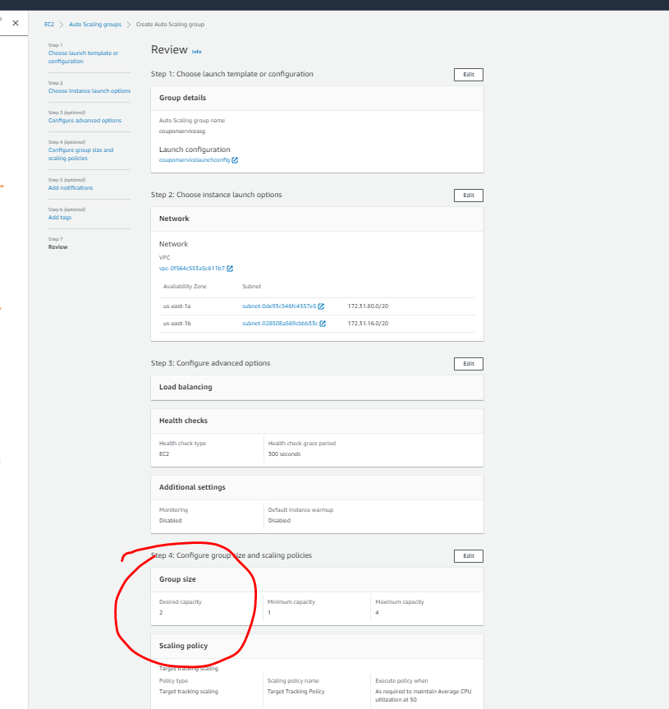

**Note : now two instance created**

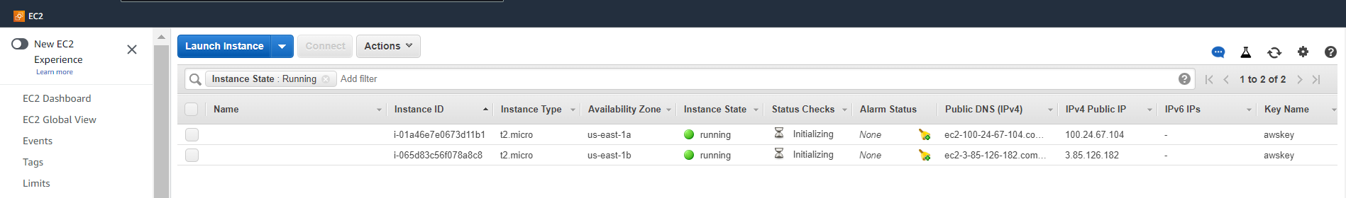

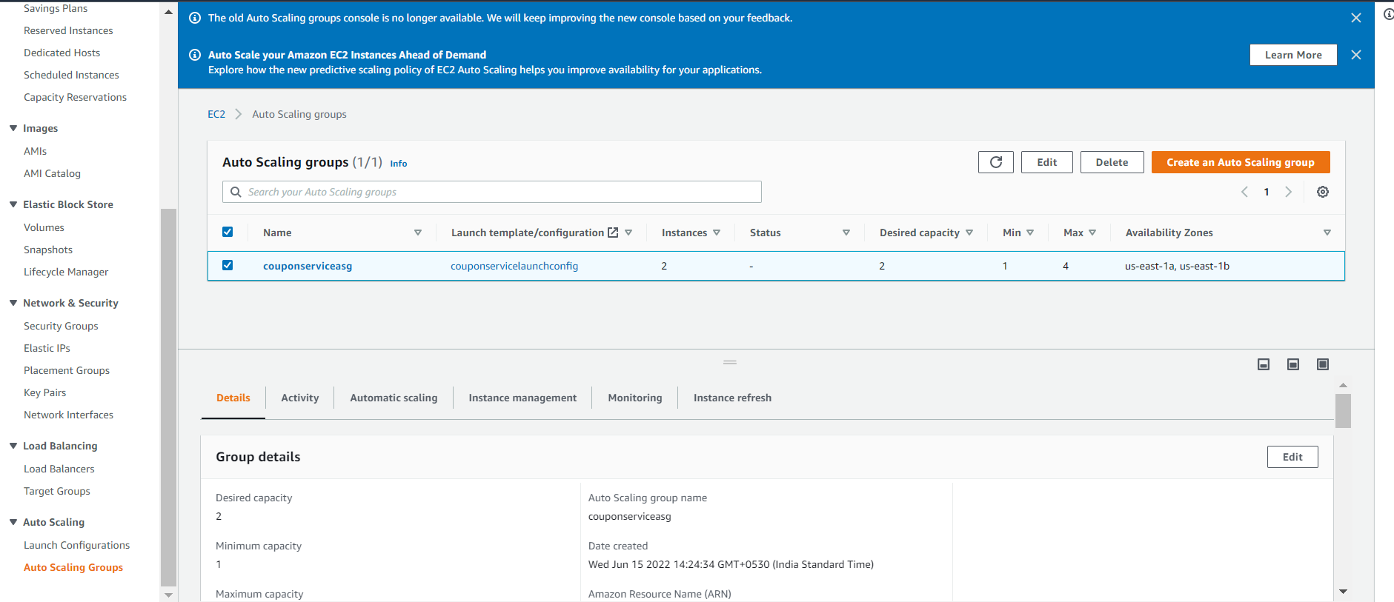

So it will use our ami and will create two instances

**Test**

Will test how autoscaling work by putting a lot of loads in one of the instances

This command will put load on cpu

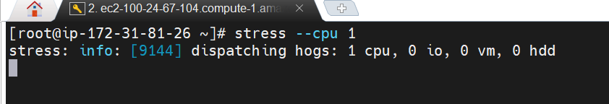

And after 5 minutes instances will create

Since load is less now once we stop stress command then only one instance will be there

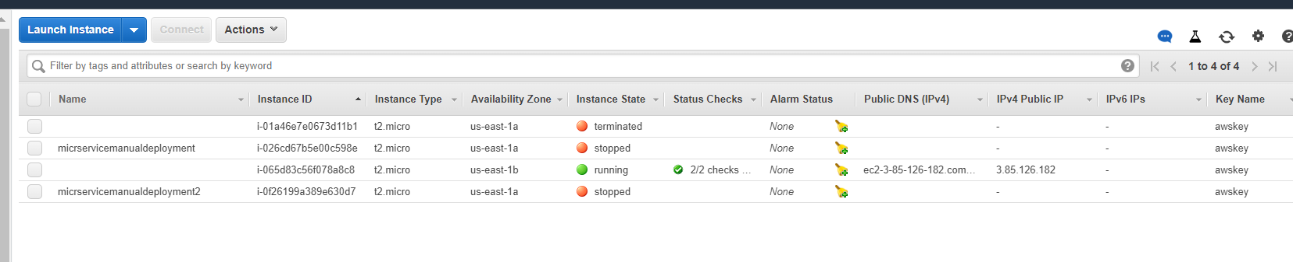

Section 10 - AWS cloudwatch , monitoring and sns

**Cloudwatch Service**

When we run m/s application local it is easy to monitor but when we are on cloud we need to collect health data of these application

All the logs, cpu usage and all that.

All these should be in place

collection of log or system health

Monitoring the system health continuously

Analyzing it

Acting on it

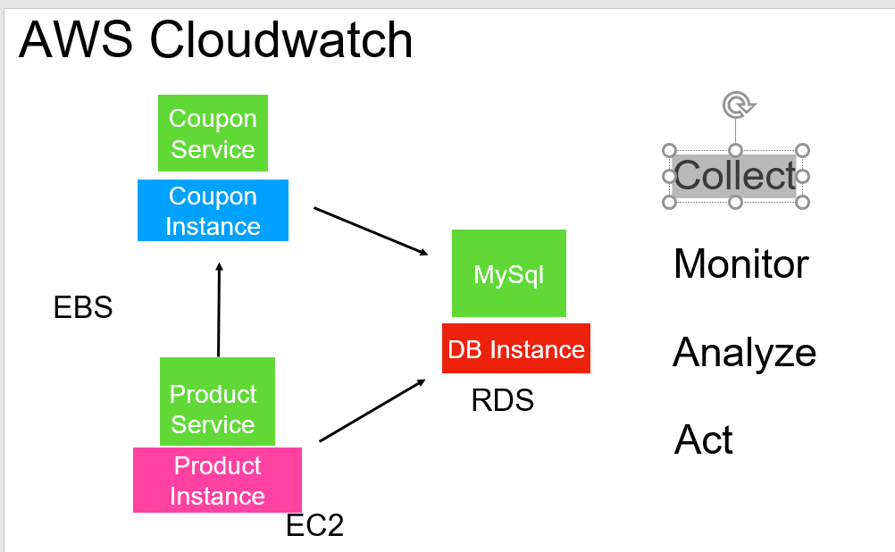

Collect, monitor,analyze,act on aws application can be automated using aws cloudwatch

All these in aws can be easily automated by **aws cloudwatch service.**

Cloudwatch can integrate with all other service can watch all other services

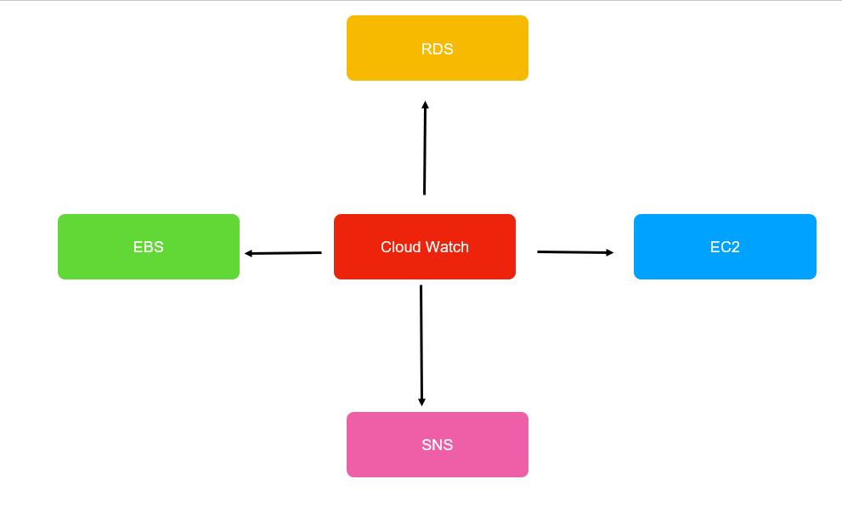

**Cloudwatch continuously** watching status of these services and we can do i**t using cloudwatch alarms**

**Simple Notification Services (SNS)**

It allows to capture events and send out notification.

**There are two imp component in SNS**

**Topic**

**Subscription**

Topic are virtual channel which will receive the message and whichever subscribers subscribe to this topic they will all get the message

And they can react to this message or event and they can do wtever they want to do

**Subscription can do following things**

They can send out **email** notification

They can do **http push** to another application

They can put a message on **aws queue that aws offer** so that other application can read from queue.

They can even run **aws lambda expression**

**The sender of the message can be done using**

Cloud watch alarm.

If cloud watch alarm goes off then it put event on topic so that subscription will take it send out email,sms so that production guys can come in

And fixed the issue or we can automate the fixing of issue as well instead of someone doing manually.

The message need not be always from cloudwatch alarm any other service within aws can use these topics to exchange

messages and it could be even

Our microservice application . **So the m/s application will deploy can use these messaging to communicate with other m/s as well**

**While creating topic in aws:**

Whom u want to access topic

**Basic :----**  anybody can access it

**Advanced :** who can access it

**Once will create topic will create subscription**

While creating subscription we need to provid**e ARN ( Amazon Resource name) ---- it is unique name**

Subscription is always for topic so we pic a topic

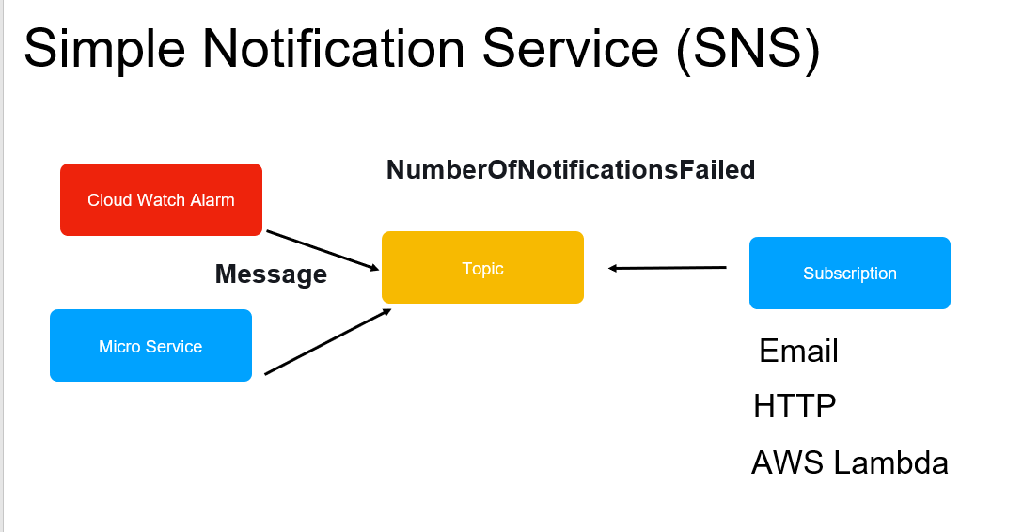

**In next lecture will do it**

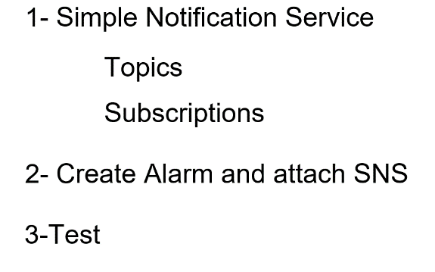

**Ms ---- cloudwatch---sns---mail**

Will create topic and subscription which will send mail to email id when a cloudwatch alarm goes off

**Will create a cloudwatch alarm for aws m/s instance when cpu usage goes beyond a certain limit , it (cloudwatch)**

**will put a message on aws topic Automatically subscription will pick up message and it will send to email**

**Create topic and subscription**

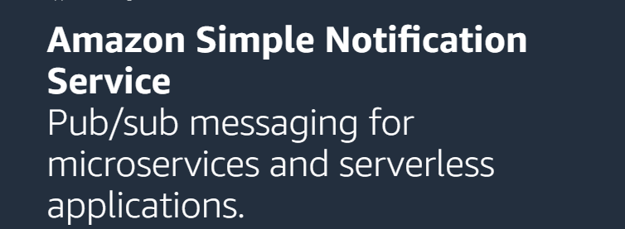

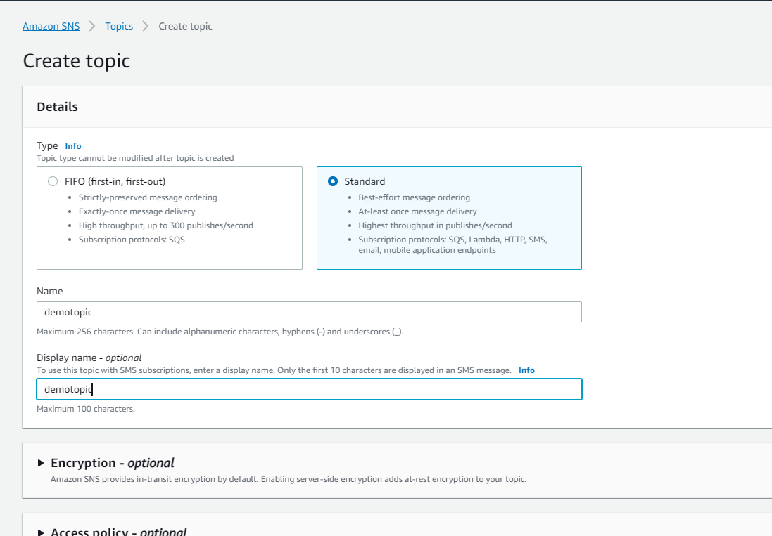

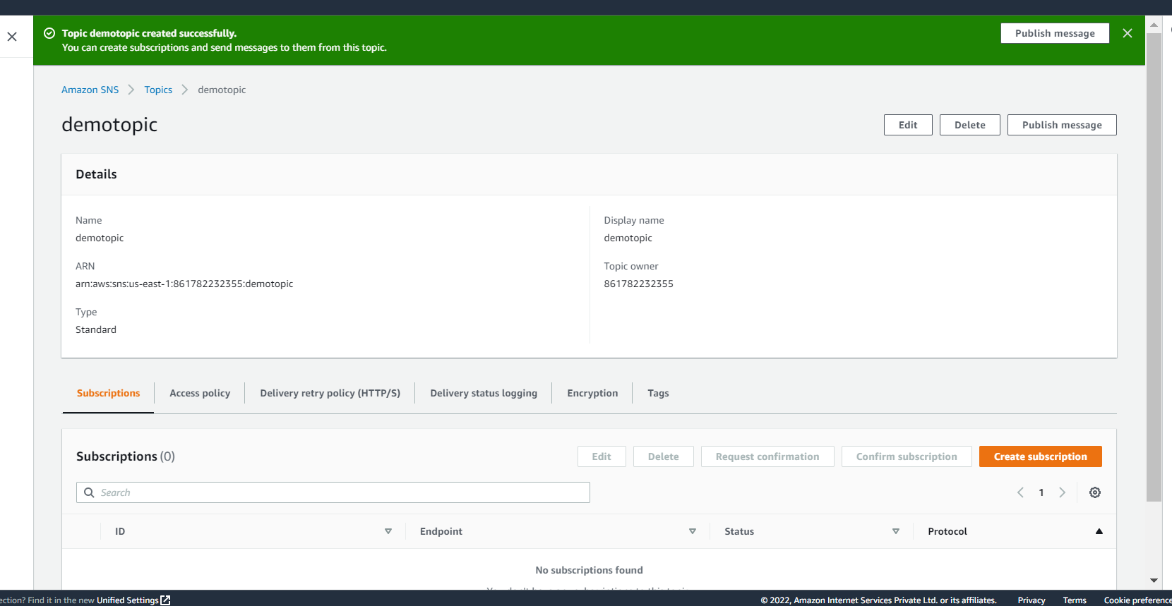

Once the topic is created , need to create subscriber using the topic who will listen to the topic

**ARN will be unique**

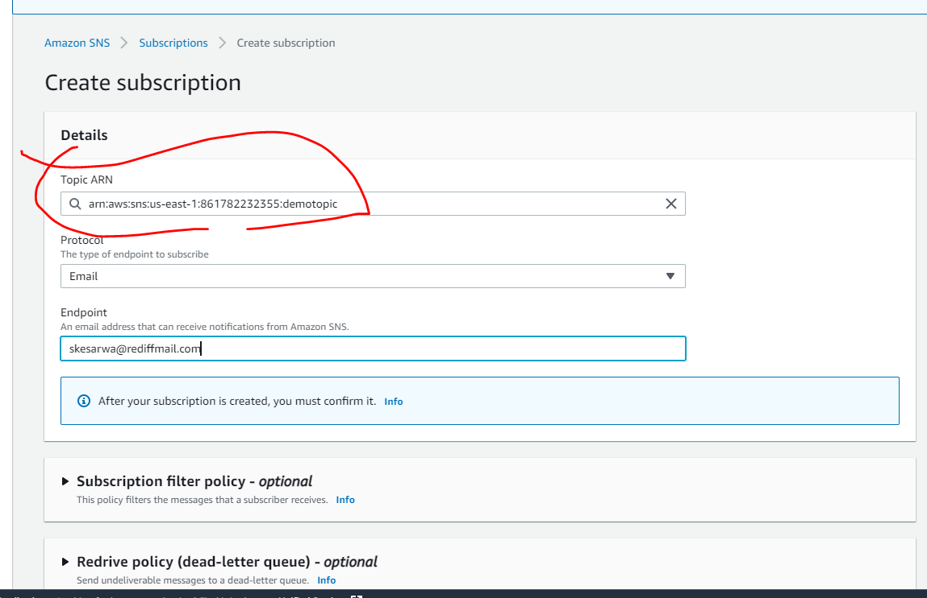

We need to confirm subscription from mail

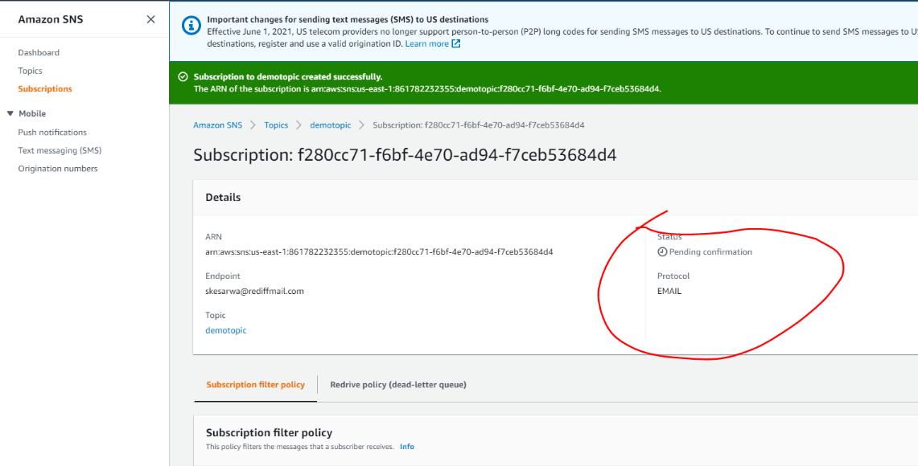

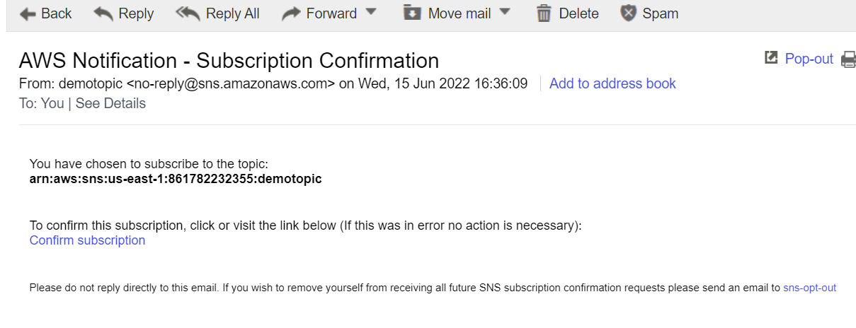

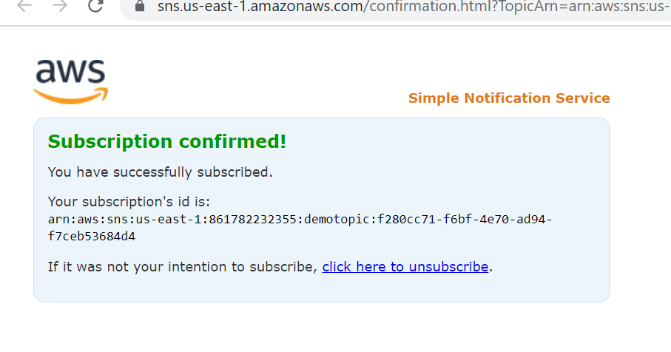

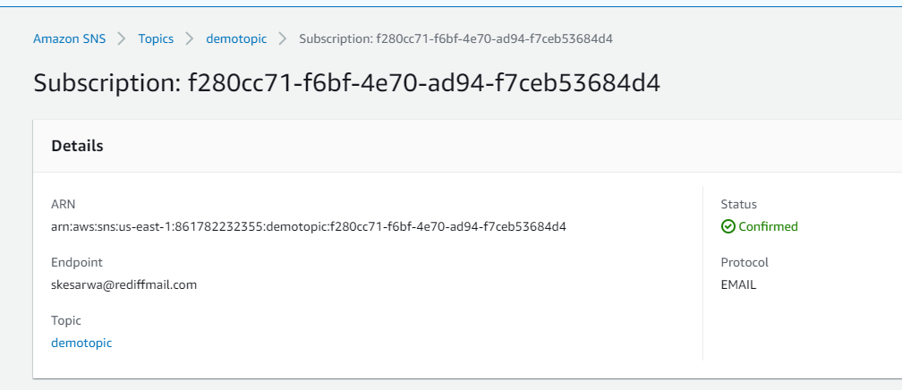

Now we can assign this notification to an alarm which will be creating next

**Create Cloudwatch alarm**

**Objective :** configure a cloudwatch using a notification service we created

**Cloudwatch :--- monitor resources and application**

Go to cloudwatch - alarm- create alarm------------ **this is one of the way**

Note :

**We can directly go to service for which we want to create alram**

**Will create alarm for ec2** service and use notification service which we created

Go to monitoring :- no alarm state configured

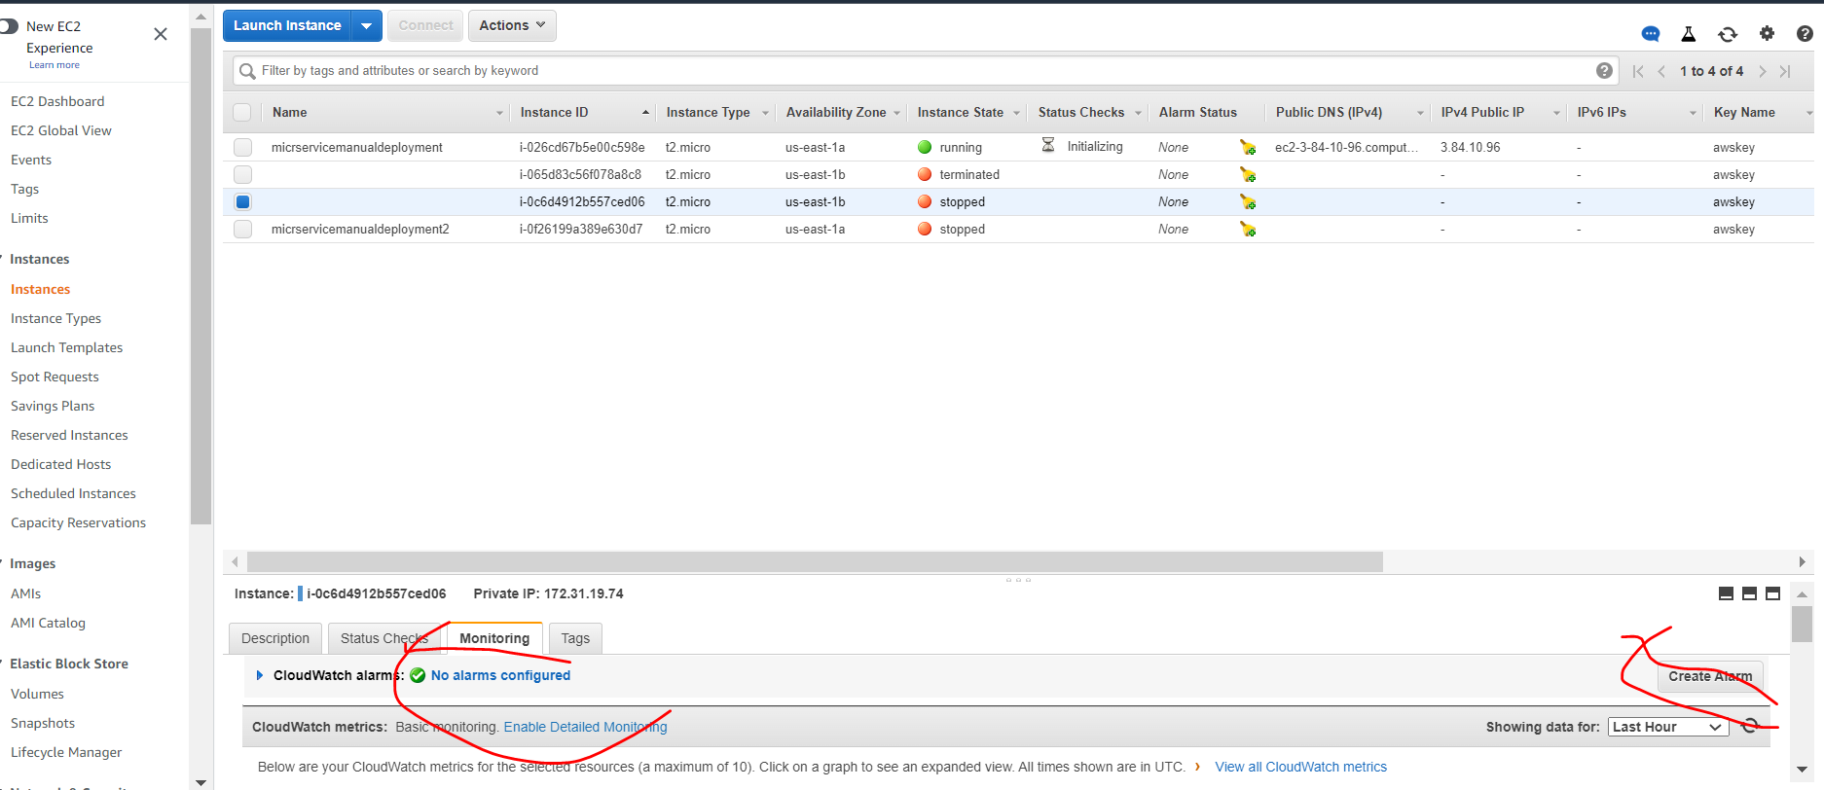

**Under monitoring tab of ec2 instance we can create alarm**

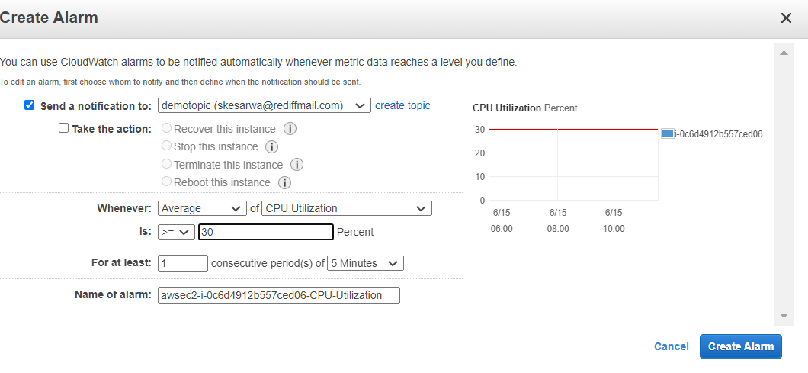

I want this alarm to be triggered for my m/s when CPU utilization is above 30 and sns topic will configured automatically here

This alarm will trigger when cpu stays for 5 min and load is more above 30 percent

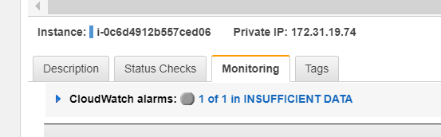

Once we create a alarm cloudwatch monitoring the instance

**Test**

Will see cloudwatch alarm and notification in action

**Stress --CPU 1 command**

**:-----will increase load to 100 % on cpu**

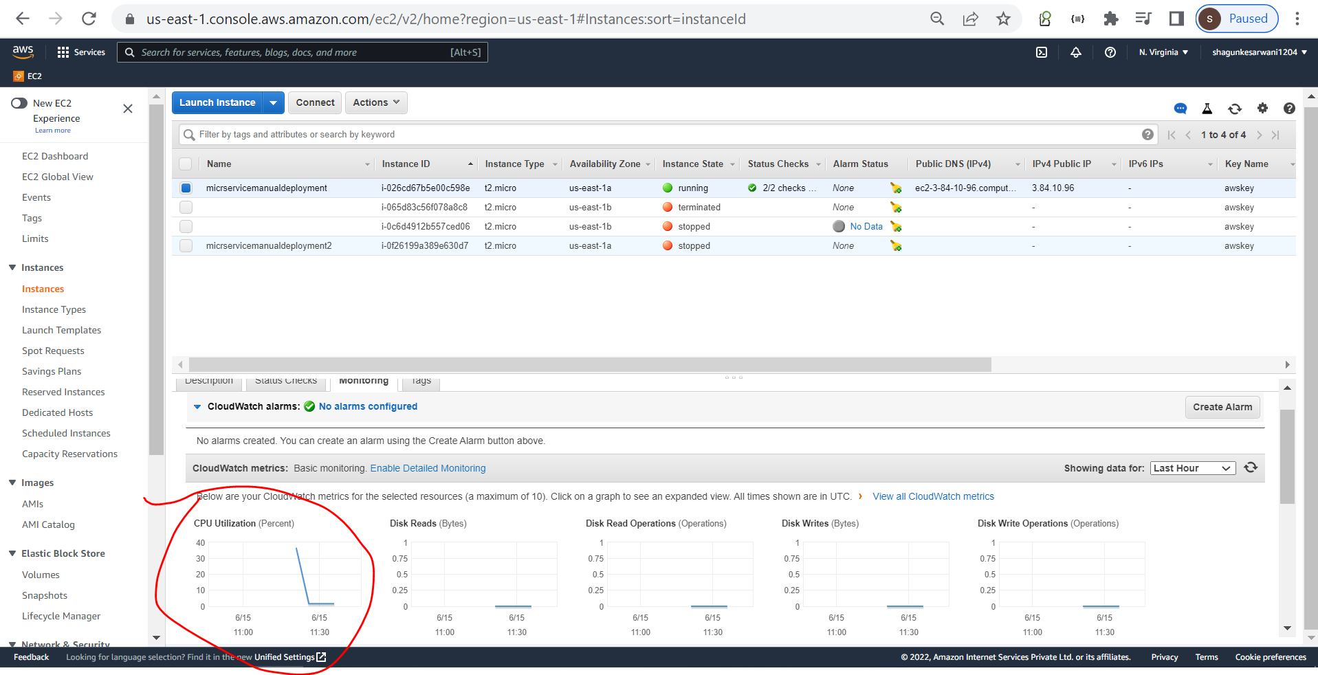

We can create alarm on aws service based on various metric and receive notification once alarm raised

We got alarm mail

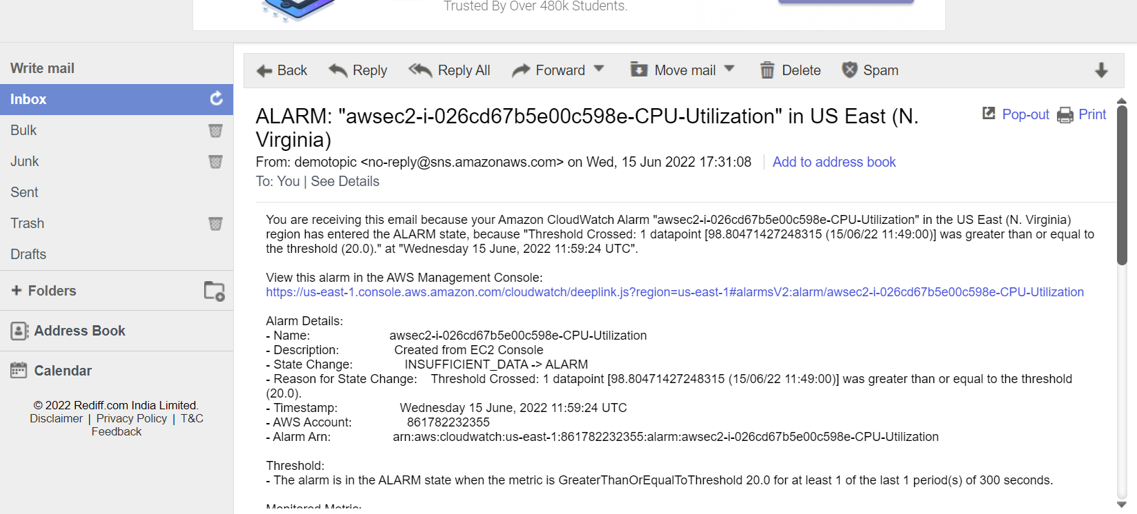

Section 11 - Deploy to AWS Elastic Beanstalk using RDS

**Orchestration** helps IT to more easily manage complex tasks and workflows

**Elastic beanstalk**  aws service will allow us to easily and quickly deploy our m/s application and run them seamlessly.

It does us by orchestrating by various aws services which are already there.

It bring all the service together and our application use the service that is required

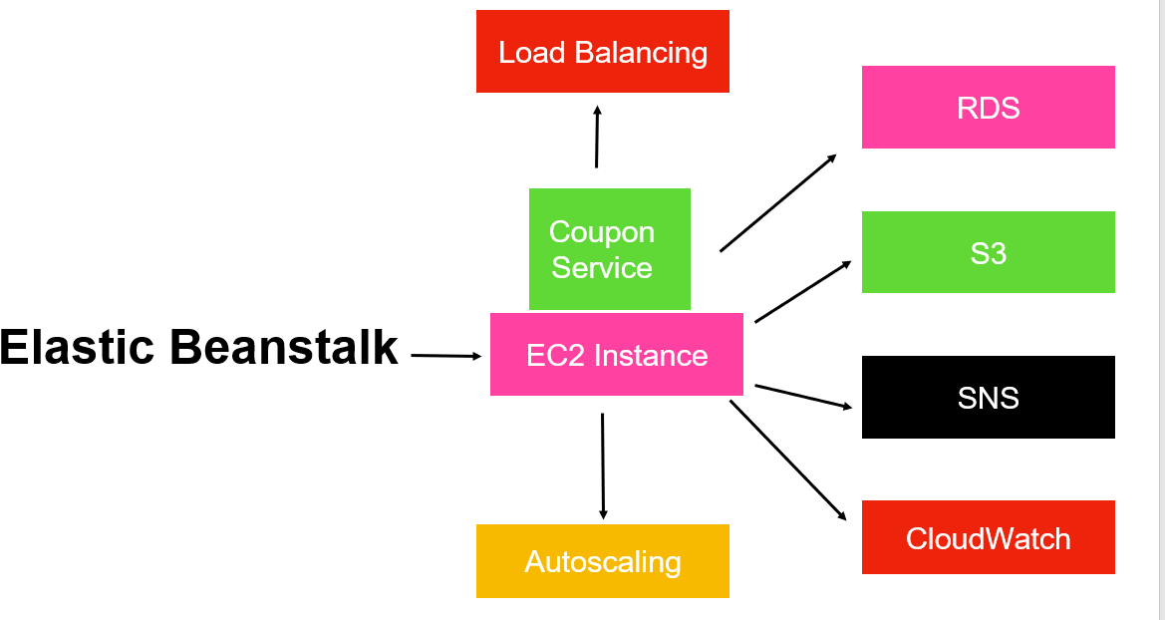

Note :

once we use elastic beanstalk it super easy to deploy any application written in any programming language

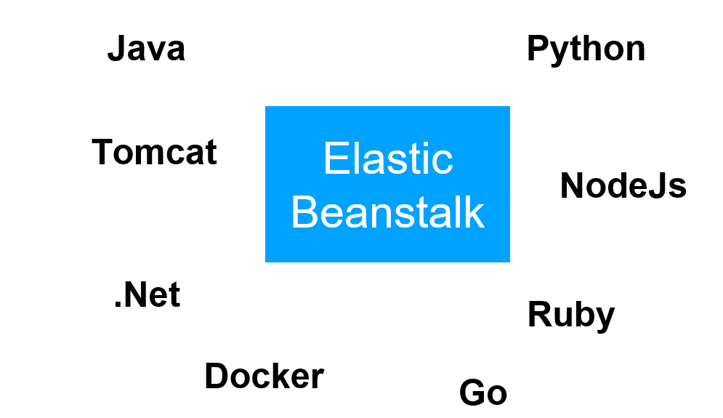

First will take our application jar file which will give to EBS while doing that we will provide version and it will

create configuration for application to run.

Mysql will be hoisted using RDS(relational d/b service)

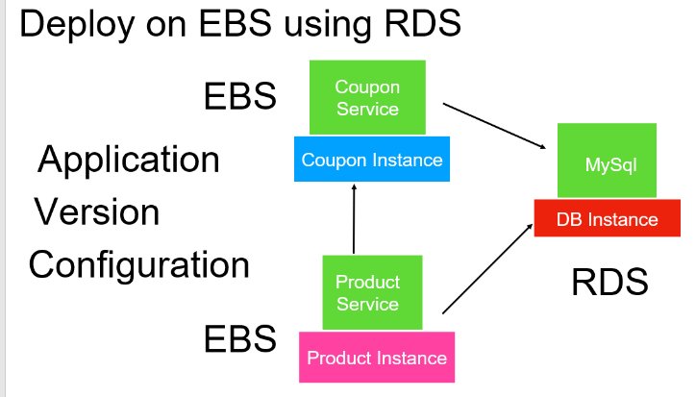

**RDS(Relational database service)**

**Step 1 :- create RDS**

**Step 2 : connect from mysql workbench and run query**

**Step 3:- change in properties file of couponservice and build it**

**Step 4:- create elastic beanstalk and deploy jar file note :- in jar file rds details is already given**

For any m/s to run the first step is to create a d/b so we need a d/b server up and running where RDS aws service come in.

It allow us to use any relational d/b server

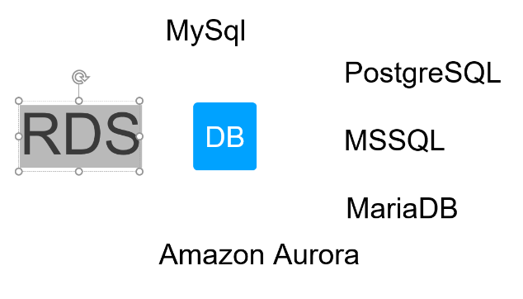

What is MariaDB used for?

MariaDB is an **open source relational database management system** (DBMS) that is a compatible drop-in replacement for the widely used MySQL database technology.

**Amazon aurora** is build on top of mysql server and it is super fast

The advantages of using RDS we don’t need to configure because we can simply configure while using RDS

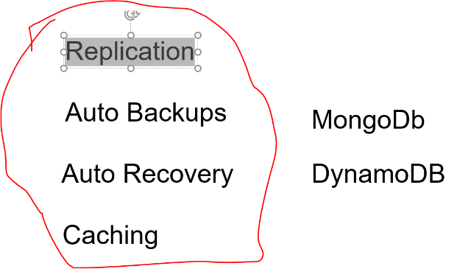

MongoDB and DynamoDB unstructured D/B which is support in aws outside RDS

**Create mysql database on RDS**

**First step to set up a database**

**Create database -**

**standard create (** we can select certain option**)**

**Easy create (**default will be configured**)**

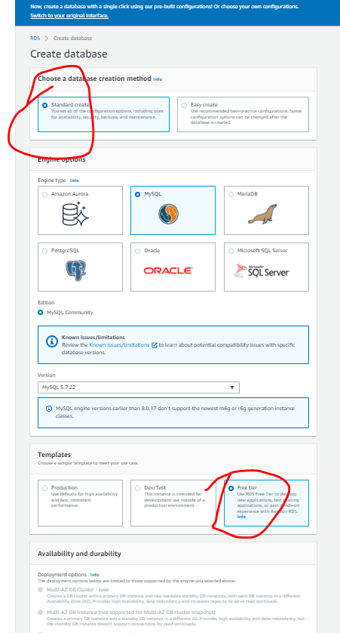

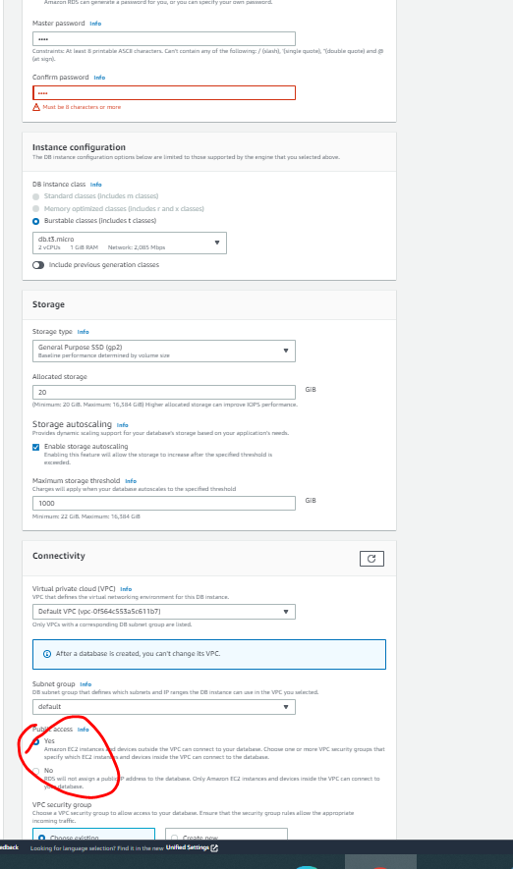

If we select public we can access outside also

Click create database :

Once it start we will get

**portNo**

**Endpoint**

**Imp**

**We can connect this from mysql workbench : endpoint we can give and pw**

**And execute query there**

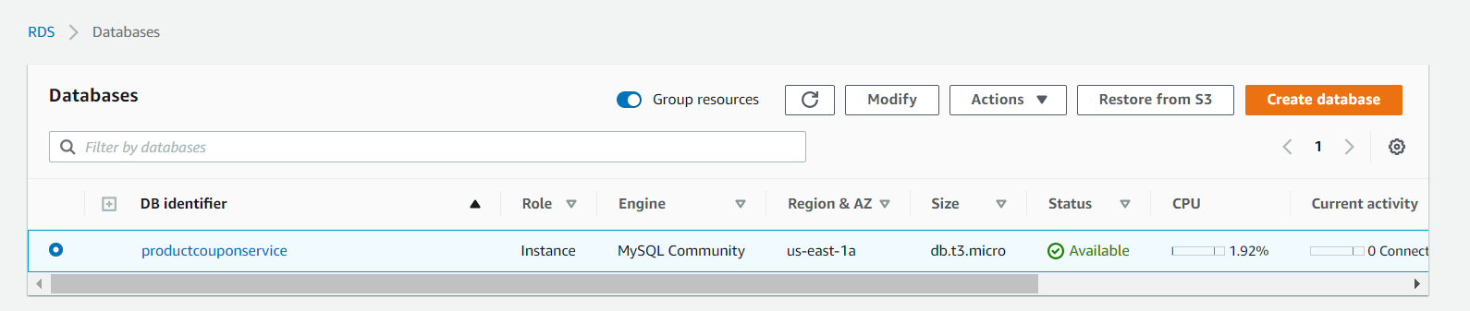

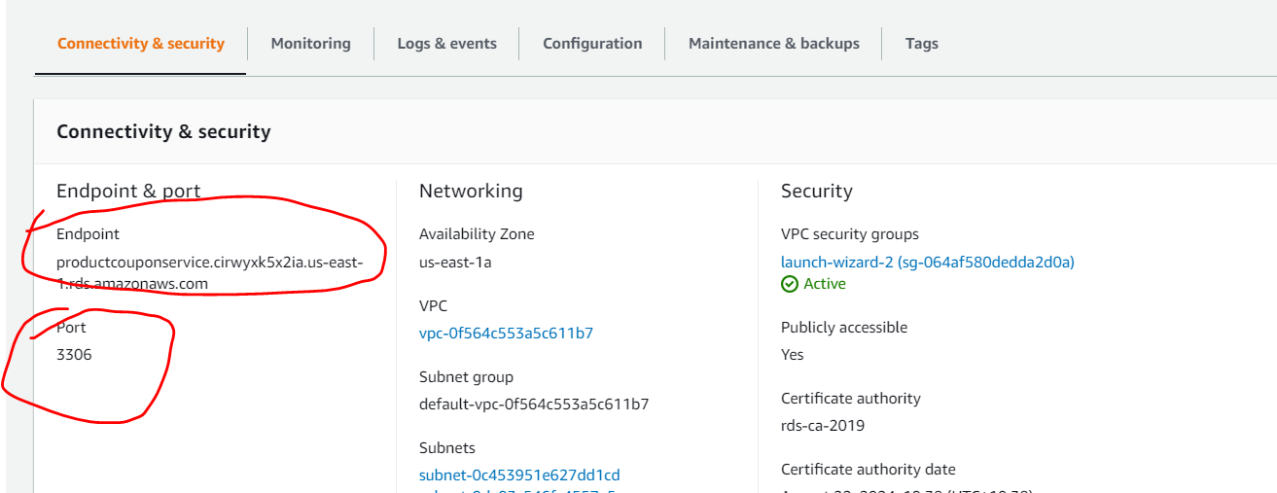

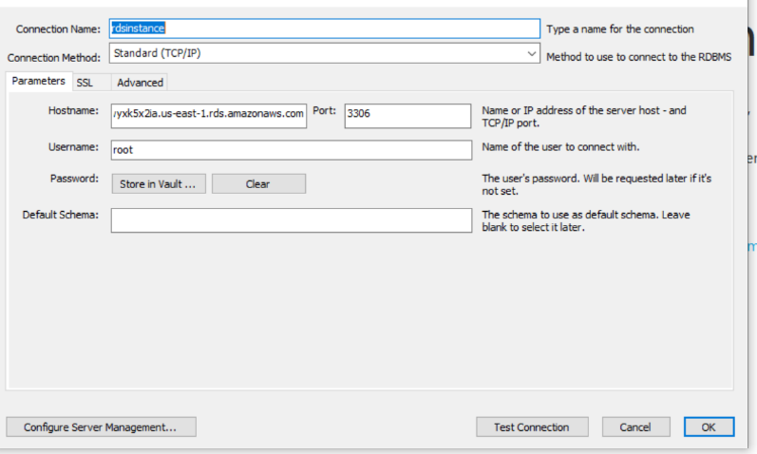

**Pw- given : test1234**

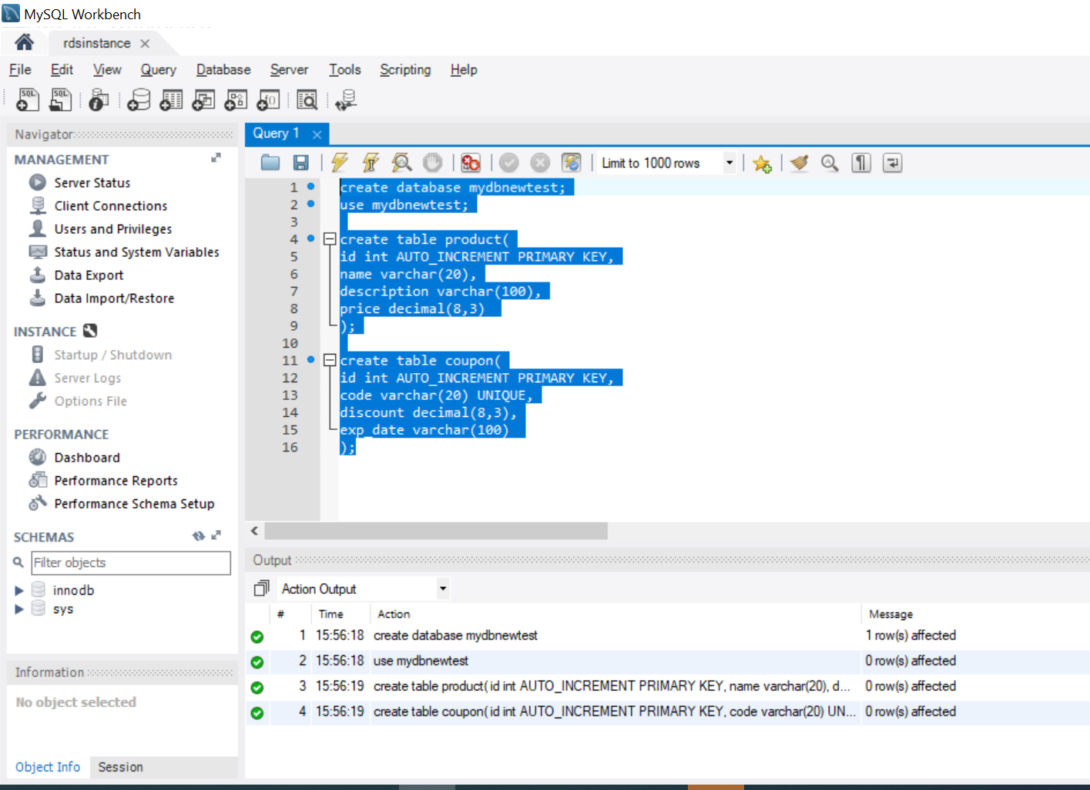

**Deploy the coupon service**

**Objective :---** deploy the coupon m/s to elastic beanstalk on aws

Step :--- we need to make change in properties file

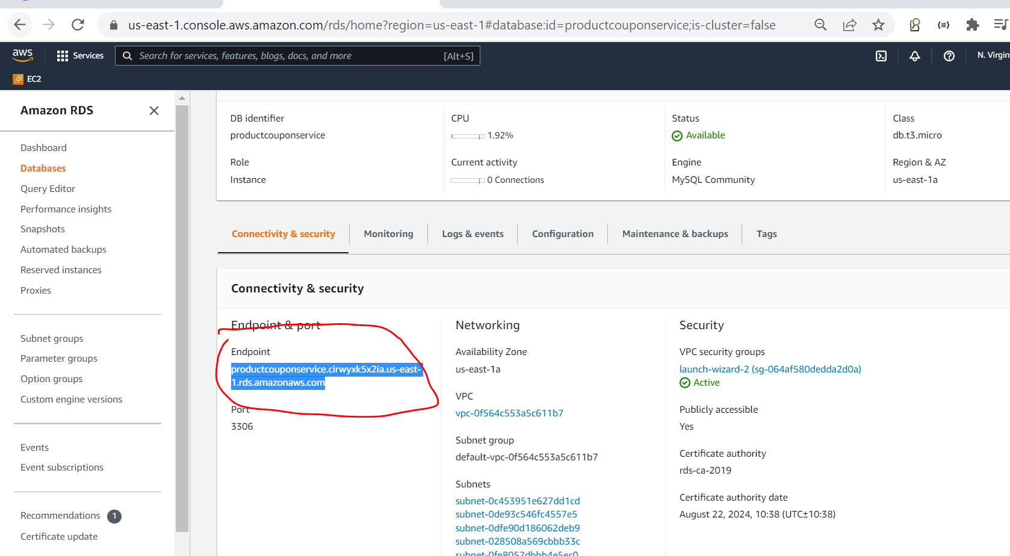

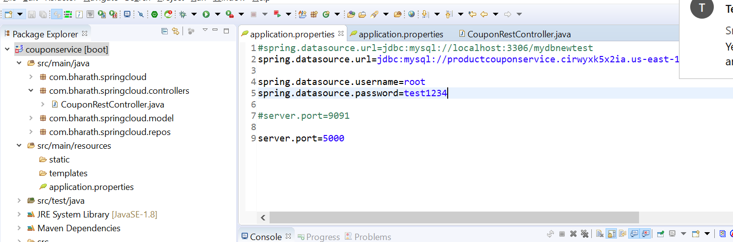

While configuring D/B in RDS we gave pw- test1234

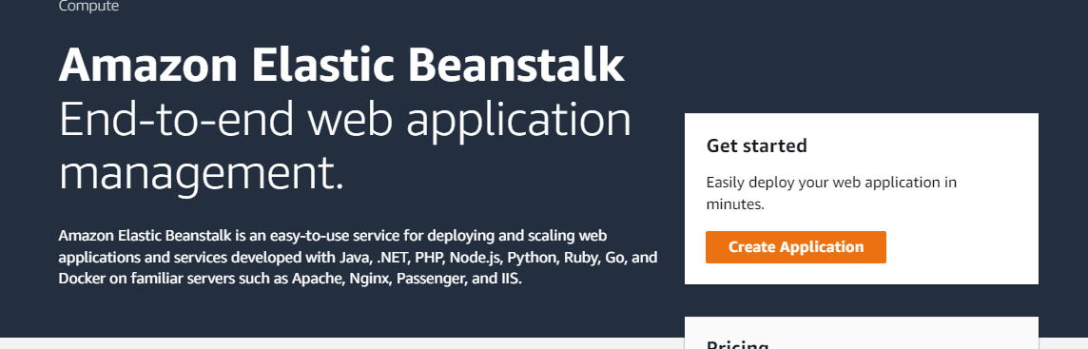

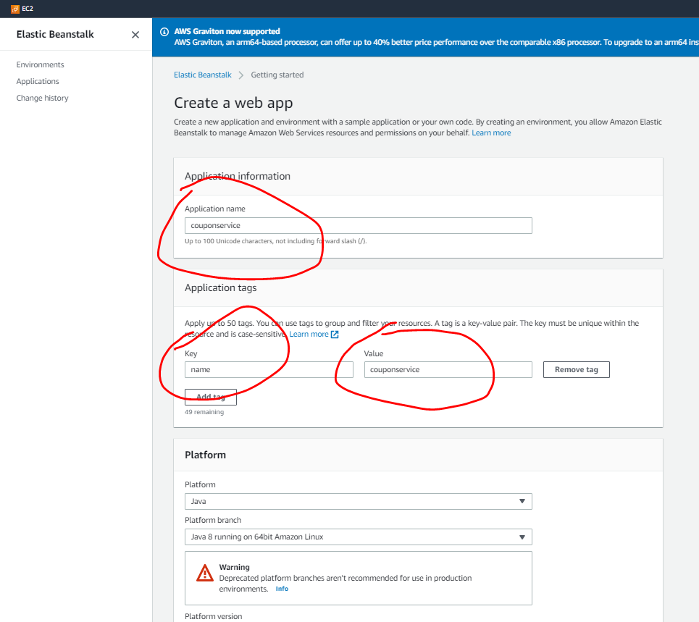

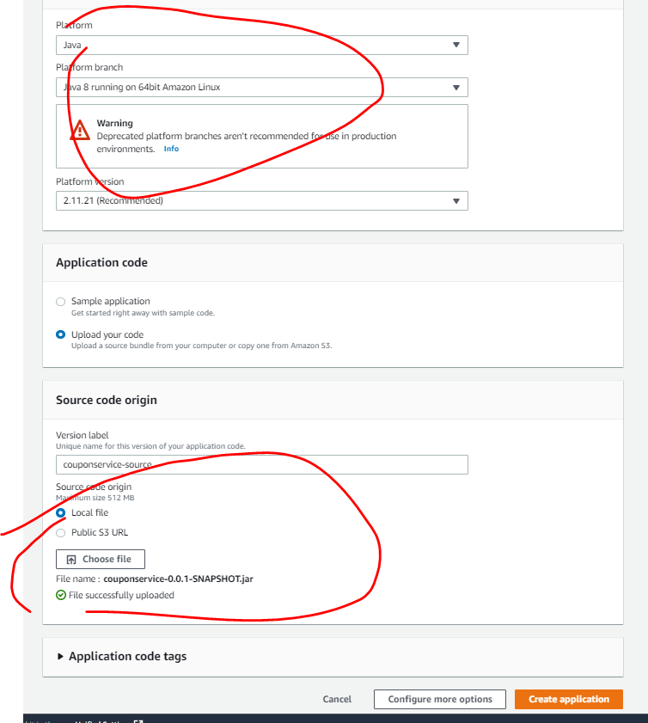

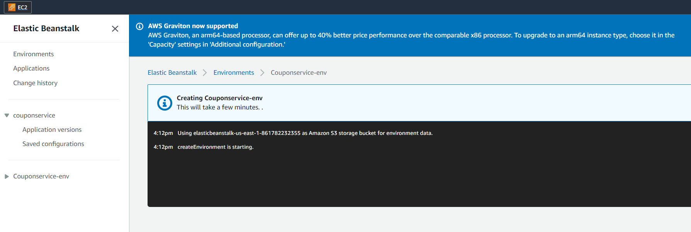

**This will take sometime because it going to create environment for us. It going to set up all the configuration.**

**Finally it will launch the application**

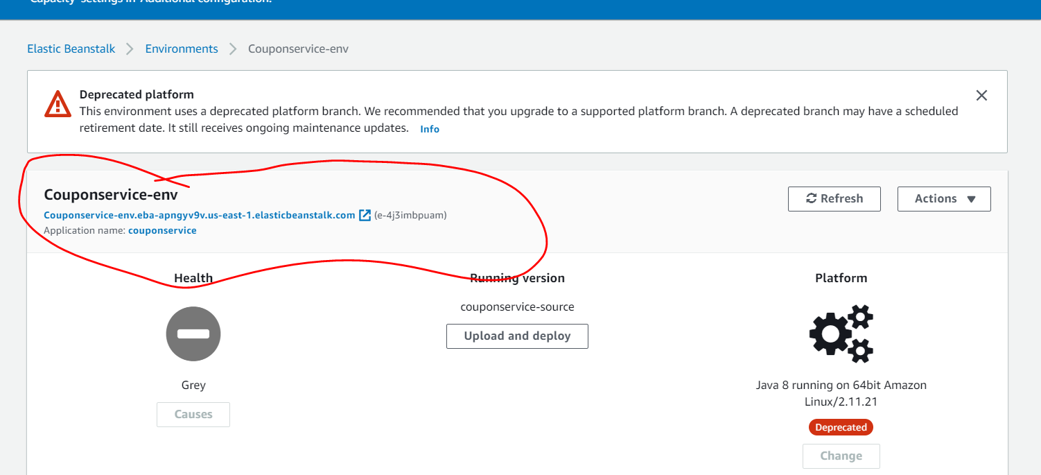

**This is the link using which we can access application**

**Note :**

**Port 5000 will automatically mapped to this url**

<http://couponservice-env.eba-apngyv9v.us-east-1.elasticbeanstalk.com/>

Now application in running in elastic beanstalk

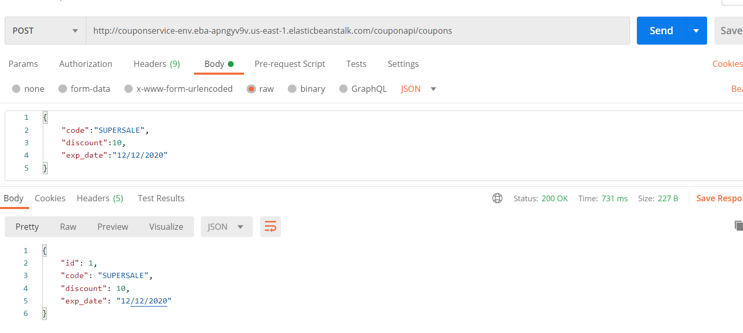

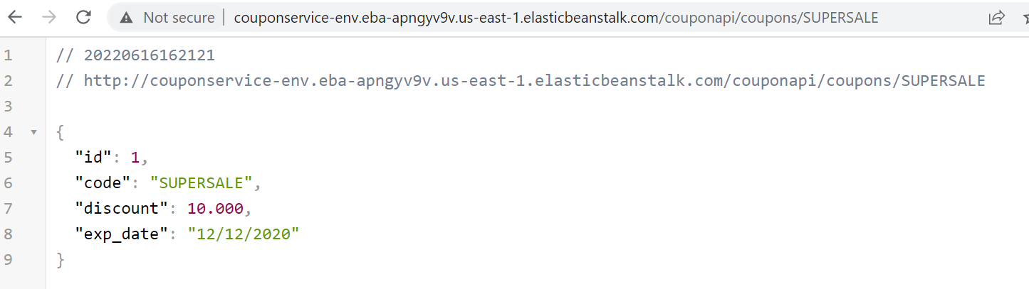

**Deploy The Product Service**

**Objective :**

To deploy product service so that it can communicate with coupon service and d/b

**Remember :**

couponService and ProductService will run in two different instance or machine or different environment in elastic beanstalk

So we can give same port number

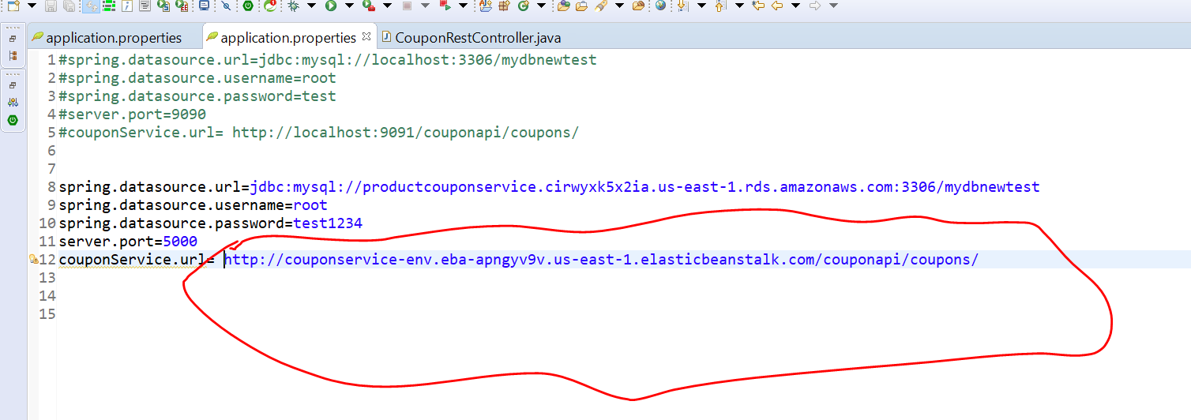

Create elastic beanstalk for product service also from starting

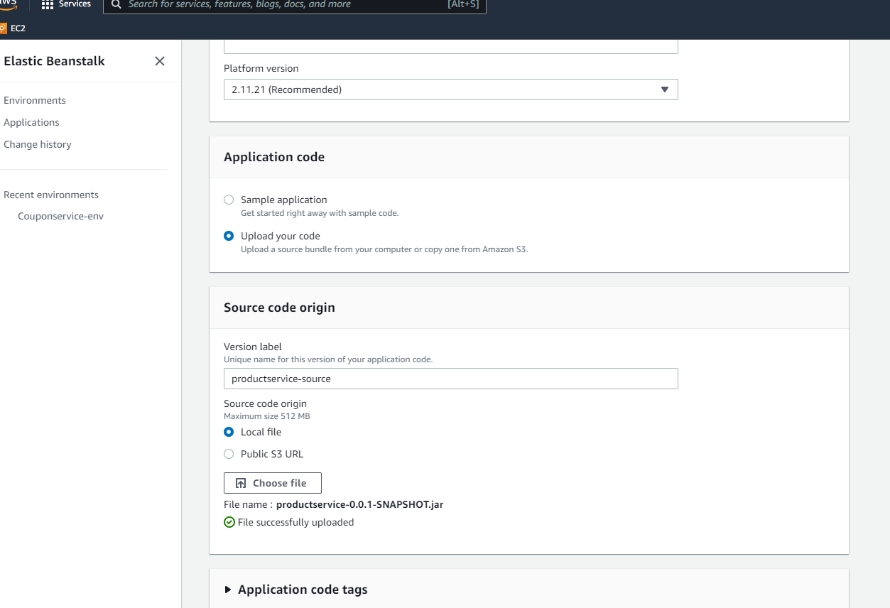

Below link will use for productService

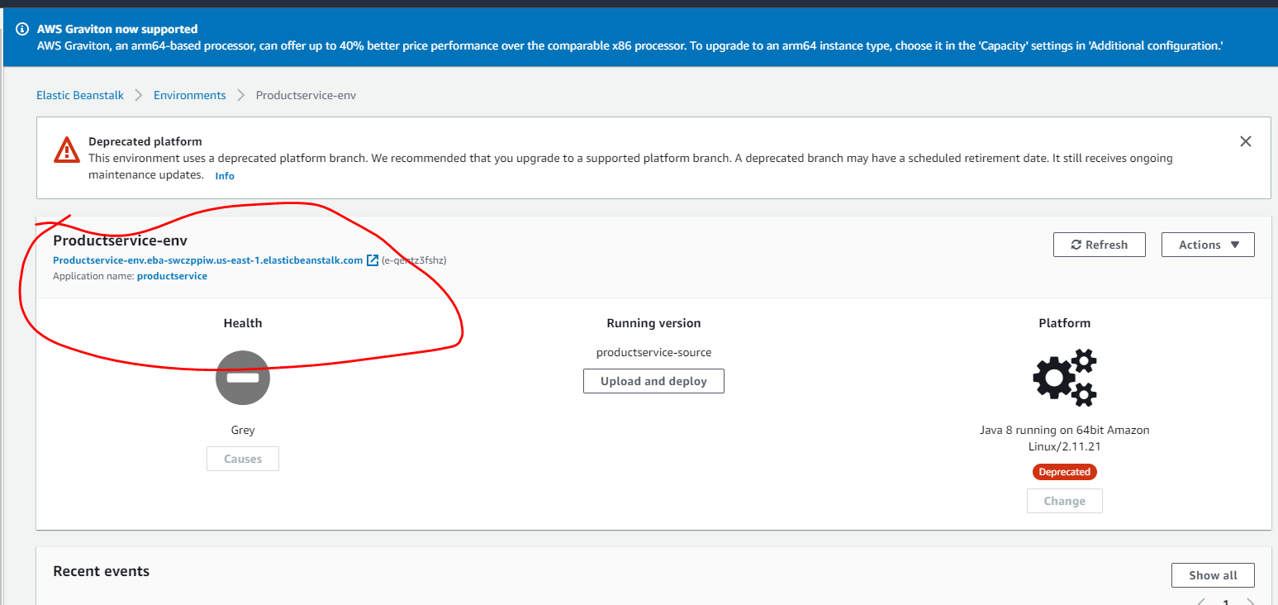

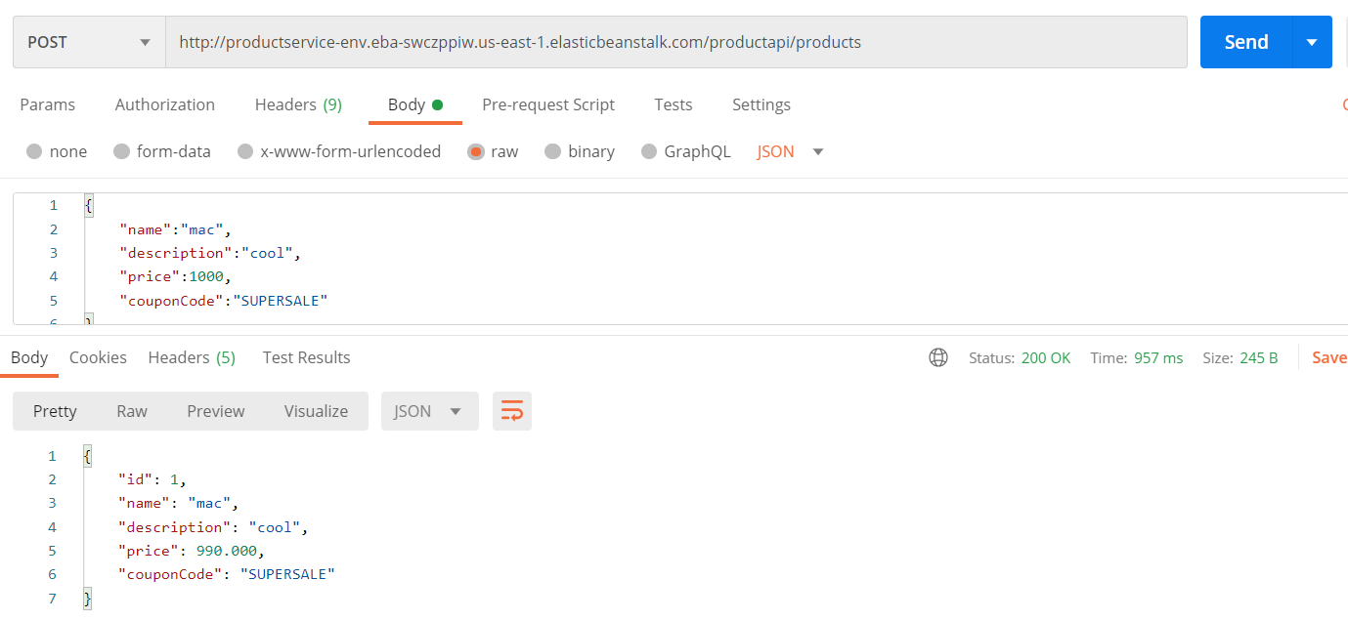

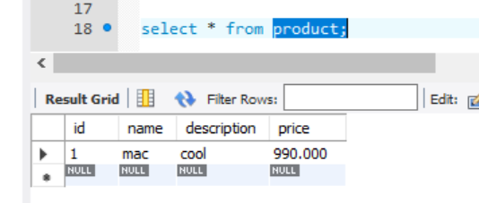

So we successfully deployed Microservice in aws using elastic beanstalk

Wrap up

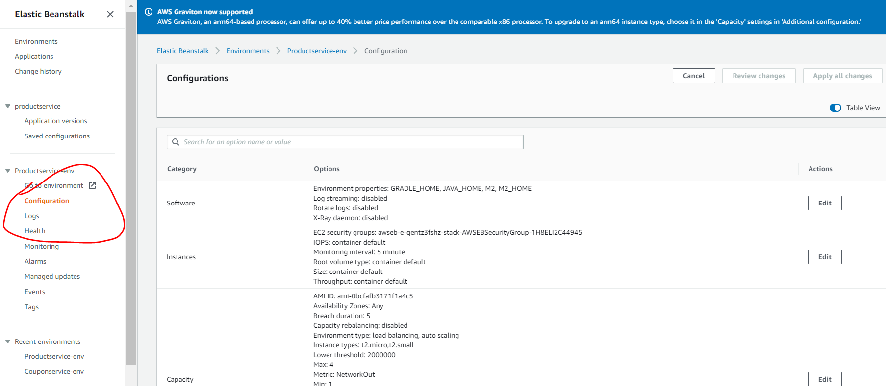

Note

We can check here configuration

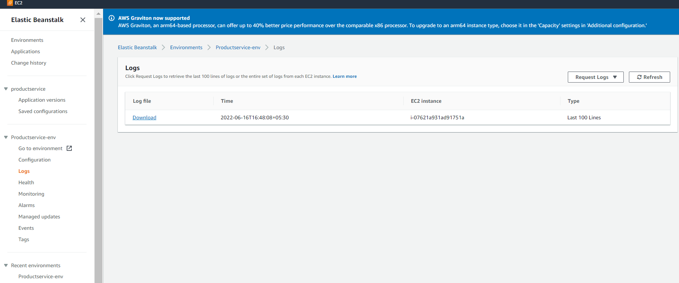

We can request for logs here and check if anything is wrong in spring boot application

**Delete rds instance**

**Delete elastic beanstalk**

**Always recommended :--- delete the environment instead of deleting ec2**